GIT AND GITHUB :

* Git: 🡪 It is version control system

Eg: Watsapp ( in watsapp created latest version , but in that having one problem like blue tick is not working for that case, they can switch the previous version which is already working)

This is called version control

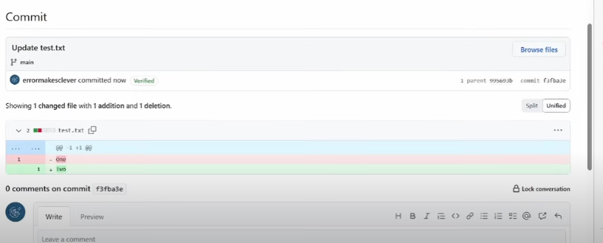

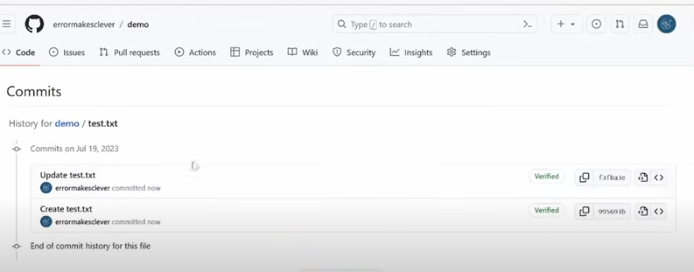

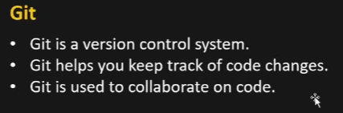

* Git🡪Multiple ppl can work at same time in git (same account also)
* GitHub🡪Github keep backbone as “git”

Eg: We have different fruit mixers for that we need to put the “fruit” 🡪 so here,

Fruit-🡪 it a backbone🡪Git

Fruit mixer🡪 Github

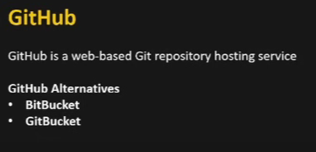

Step1: create github account

Step2: have visualstudio code also (for programming purposes)

Step1:

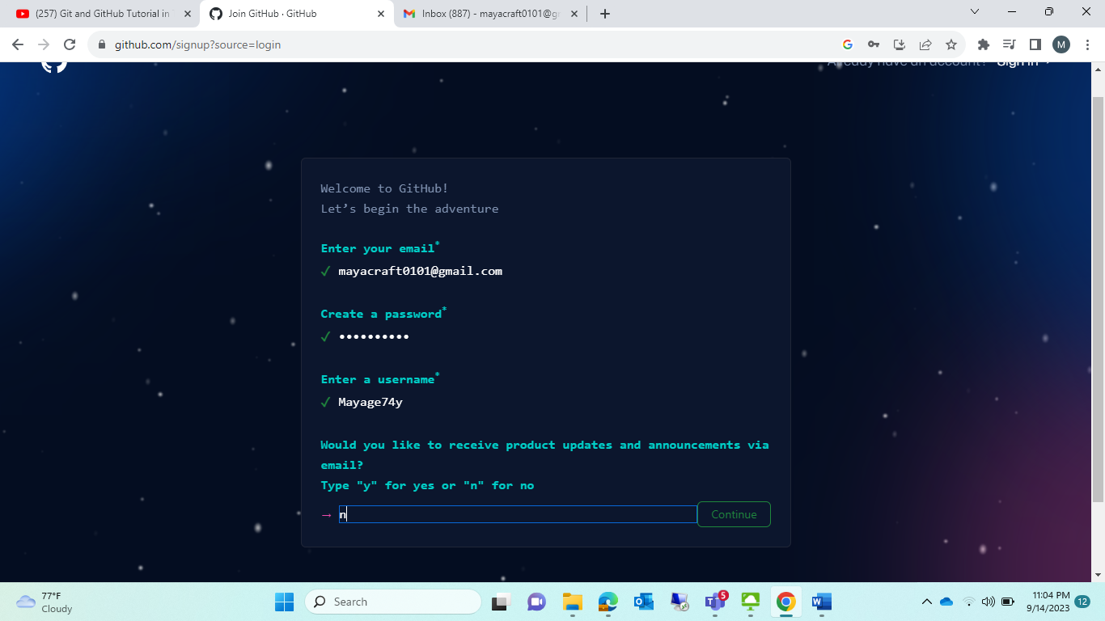

Username:Mayage74y

Pwd:Yaam459@@@



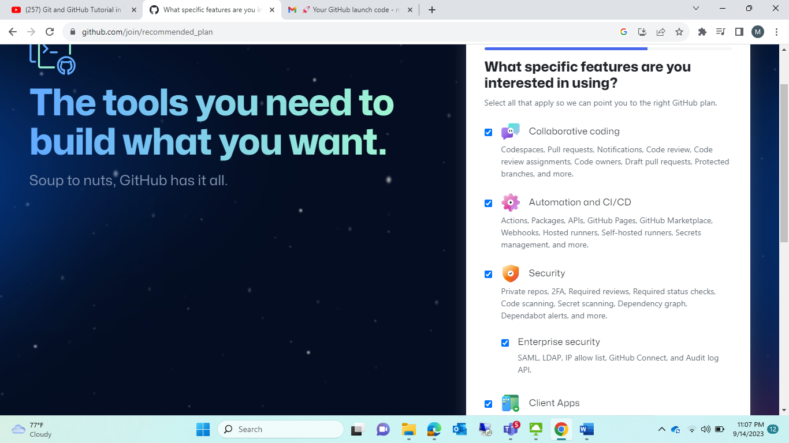

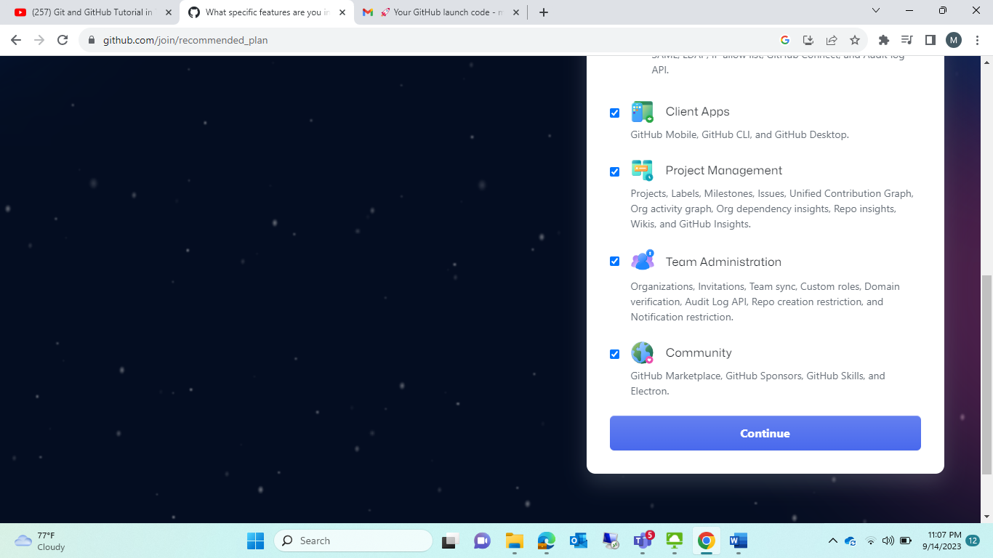

Step2: create new respostory(it is like afolder)

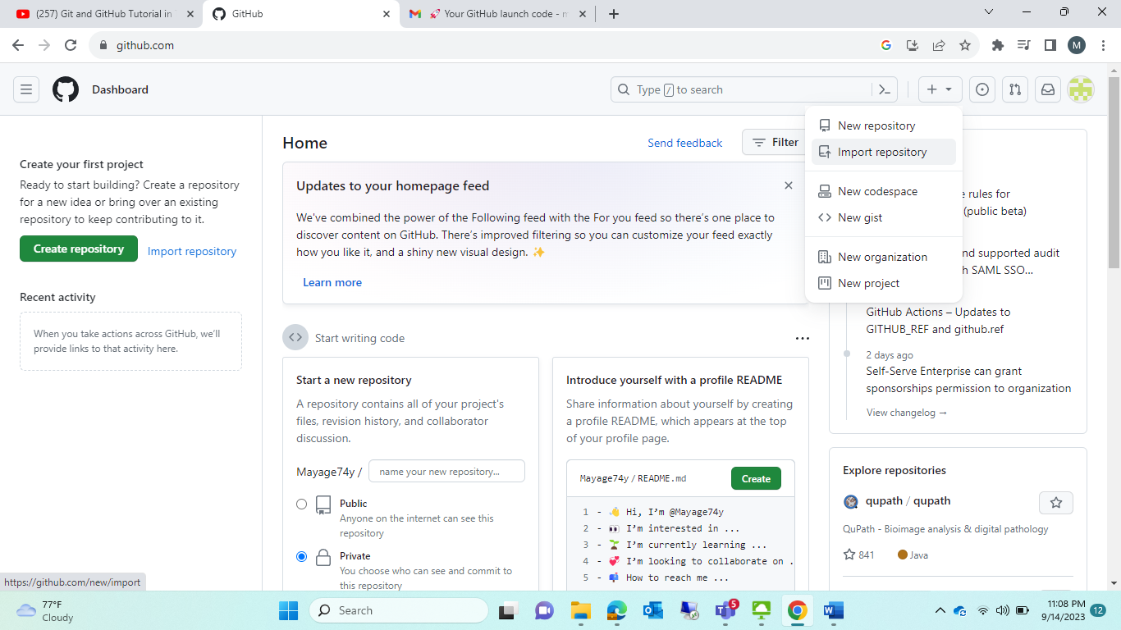

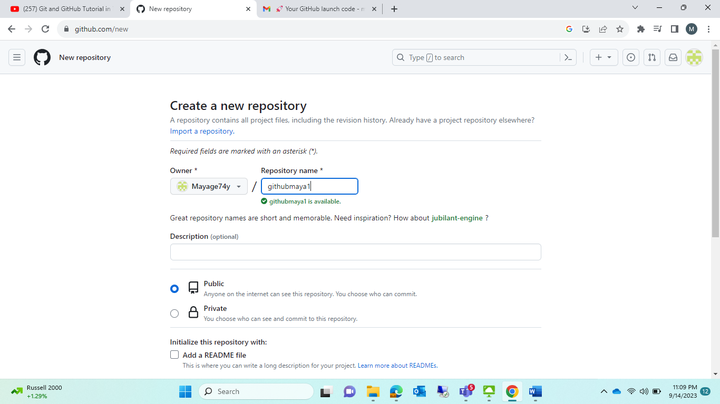

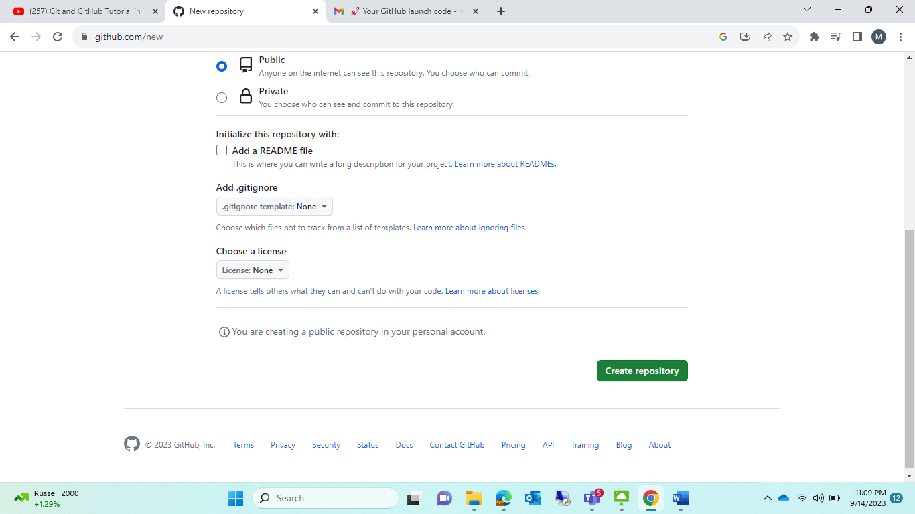

Respostory got created:

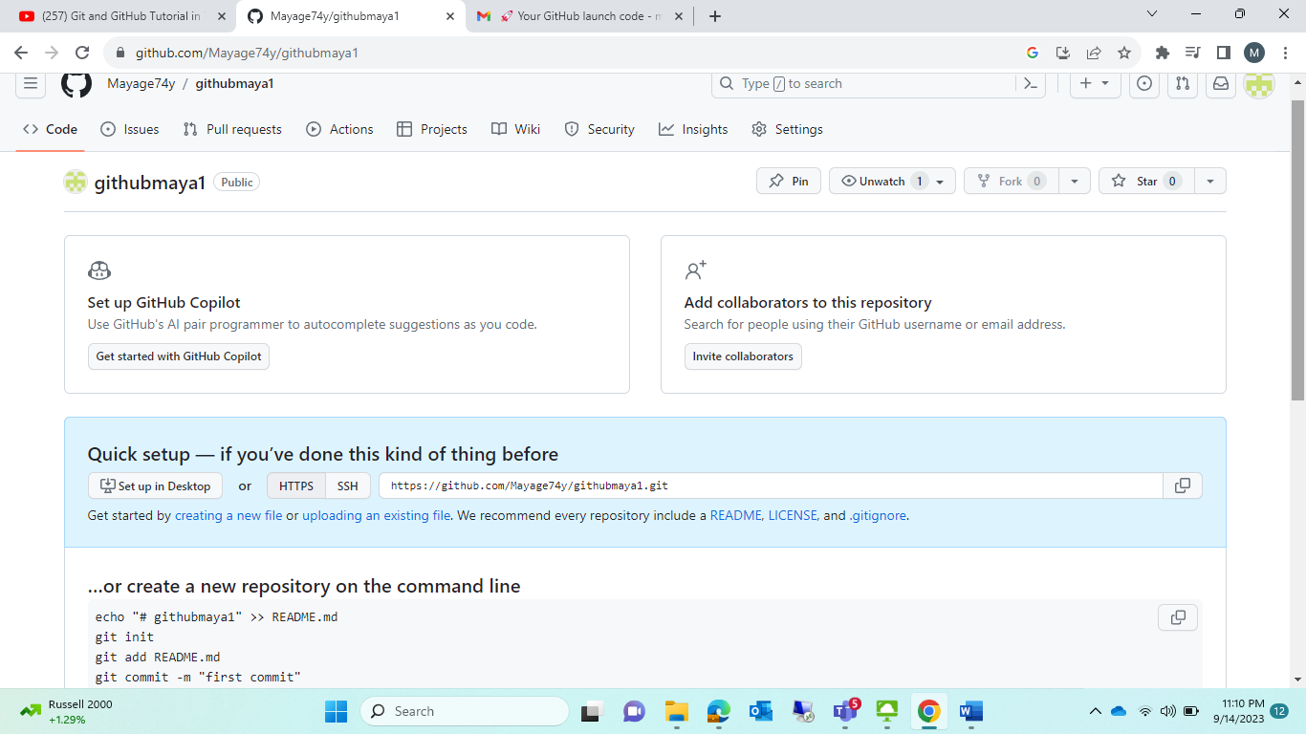

<https://github.com/Mayage74y/githubmaya1.git>

step3: in above image it will show (creating a new file)🡪click that

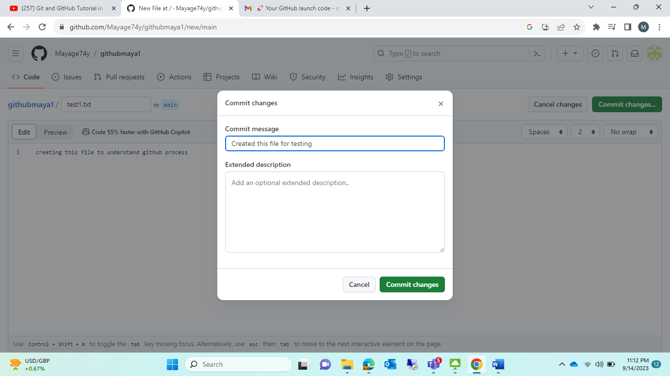

Create file 🡪I am creating text file 🡪 after entering message in that 🡪 click commit changes 🡪 then popup box apper 🡪 always ensure “commit message “ should give or otherwise it will take automatically some message --. Then press “commit chngaes “

Note :COMMIT CHNAGES🡪 MEANS (SAVE)

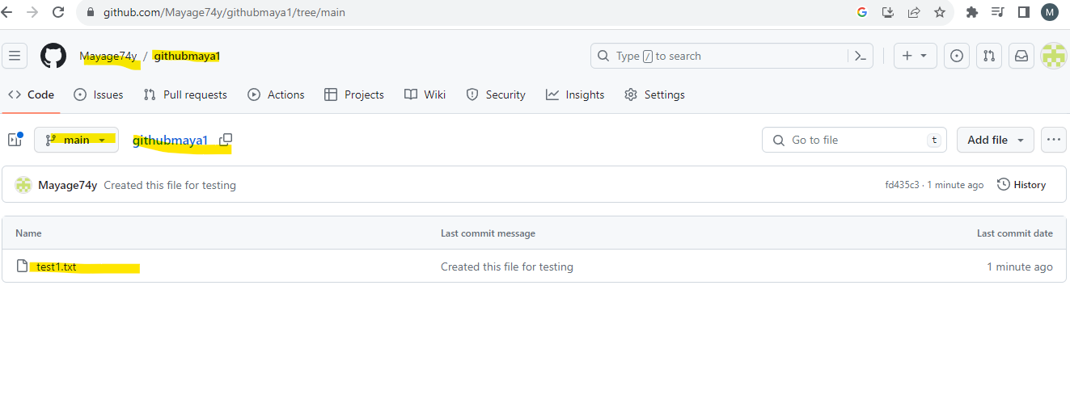

ACCOUNT: Mayage74y

RESPOSTORY(FOLDER): githubmaya1

BRANCH(sub-folder): main

FILE: test1.txt

Above is above 🡪 How to create a file in github

Module2:

How to bring Html code in Github process🡪 normally we can’t do programming inside github,so we taking github path to our local system

Step1: install Git in your local system

Step2: open cmd type 🡪 git

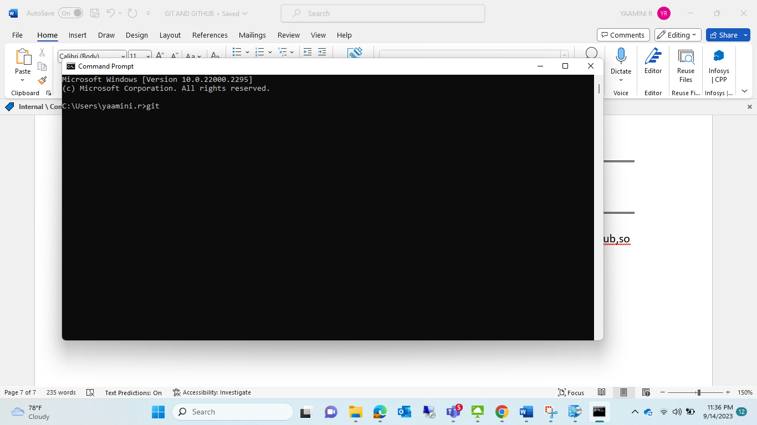

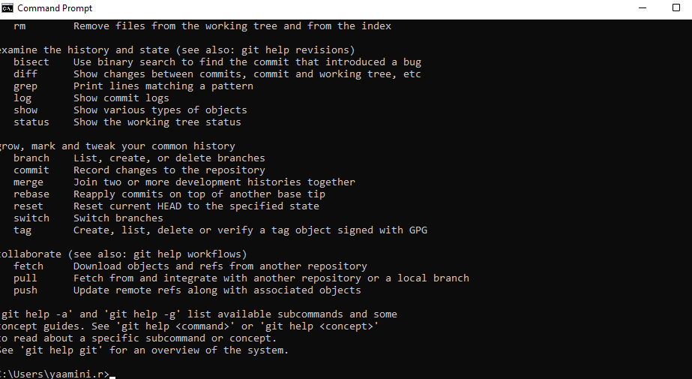

If u got like this 🡪 ur git successfully installed.

Step3:

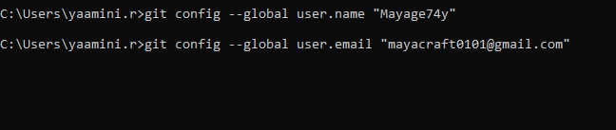

git config --global user.name "Mayage74y"

git config --global user.email “[mayacraft0101@gmail.com](mailto:mayacraft0101@gmail.com)”

step4: create any new folder in your local system,🡪name : “Git_learn”(Folder name)

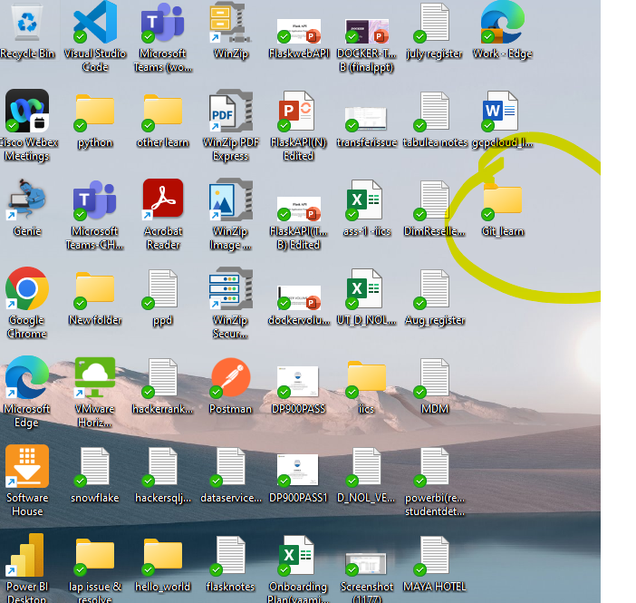

Step5: open this folder in your visualstudiocode.

Note : how to bring respostory folder github into our local folder(Git_learn) ?

For that make copy command how !!!

Step6: for that case open VS code

(file🡪open folder🡪Git_learn)

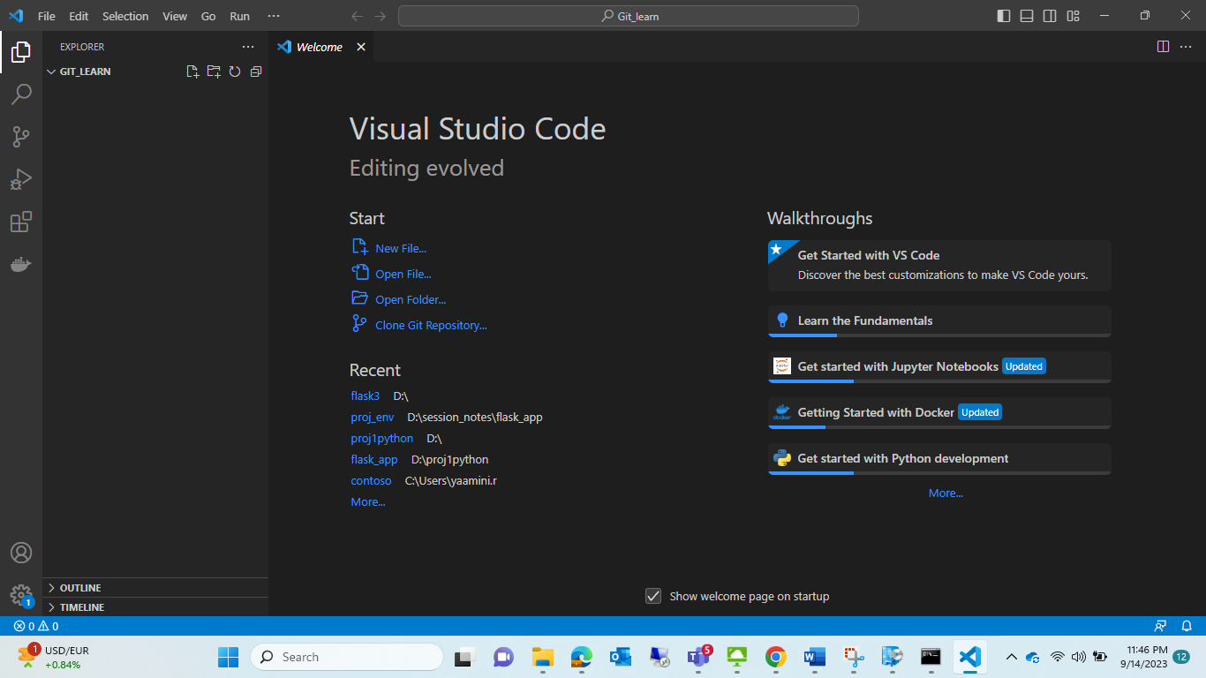

Step7:

Terminal click🡪 type🡪synatx:🡪 git clone <paste that git path here>

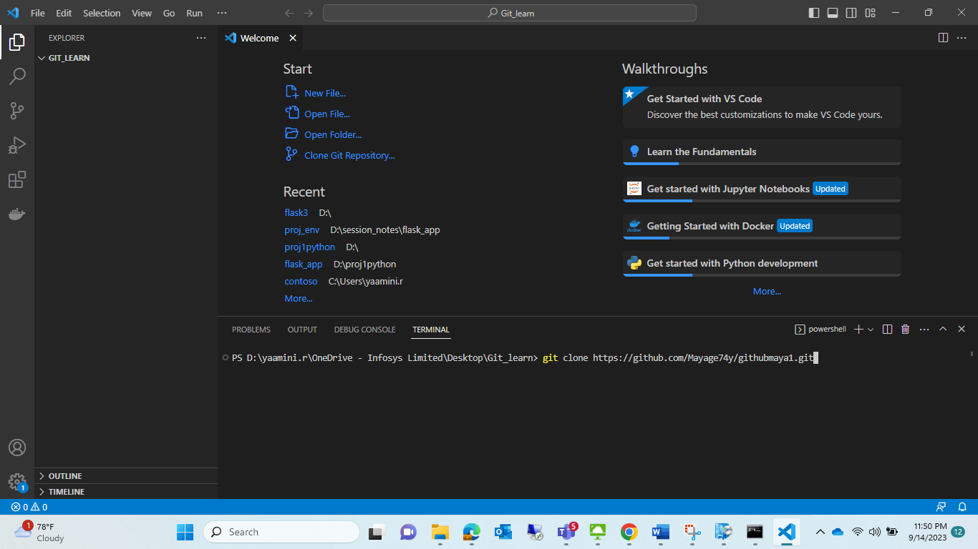 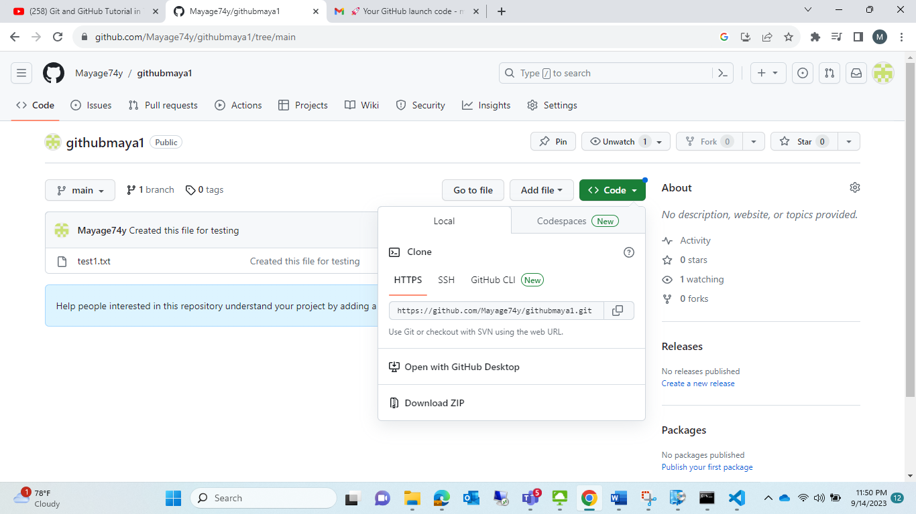

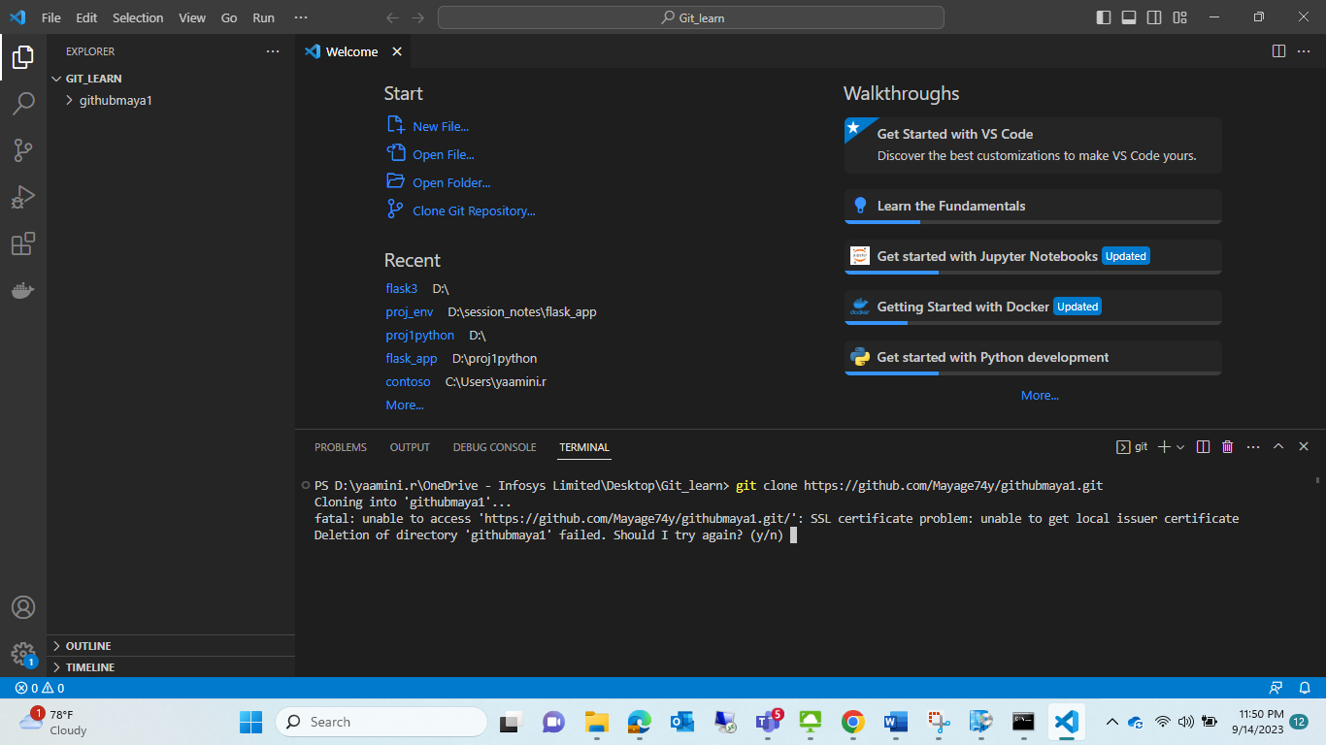

Problem :fatal error🡪 unable-to-resolve-unable-to-get-local-issuer-certificate-using-git-on-windows

Solution: run in cmd prompt these cmd ::

git config --global http.sslbackend schannel

git config --global http.sslVerify false

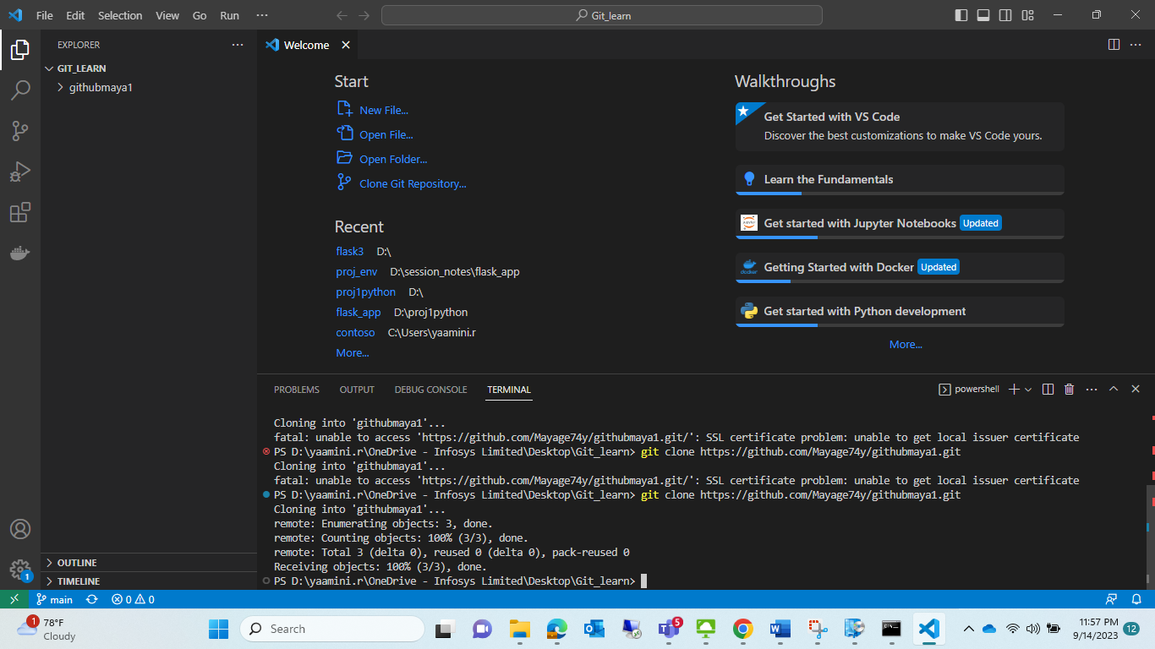

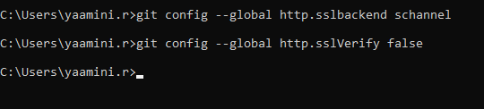

Check that github respostory is import in local folder or not :

* See in vs-code githubmaya1 and also test1.txt is there
* Also check that local folder is imported this git or not
* 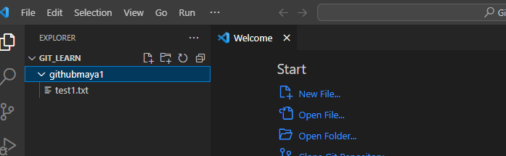
* 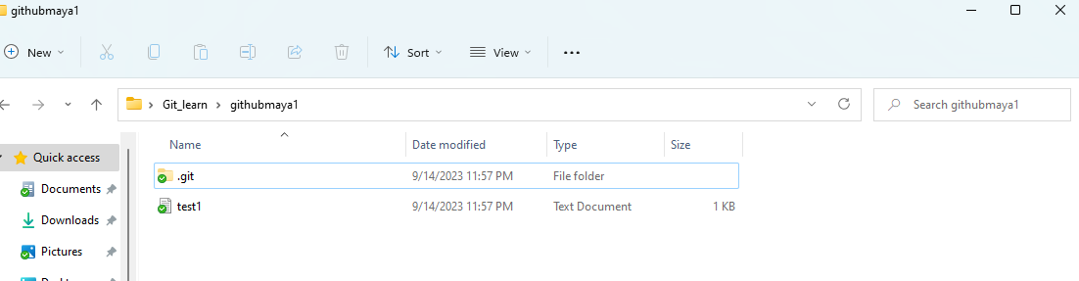
* Normally that git will not visible 🡪 it was in hidden mode so 🡪 go for “VIEW” --. SHOW🡪 HIDDEN
* What is this 🡪git folder ?

This git 🡪 it was act like between respostoy of github and local folder 🡪 this git folder (act like bridge between these twoo)

Cmd☹notes too remember☹to configure)

Microsoft Windows [Version 10.0.22000.2295]

(c) Microsoft Corporation. All rights reserved.

C:\Users\yaamini.r>git

usage: git [-v | --version] [-h | --help] [-C <path>] [-c <name>=<value>]

[--exec-path[=<path>]] [--html-path] [--man-path] [--info-path]

[-p | --paginate | -P | --no-pager] [--no-replace-objects] [--bare]

[--git-dir=<path>] [--work-tree=<path>] [--namespace=<name>]

[--config-env=<name>=<envvar>] <command> [<args>]

These are common Git commands used in various situations:

start a working area (see also: git help tutorial)

clone Clone a repository into a new directory

init Create an empty Git repository or reinitialize an existing one

work on the current change (see also: git help everyday)

add Add file contents to the index

mv Move or rename a file, a directory, or a symlink

restore Restore working tree files

rm Remove files from the working tree and from the index

examine the history and state (see also: git help revisions)

bisect Use binary search to find the commit that introduced a bug

diff Show changes between commits, commit and working tree, etc

grep Print lines matching a pattern

log Show commit logs

show Show various types of objects

status Show the working tree status

grow, mark and tweak your common history

branch List, create, or delete branches

commit Record changes to the repository

merge Join two or more development histories together

rebase Reapply commits on top of another base tip

reset Reset current HEAD to the specified state

switch Switch branches

tag Create, list, delete or verify a tag object signed with GPG

collaborate (see also: git help workflows)

fetch Download objects and refs from another repository

pull Fetch from and integrate with another repository or a local branch

push Update remote refs along with associated objects

'git help -a' and 'git help -g' list available subcommands and some

concept guides. See 'git help <command>' or 'git help <concept>'

to read about a specific subcommand or concept.

See 'git help git' for an overview of the system.

C:\Users\yaamini.r>git config --global user.name "Mayage74y"

C:\Users\yaamini.r>git config --global user.email "mayacraft0101@gmail.com"

C:\Users\yaamini.r>git config --global http.sslbackend schannel

C:\Users\yaamini.r>git config --global http.sslVerify false

C:\Users\yaamini.r>

Module3:

How to bring local file to github repository ??

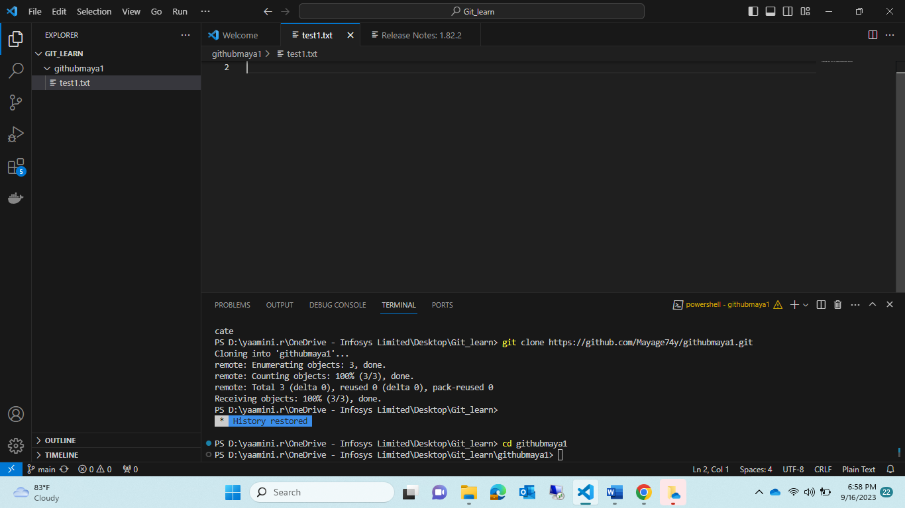

* cd githubmaya1
* create new file in vs code eg:test2.txt
* it will represent as ‘U’🡪 which means unmodified
* use 🡪 git status(in terminal)🡪it will show as “untracked files”
* 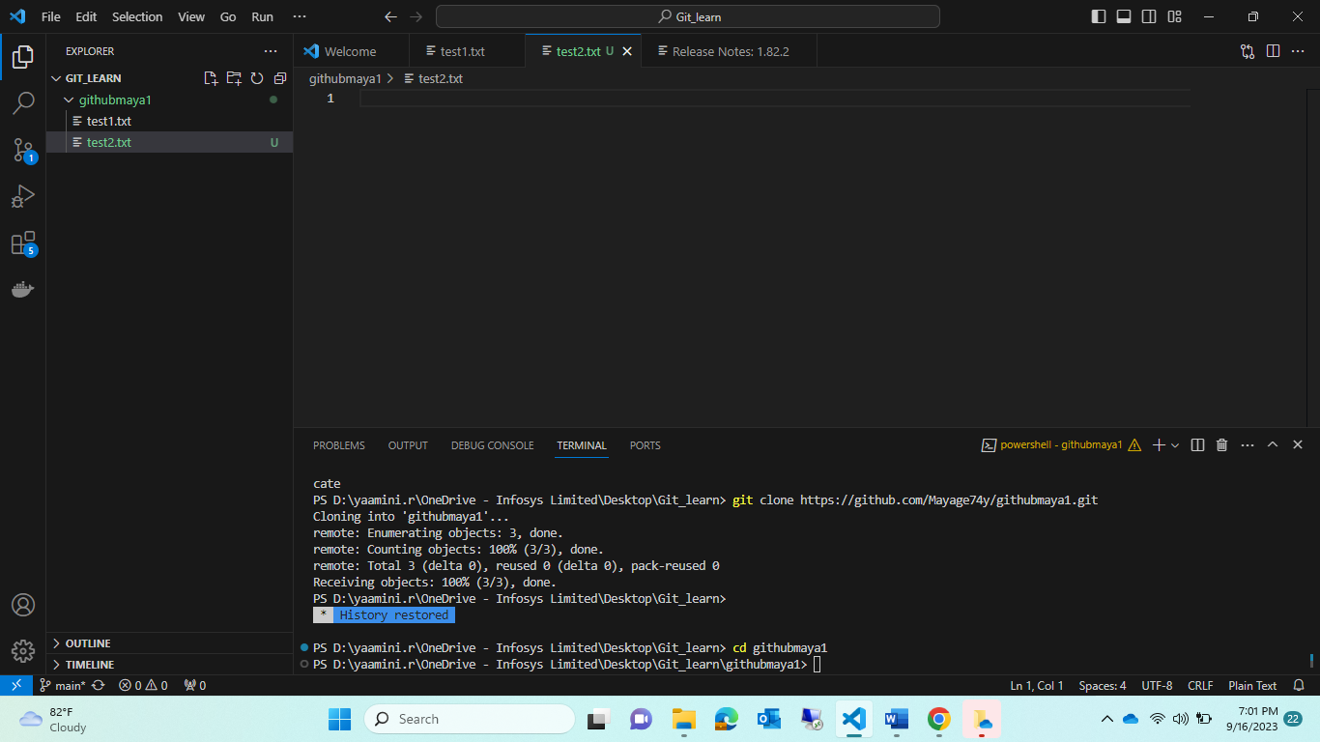
* 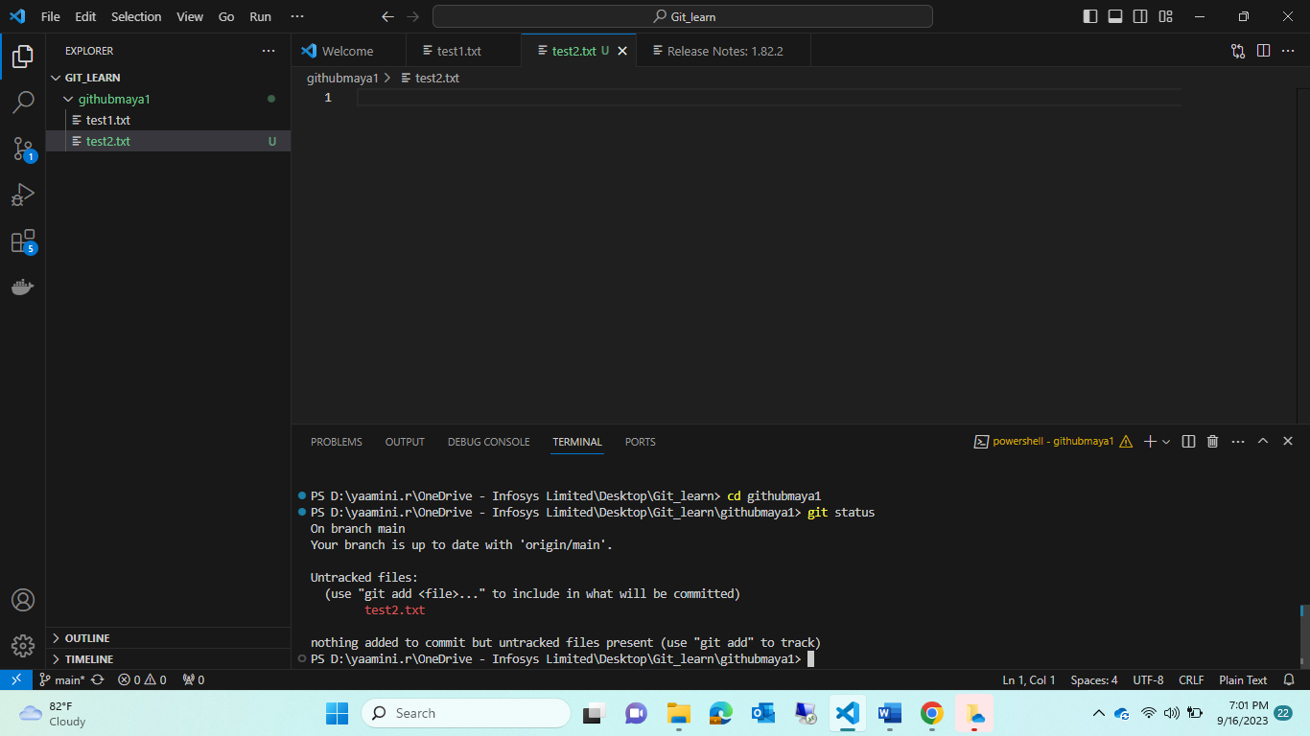
* 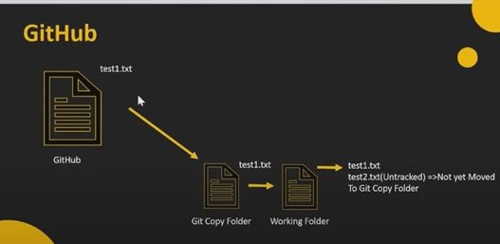
* Github repository🡪 we created “test1.txt🡪 that file & repository we pushed to local system🡪 it was making as two folder
* 1. GIT COPY FOLDER
* 2. WORKING FOLDER
* First that test1.txt 🡪 land into git copy folder 🡪 then working folder
* Test2.txt which is created in local vs code🡪 that how we send to GITHUB folder ?
* Test2.txt want to move to 🡪 git copy folder then 🡪only Github folder

Step1: git add test2.txt

Step2: check 🡪 git status

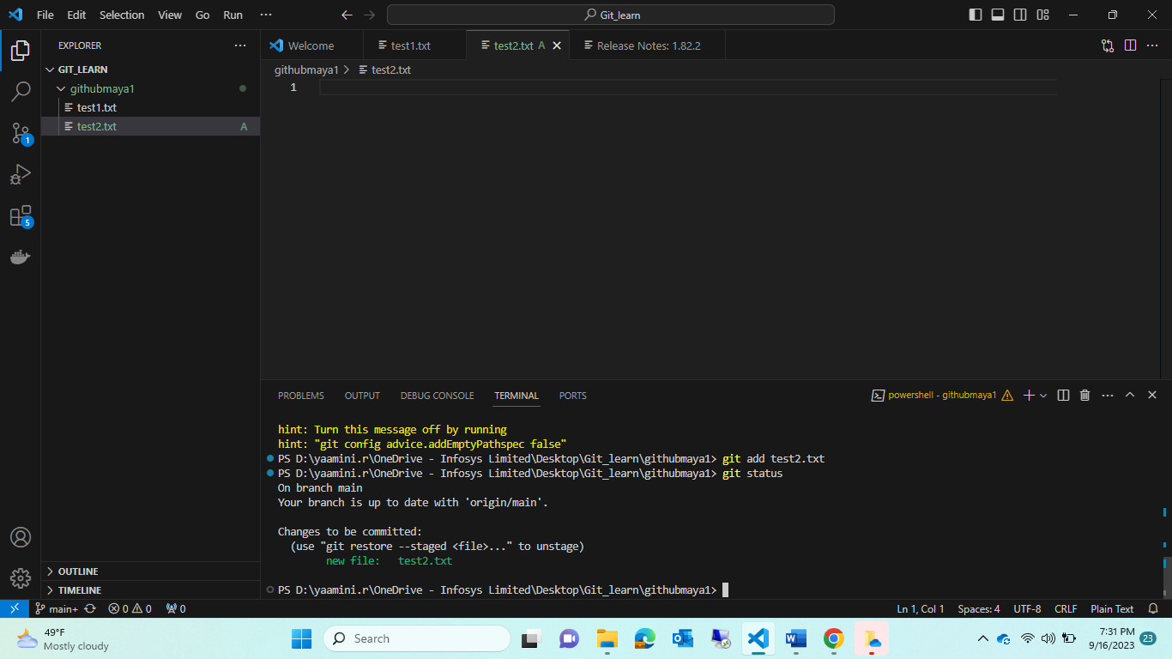

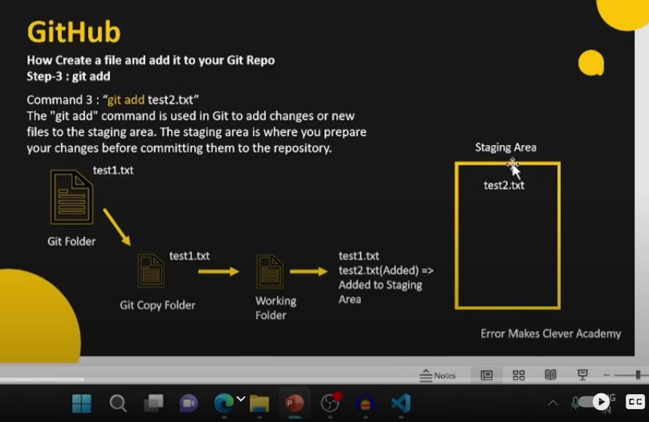

Step3: after adding that git add cmd🡪 that file will wait in stageing area🡪 then how to first into our “git copy folder🡪 then from there move into Git folder

* Use cmd to bring staging area to “git copy folder” in vs code

git commit -m “Test2.txt is adding to git copy folder”

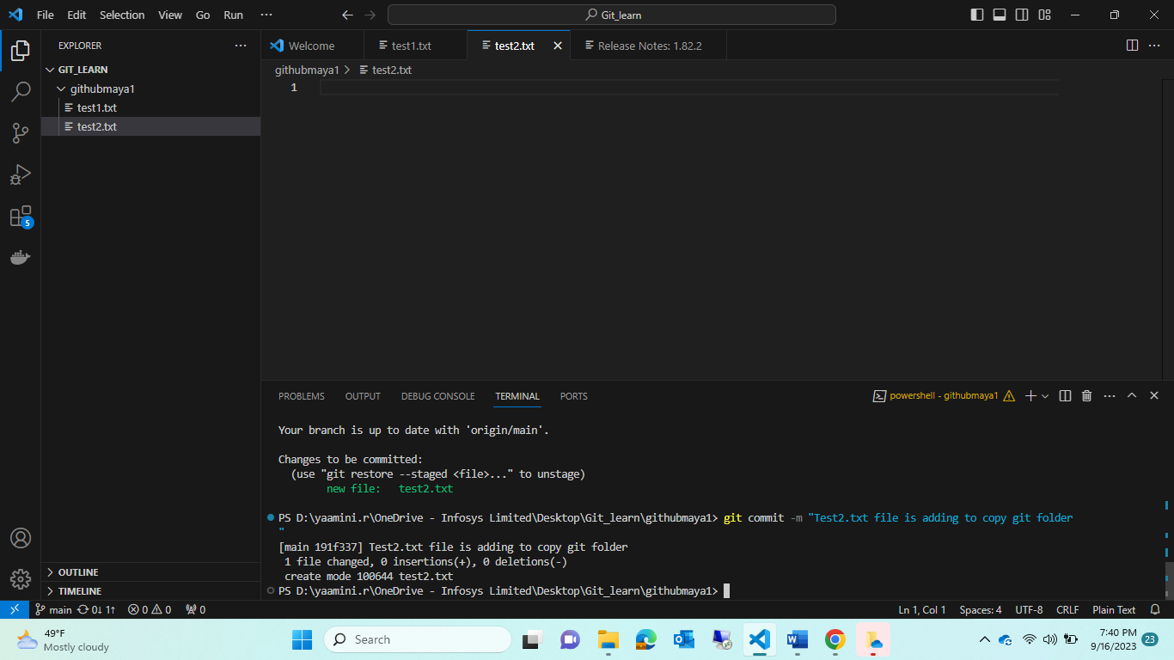

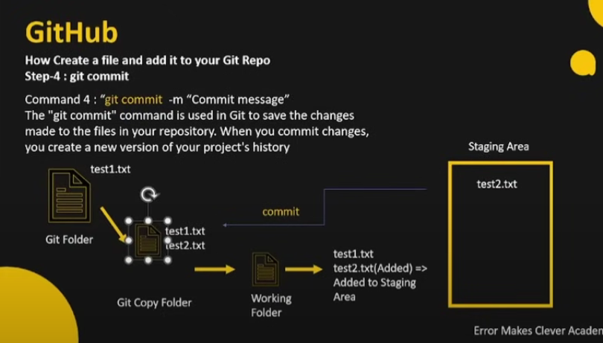

Now it was in “git copy folder 🡪 from here how to move into 🡺Git folder?

** by using “git push “ cmd 🡪 so it will move from local into github repository

git push origin main

origin🡪 it called as 🡪<https://github.com/Mayage74y/githubmaya1.git>

* git push origin main 🡪 when u give this cmd🡪 for first time Github will ask Sign-in

complete that all step🡪 then execute this cmd again🡪 git push origin main

* then check in github respostory whether that test2.txt file is uploaded or not !!

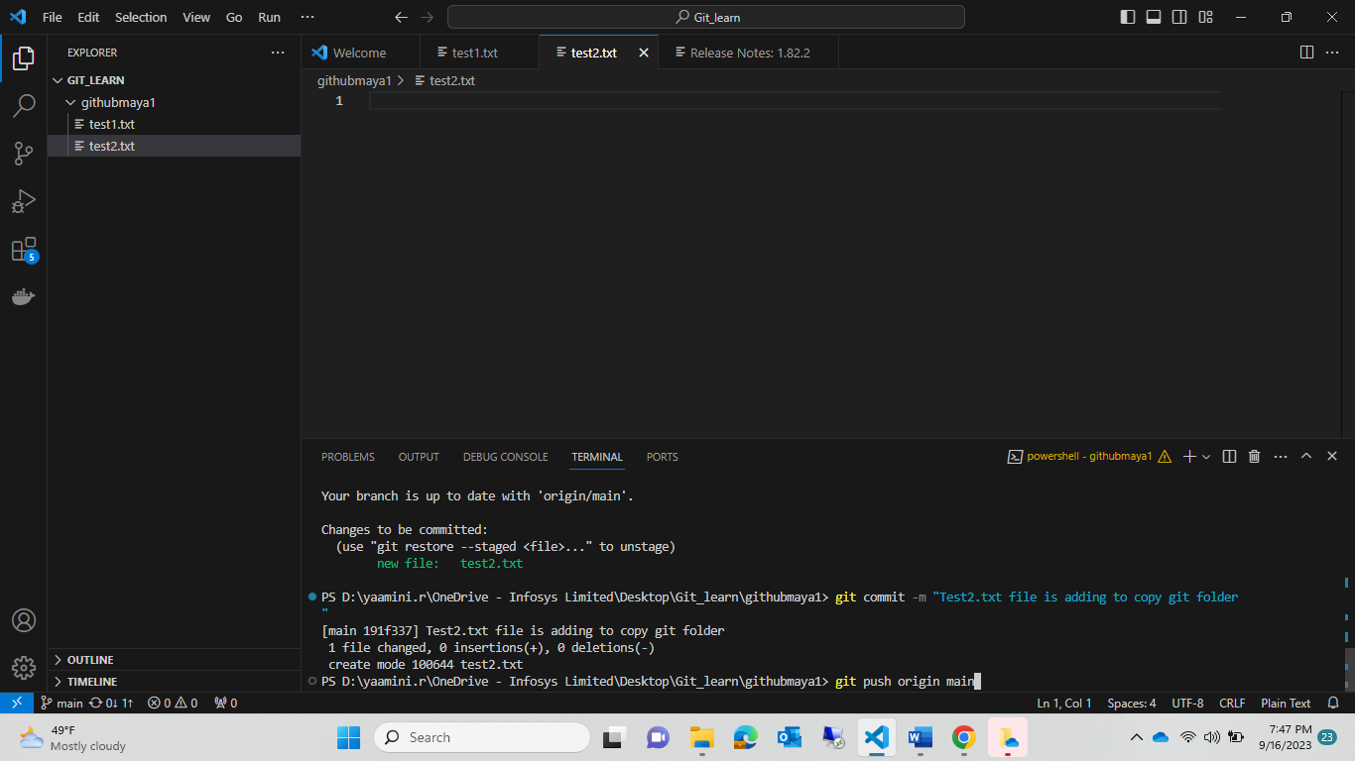

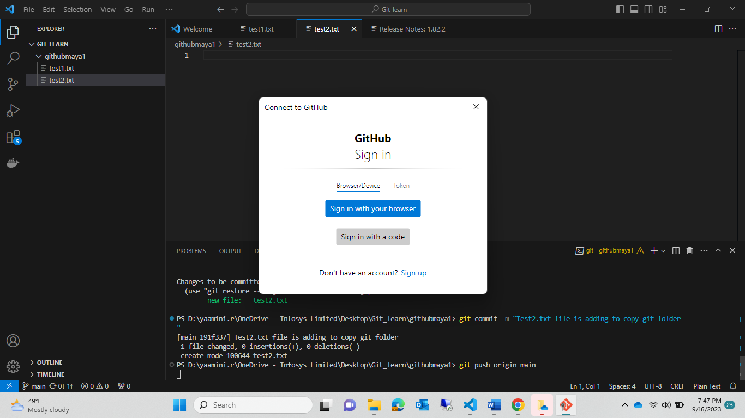

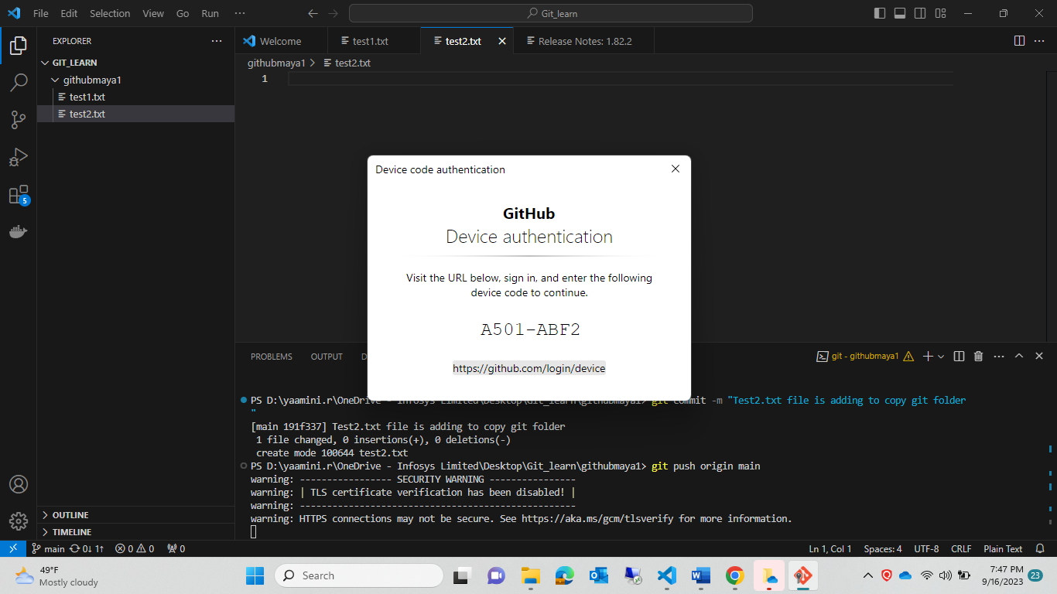

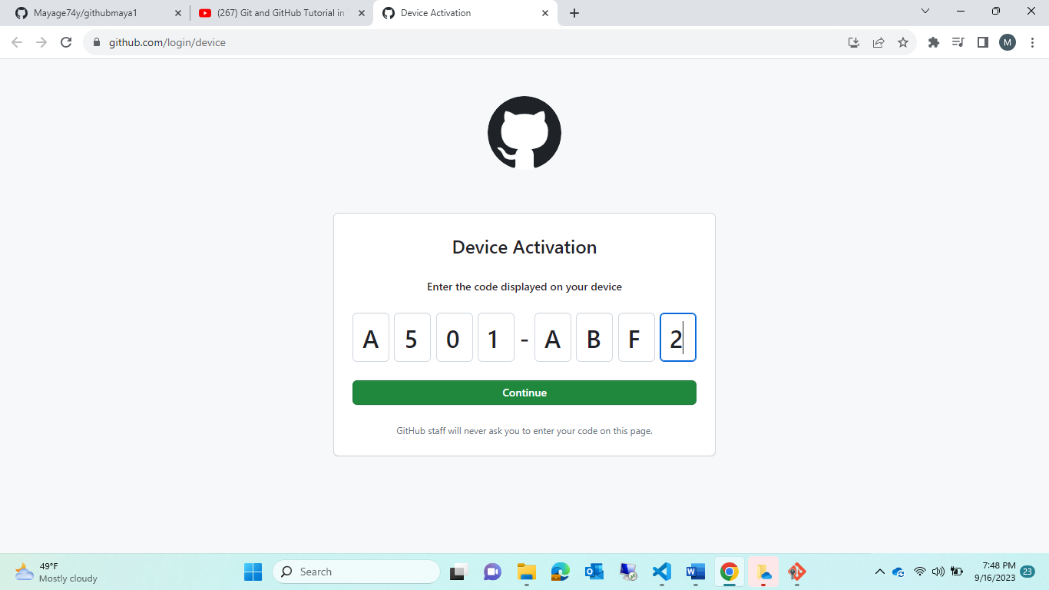

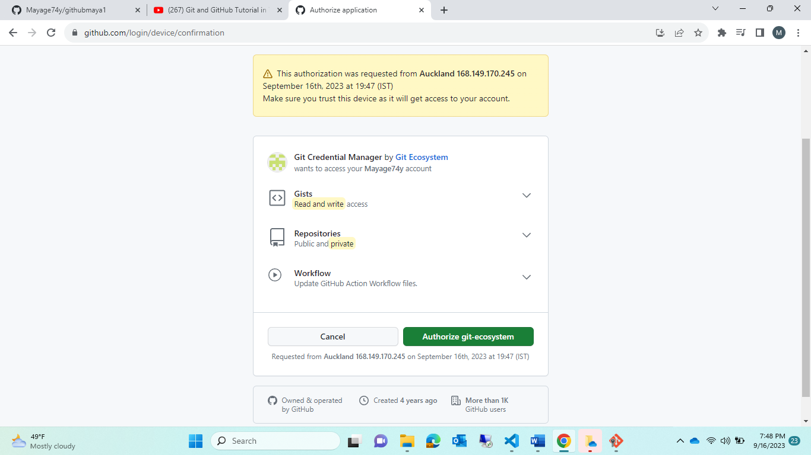

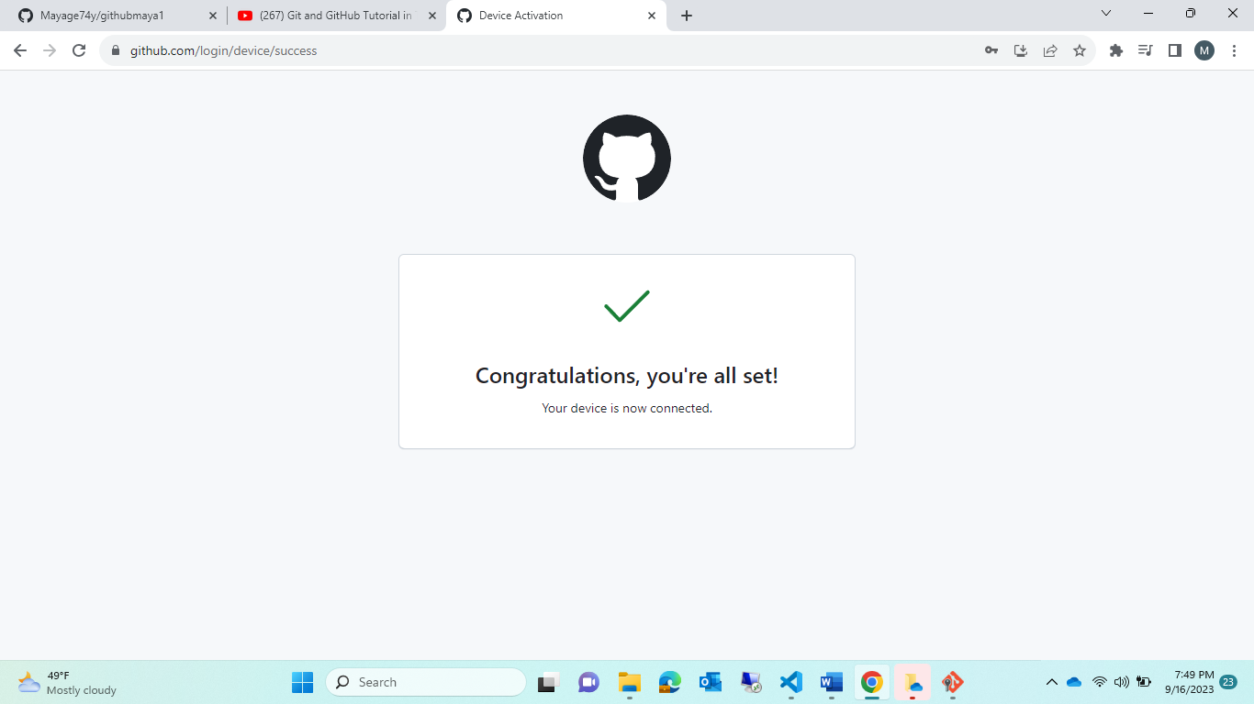

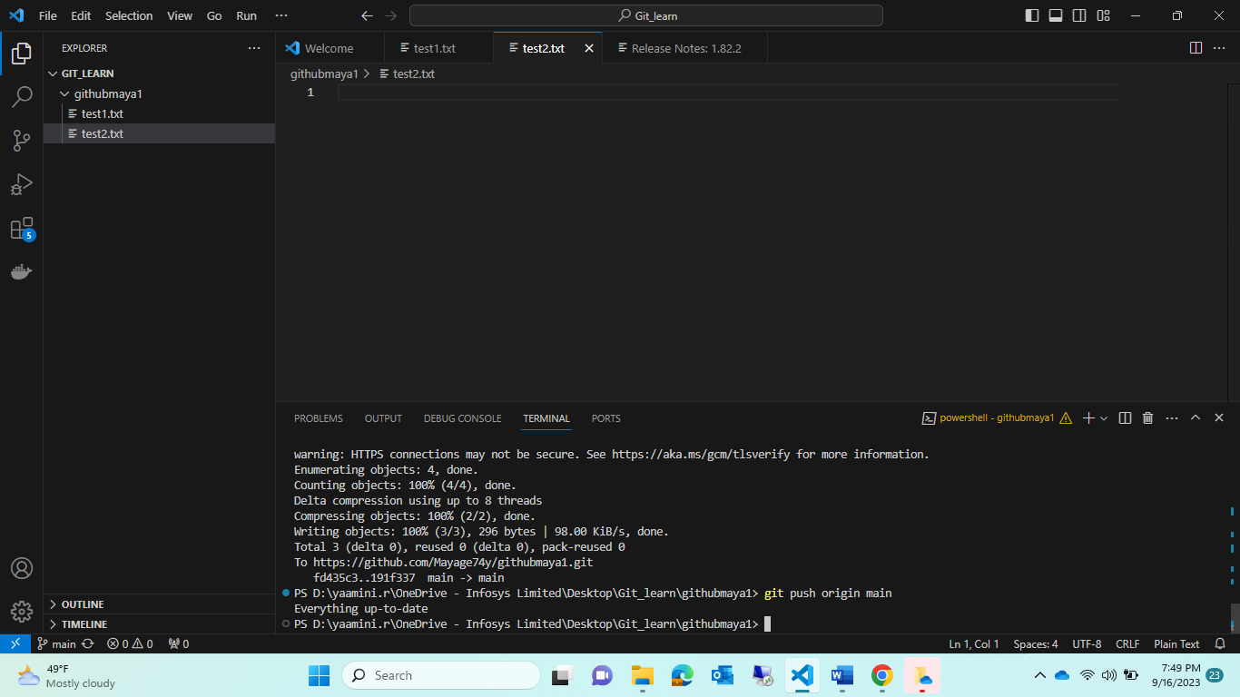

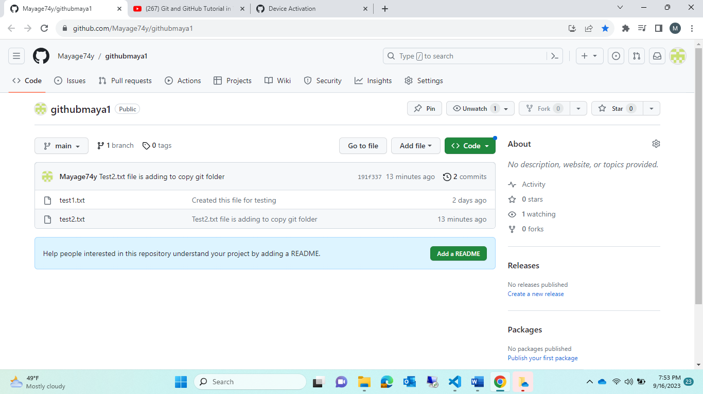

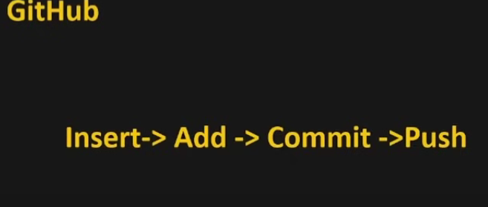

Finally walkthrough :

* step1: create a file in local system eg:test2.txt
* step2: it was in unmodified status 🡪 so use git add test2.txt cmd
* step3: it will be in add status🡪it was waiting in stage area
* step4: from stage area we want to push in to copy git folder🡪 use git commit -m “test2.txt commit msg”
* step5:from git copy folder(local resposirtoy) move into git folder(remote repository)🡪 use PUSH cmd🡪git push origin main
* step6: then we can see the changes which was reflected in remote git repository

now try again doing with test3.txt

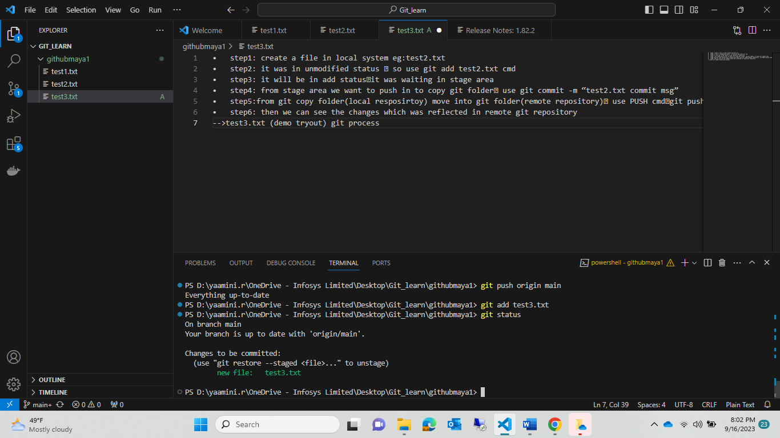

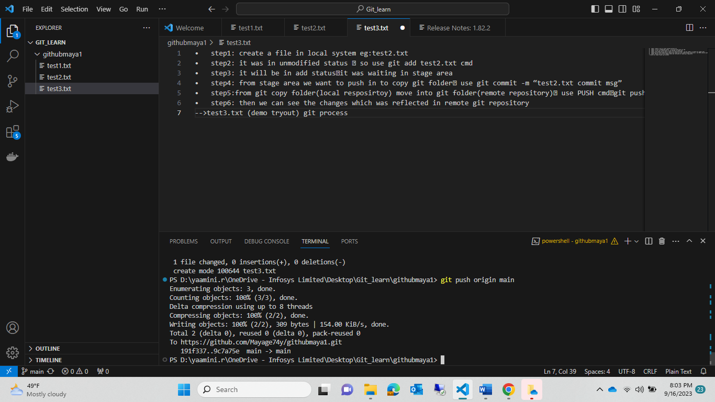

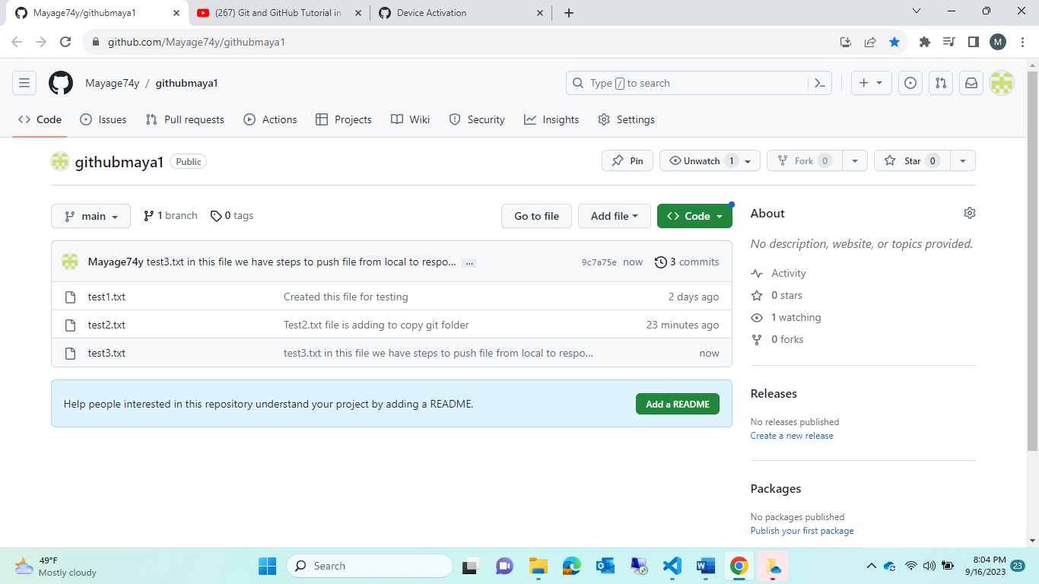

Now try with🡪how to modified the file in local system after loaded into git respostory?

That same changes also reflex in github rspsotory!!

** do some changes in test2.txt

** delete the test2.txt

Step1: SEE “M”🡪modified

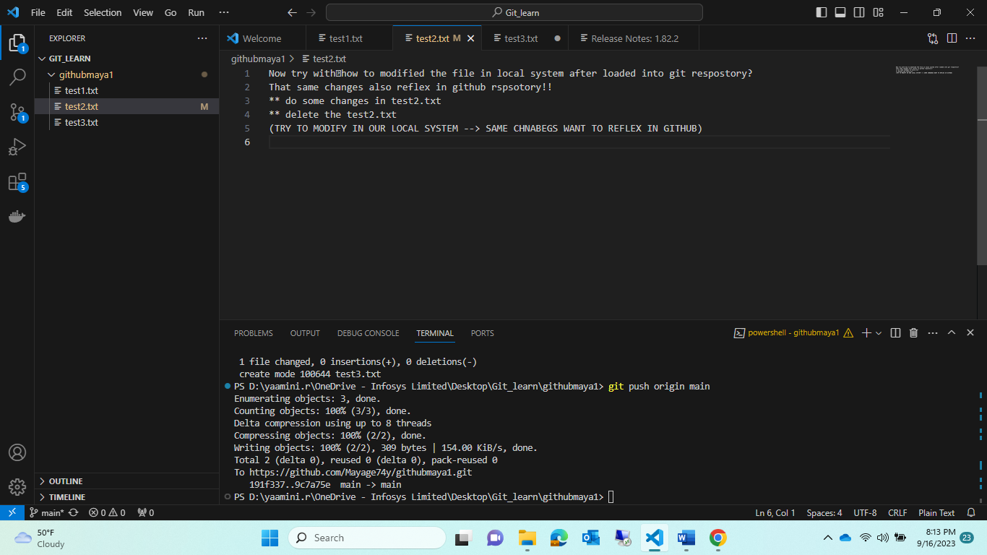

Step2:

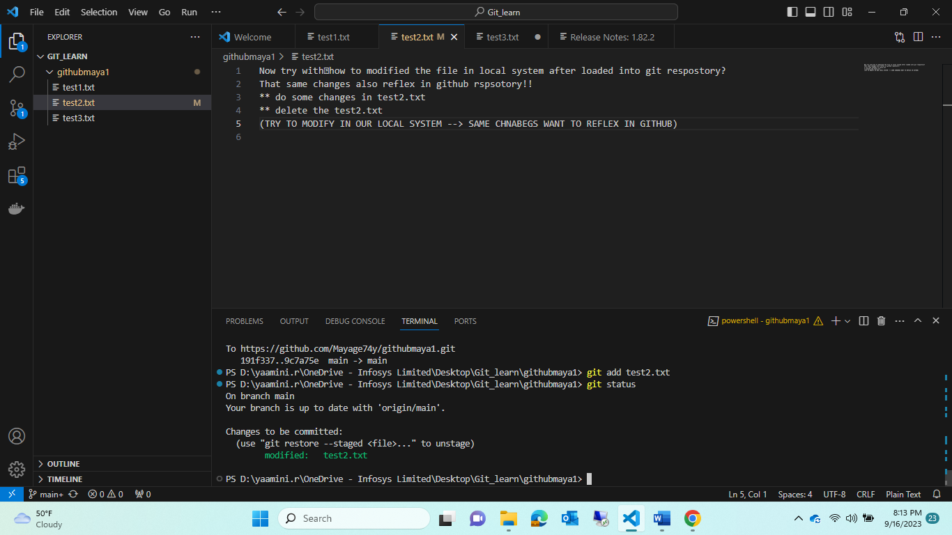

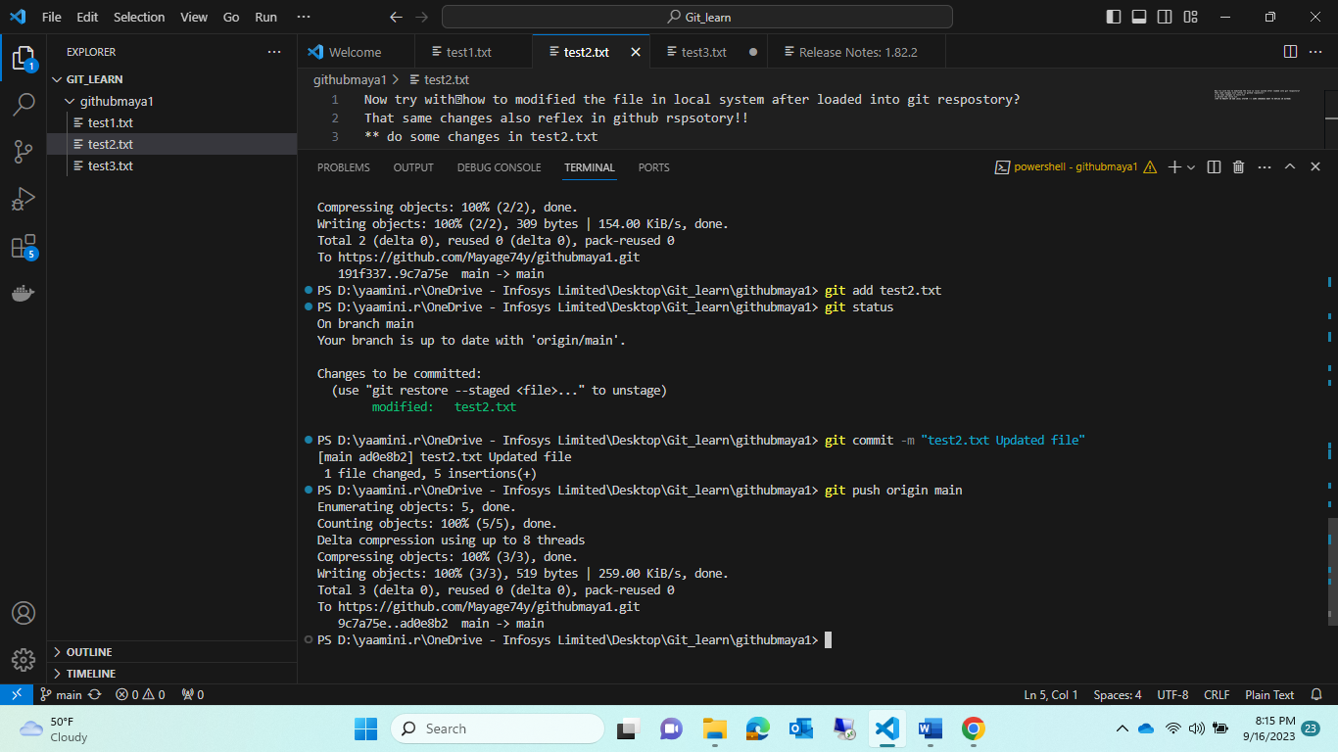

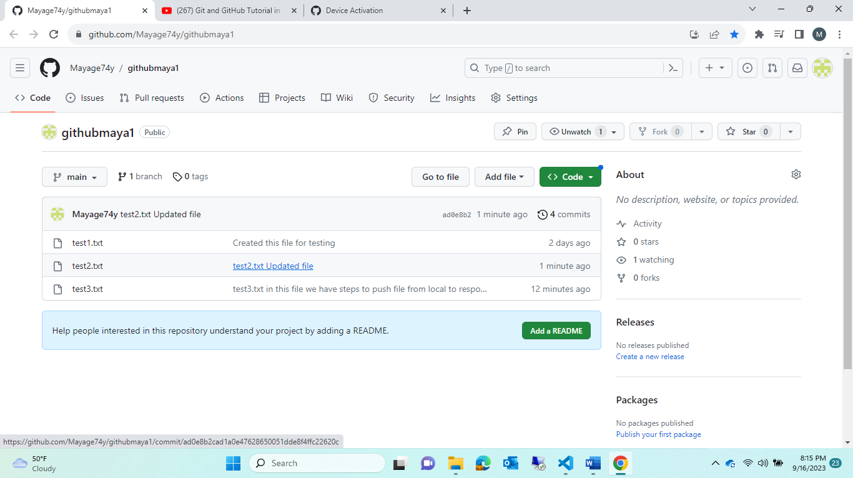

Step1: try to delete that test2.txt in local

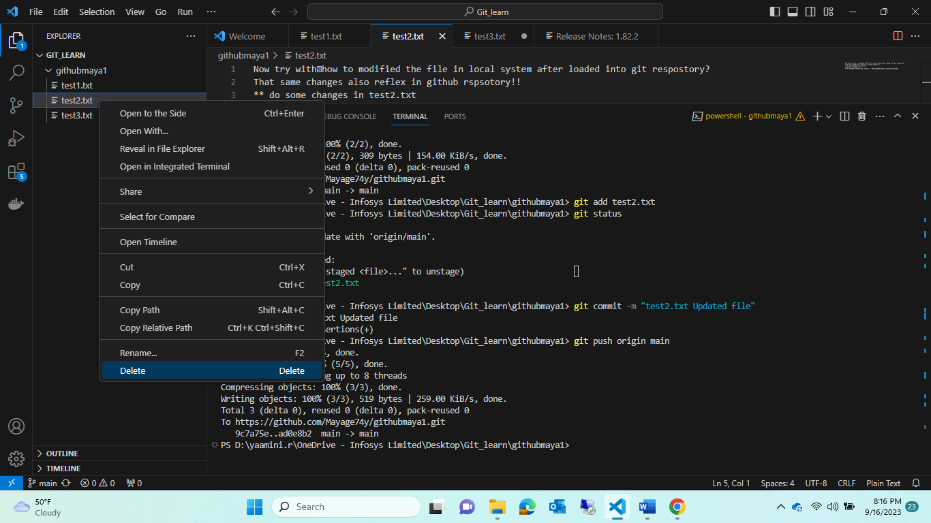

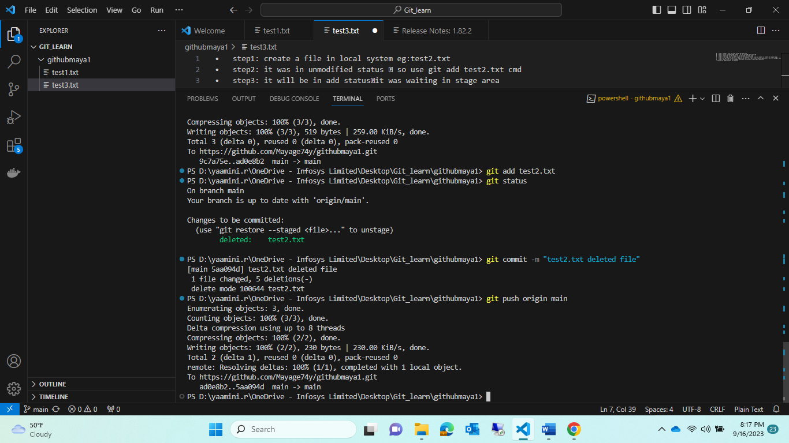

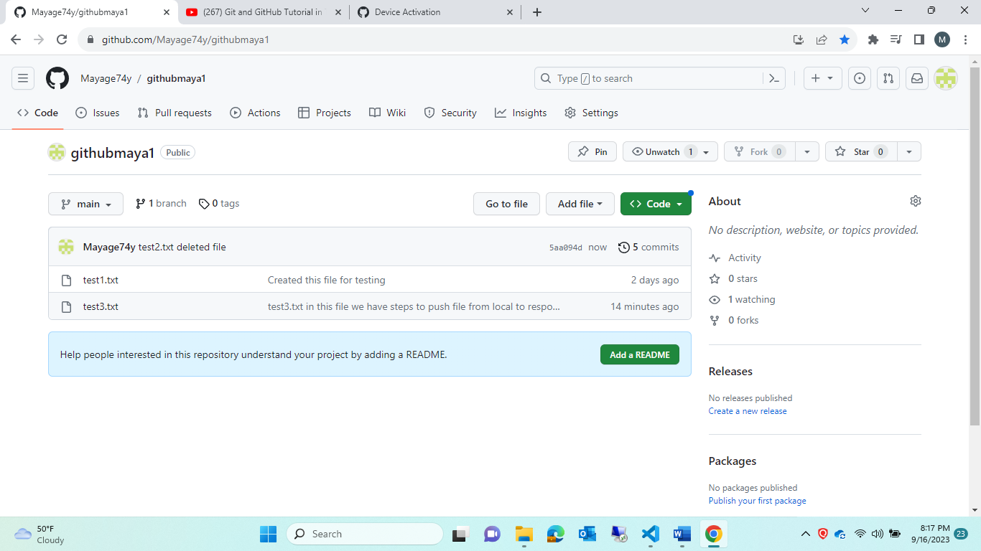

Module3:

Create one dummy.txt file in git respostiry-> move into local how !1

Note : if u use git clone cmd it will copy all the file into again into local🡪instead of that try in different way:

Solutions: use cmd 🡪 git pull

Which means whathever changes done in github 🡪that will reflex into our local systems

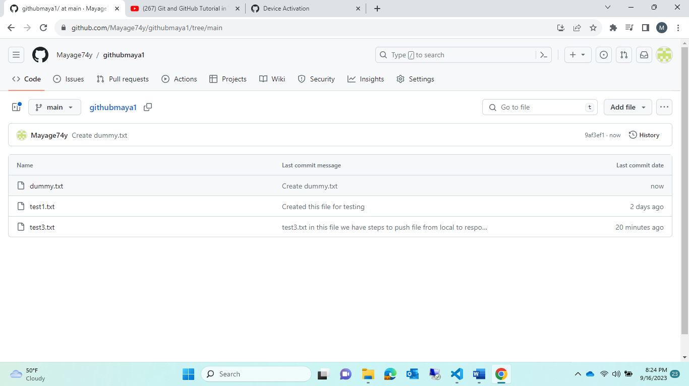

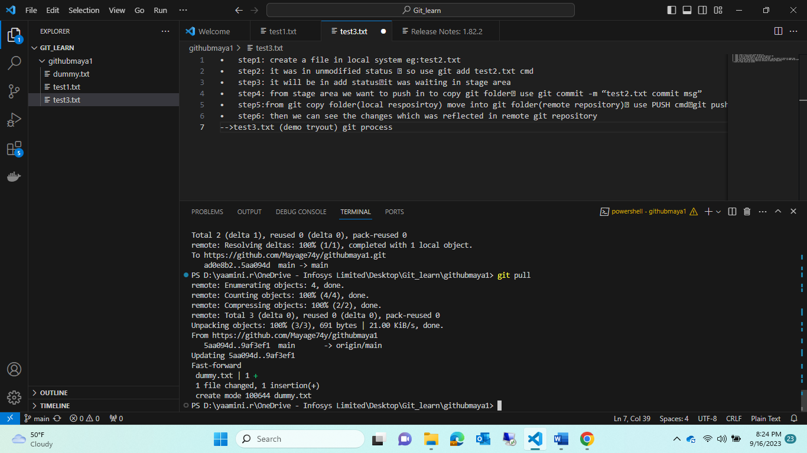

Other eg:

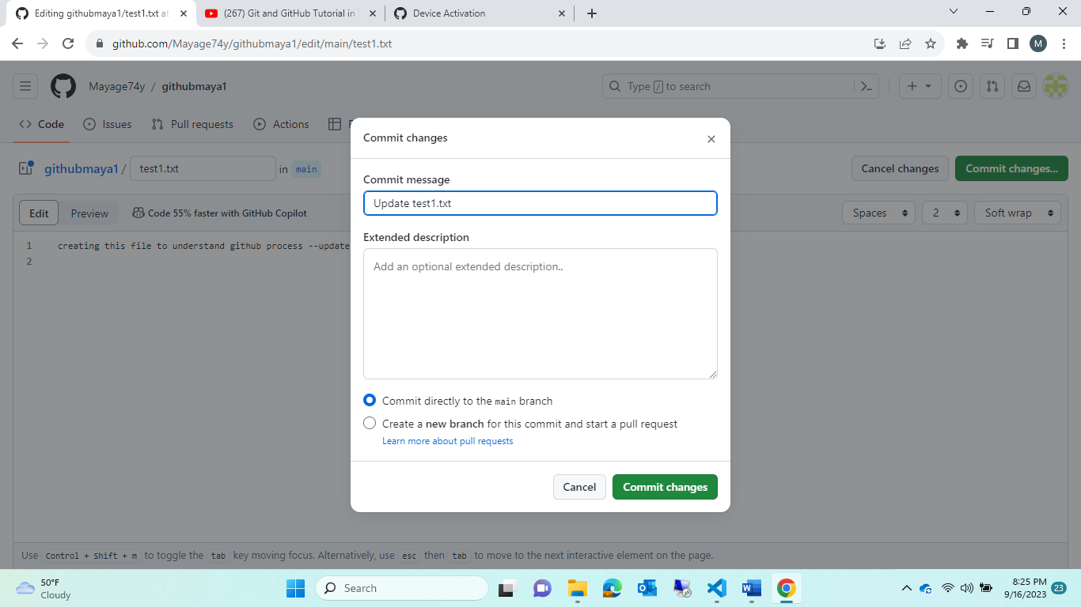

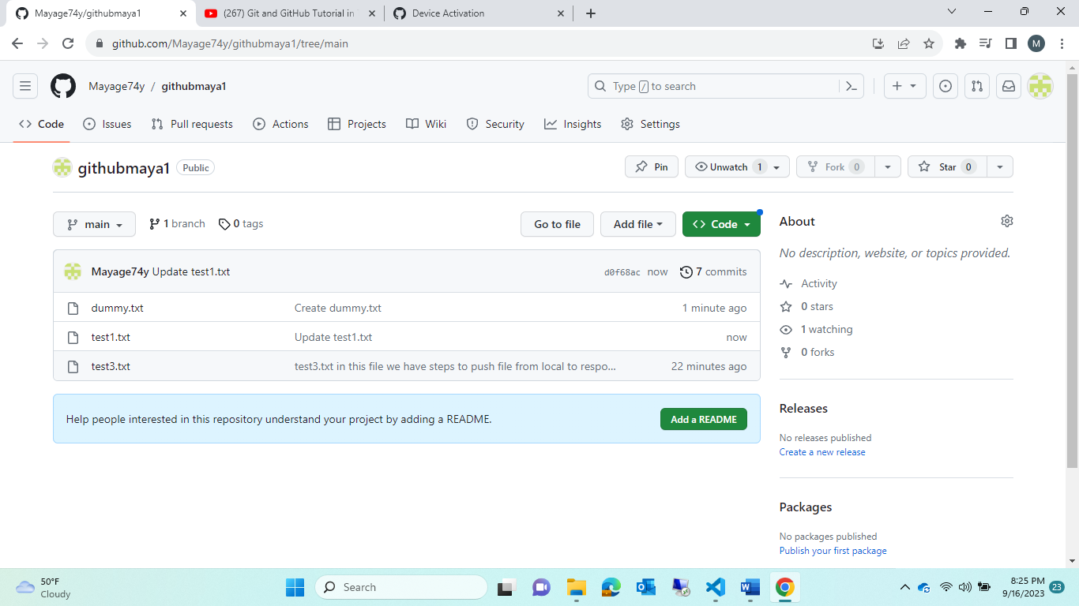

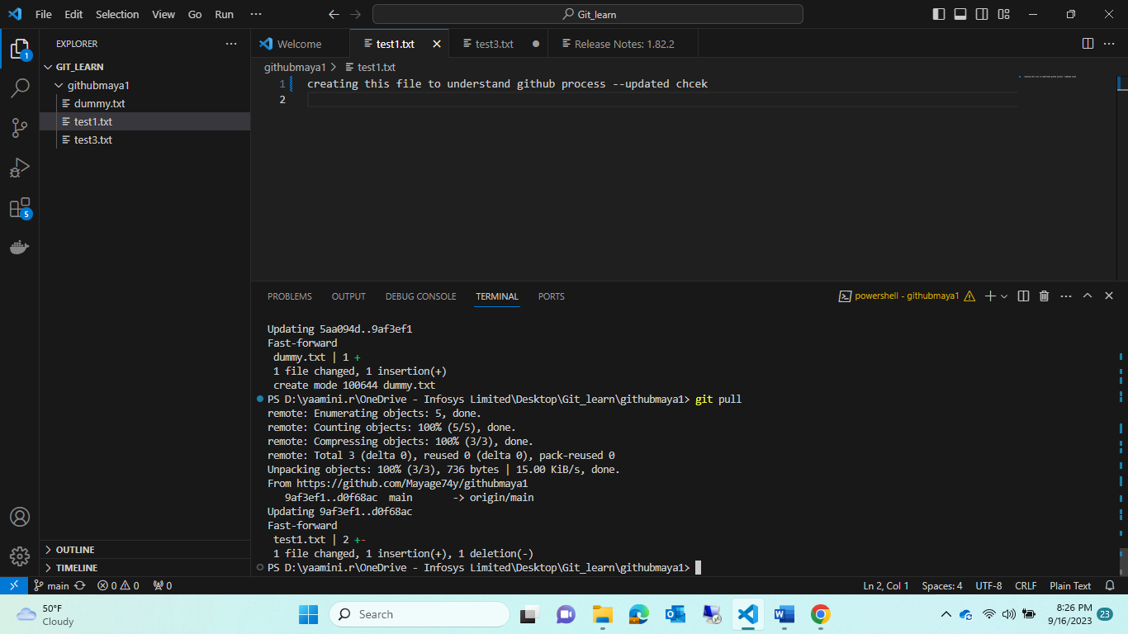

Notes to remember:

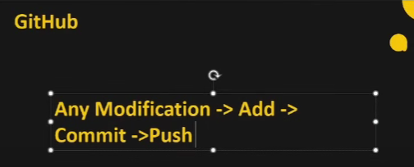

Module4:

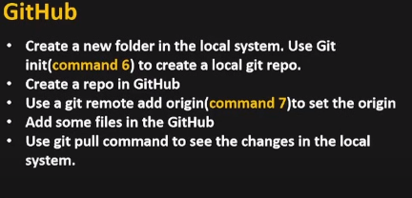

Step1: create a folder in local system eg:foldername<githubmaya2>

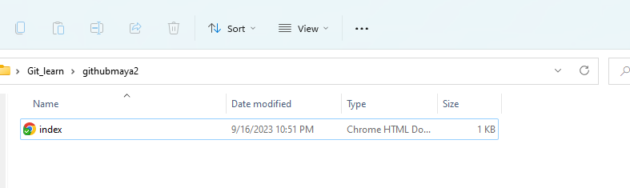

Step2: add a file index.html and style.css file to it in vs code

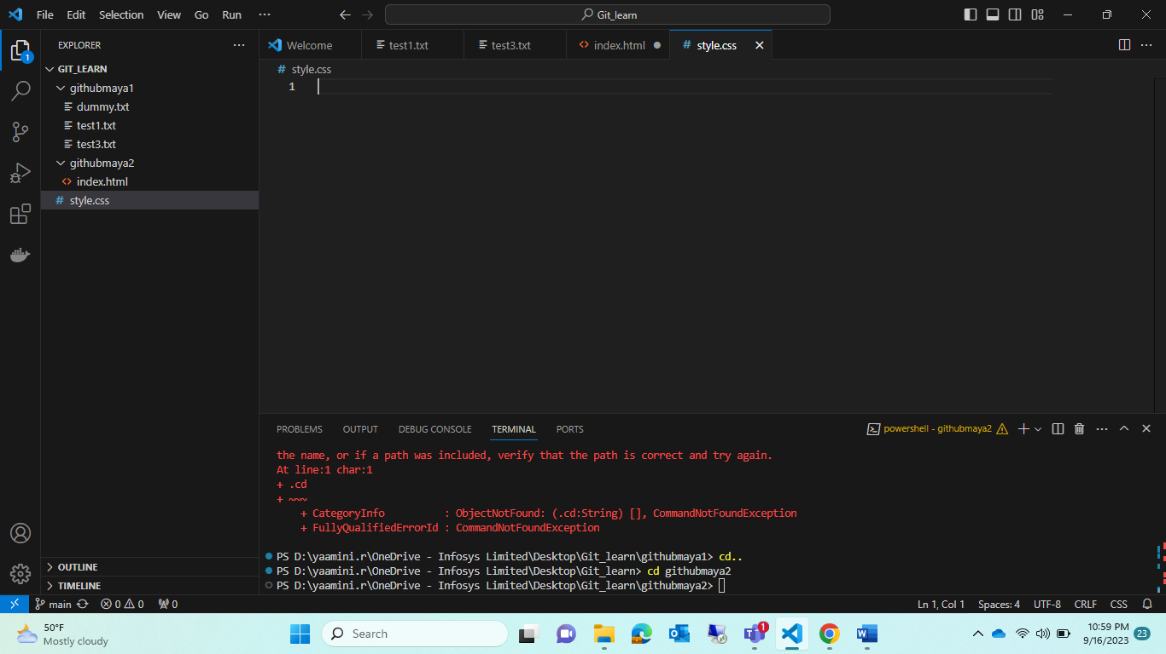

Step3: But in that folder u will not see <.git folder> because it was not github copy folder 🡪 to make that 🡪in vs code (terminal) 🡪cmd: git init

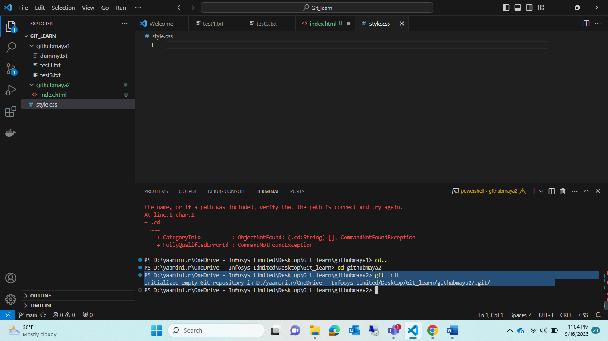

note: before using this cmd<git init> make sure your in current directory path

Note: git init🡪 which create empty repository

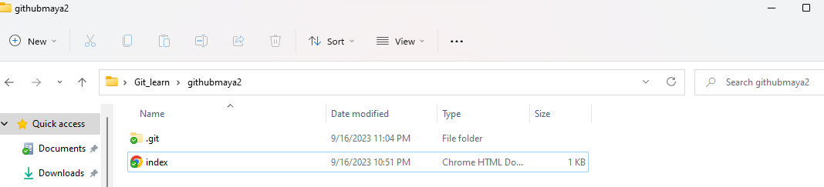

Note:

PS D:\yaamini.r\OneDrive - Infosys Limited\Desktop\Git_learn\githubmaya1> cd..

cd🡪 change directory

Step4: if u notice index.html🡪it was untracked 🡪 so make as track

Use following cmds:

Add->commit🡪push

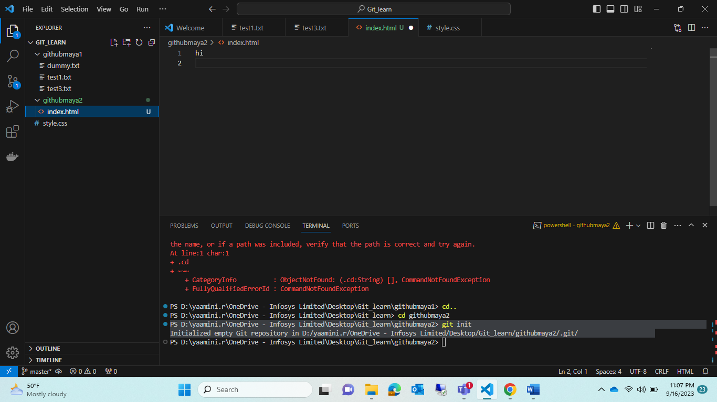Step5:< git add index.html>instead of this cmd ..use🡪<git add . > 🡪 this is used for whathever update in local system will reflex in git repository.

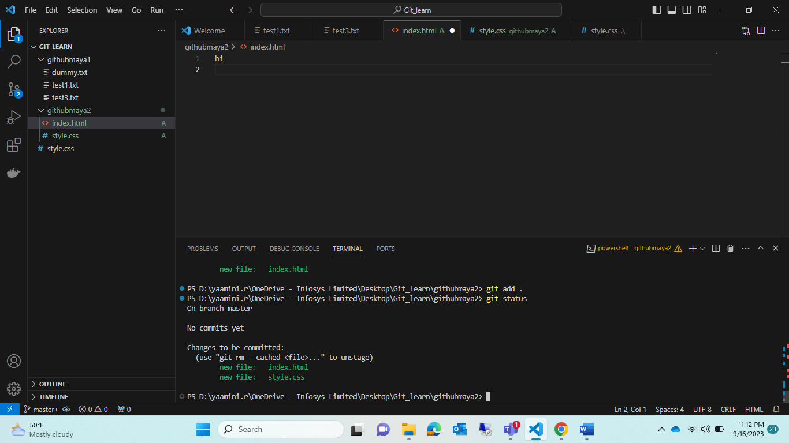

Step6: In above img if u notice🡪branch as”master” instead of “,main”

Step7:

1. git add .
2. git status
3. git commit -m " add file index.html and style.css"
4. git push origin main

error: src refspec main does not match any

error: failed to push some refs to 'origin'

1. git push origin master

fatal: 'origin' does not appear to be a git repository

fatal: Could not read from remote repository.

🡪note: because of this origin that path was not there in github 🡪 so first create 🡪new respostory give that path

Please make sure you have the correct access rights

and the repository exists.

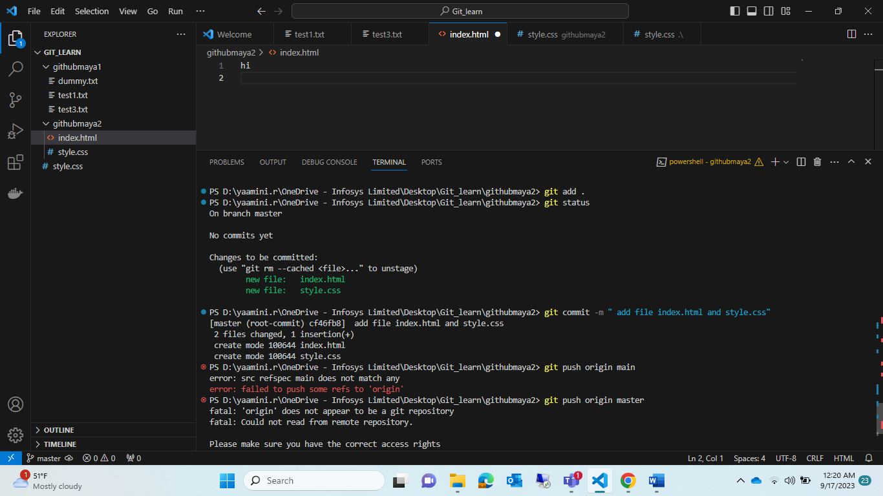

Step8: create repository “githubmaya2” in git repository.

And copy that path

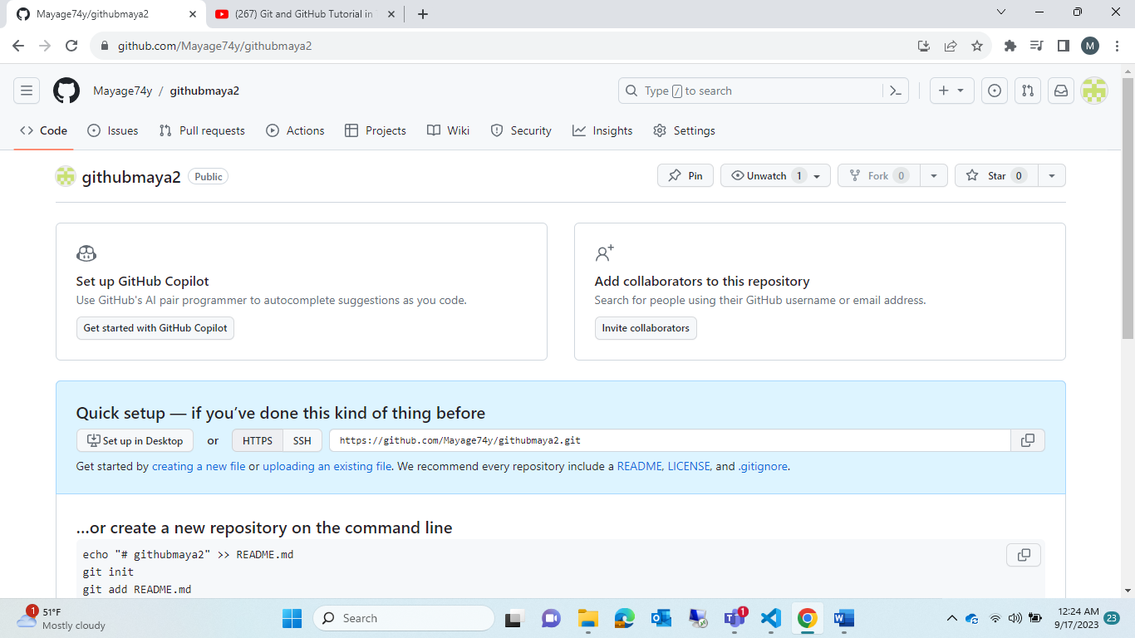

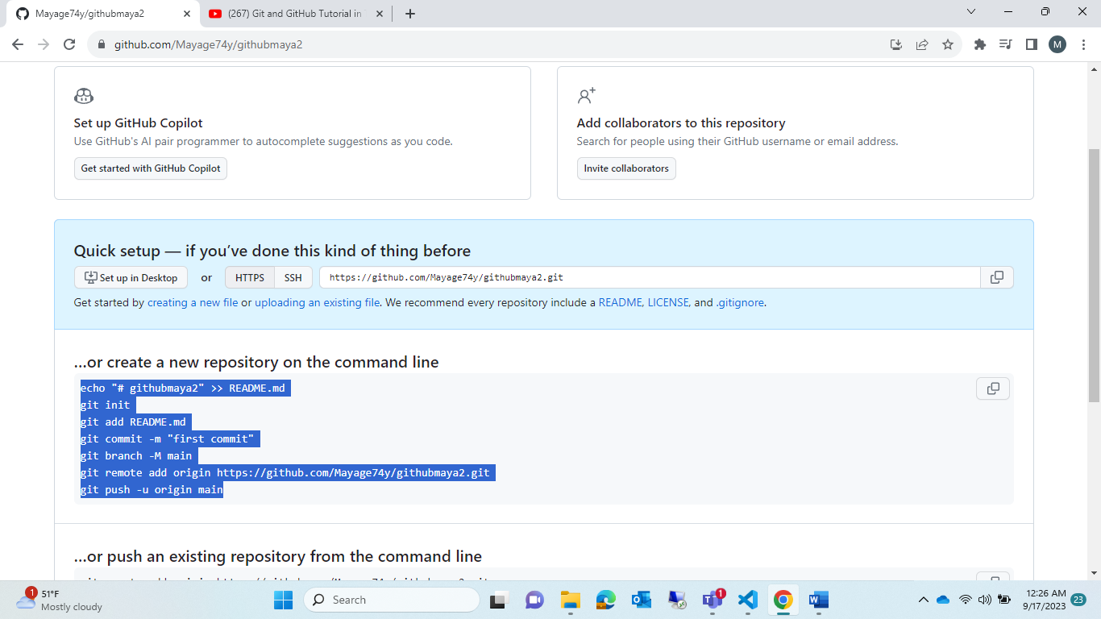

echo "# githubmaya2" >> README.md

git init

git add README.md

git commit -m "first commit"

git branch -M main

git remote add origin https://github.com/Mayage74y/githubmaya2.git

git push -u origin main

Step9: < git remote add origin <https://github.com/Mayage74y/githubmaya2.git>>

Excute this in cmd line (bec before error says origin can’t found it.. so “remote” which refer to current path)

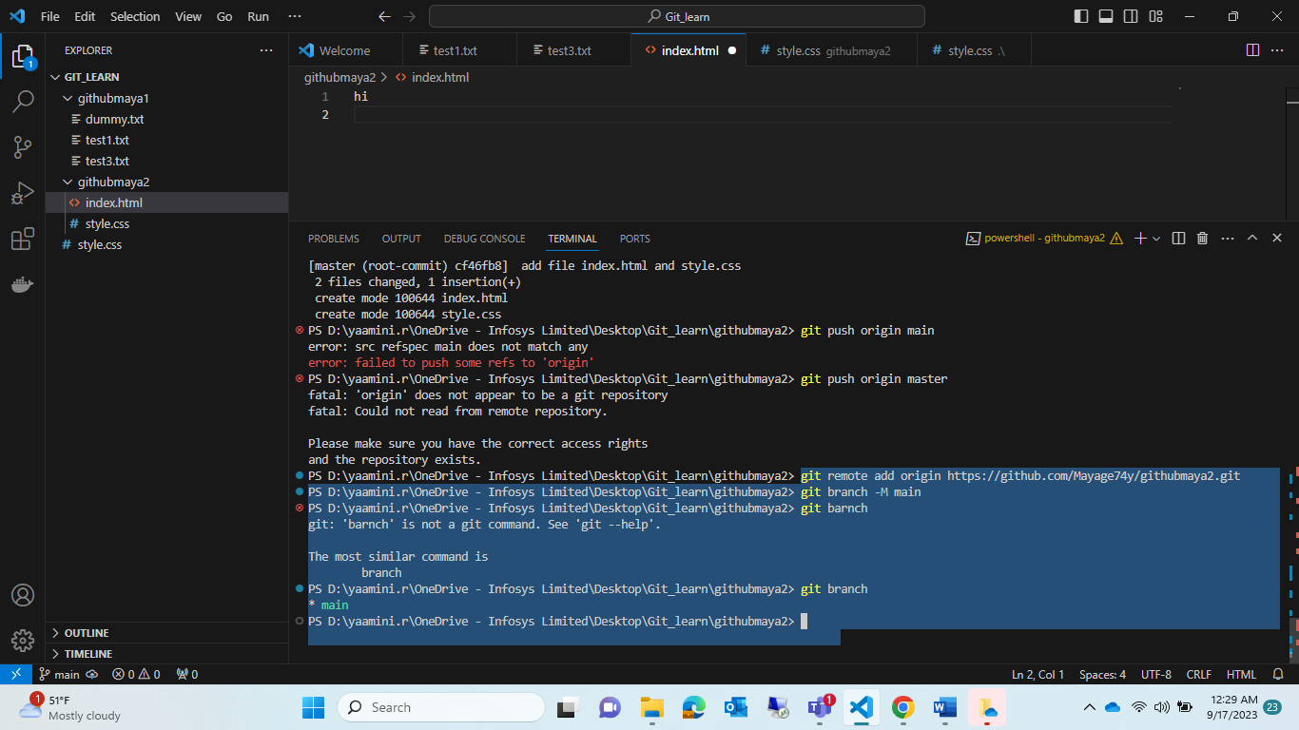

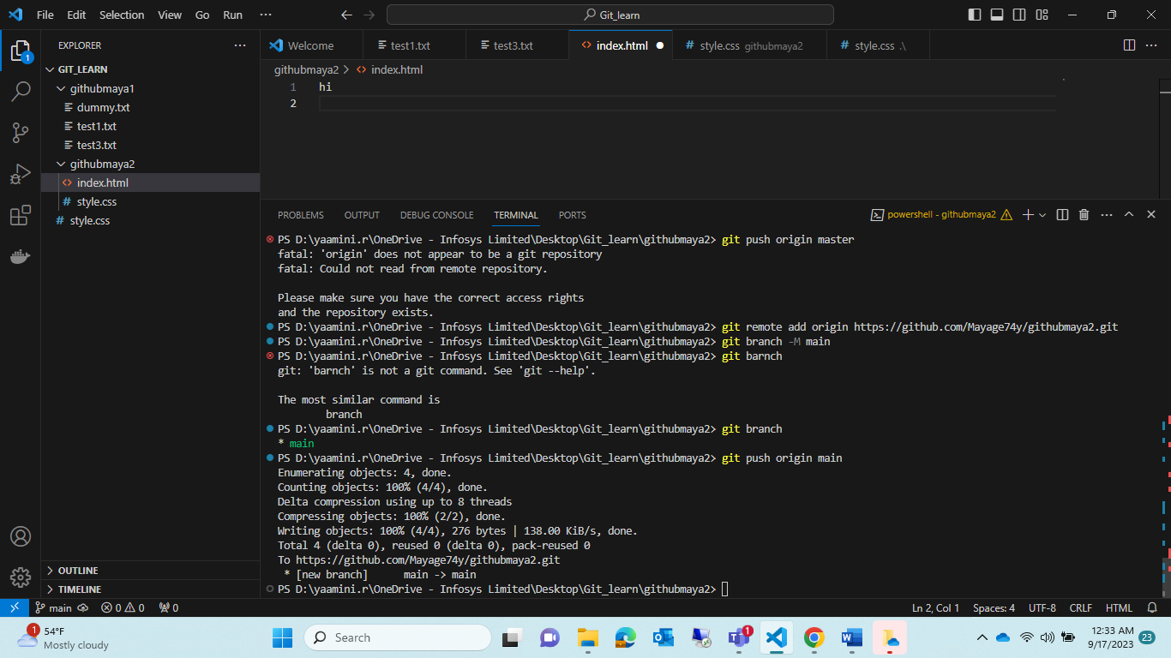

Note : it change master to main use this cmd :<git branch -M main>

Note : before it was master then🡪git version got changes and updated as “main”

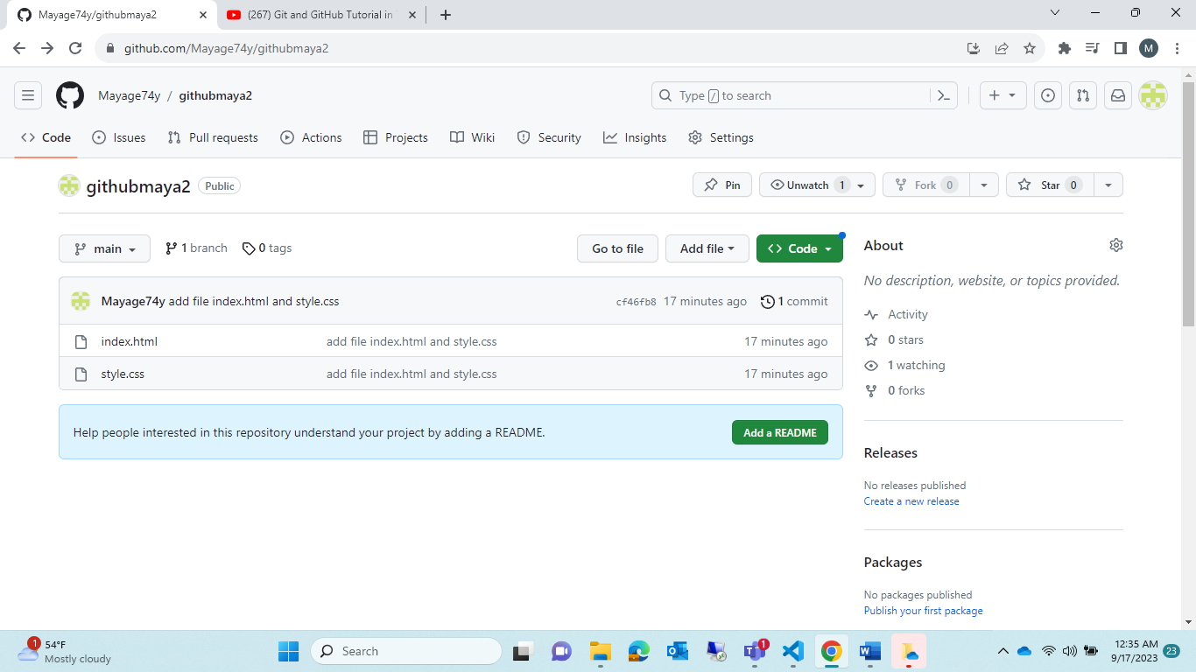

Tryout :

Add one file 🡪 dummy.txt in local 🡪 move to git respostory !!

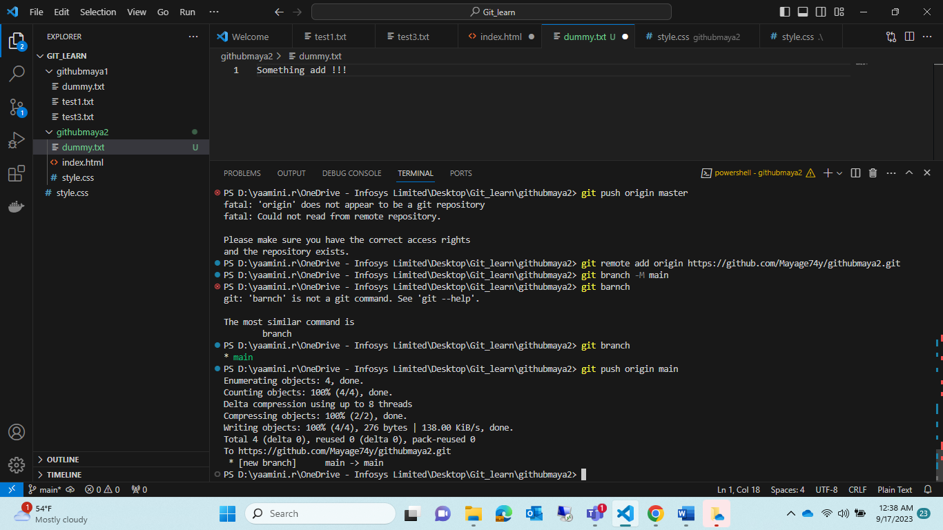

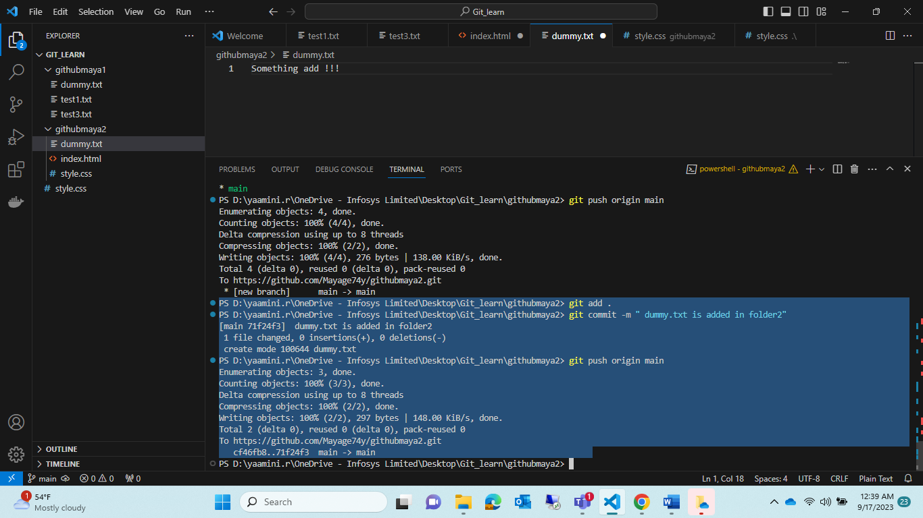

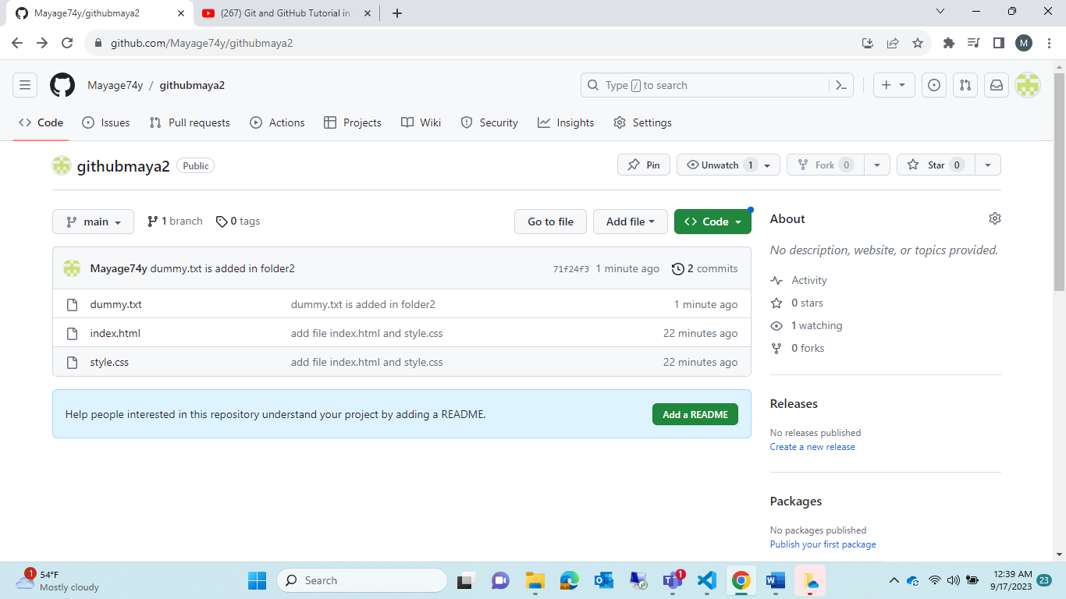

Module5:

What is branches !!

Step1: create one new branches in git hub repository

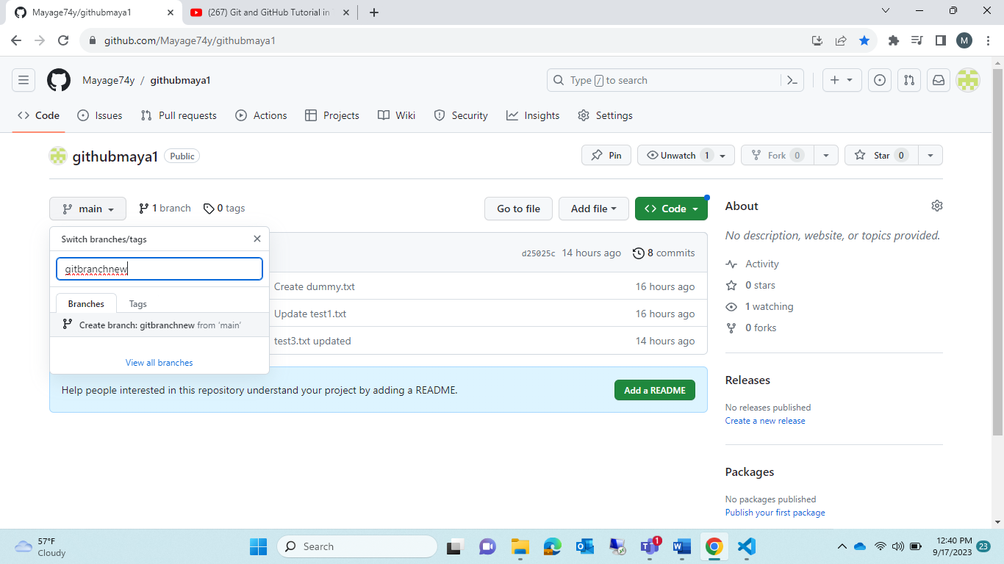

Step2: if u notice whathever file in “main branch” it also copied to “gitbranchnew”

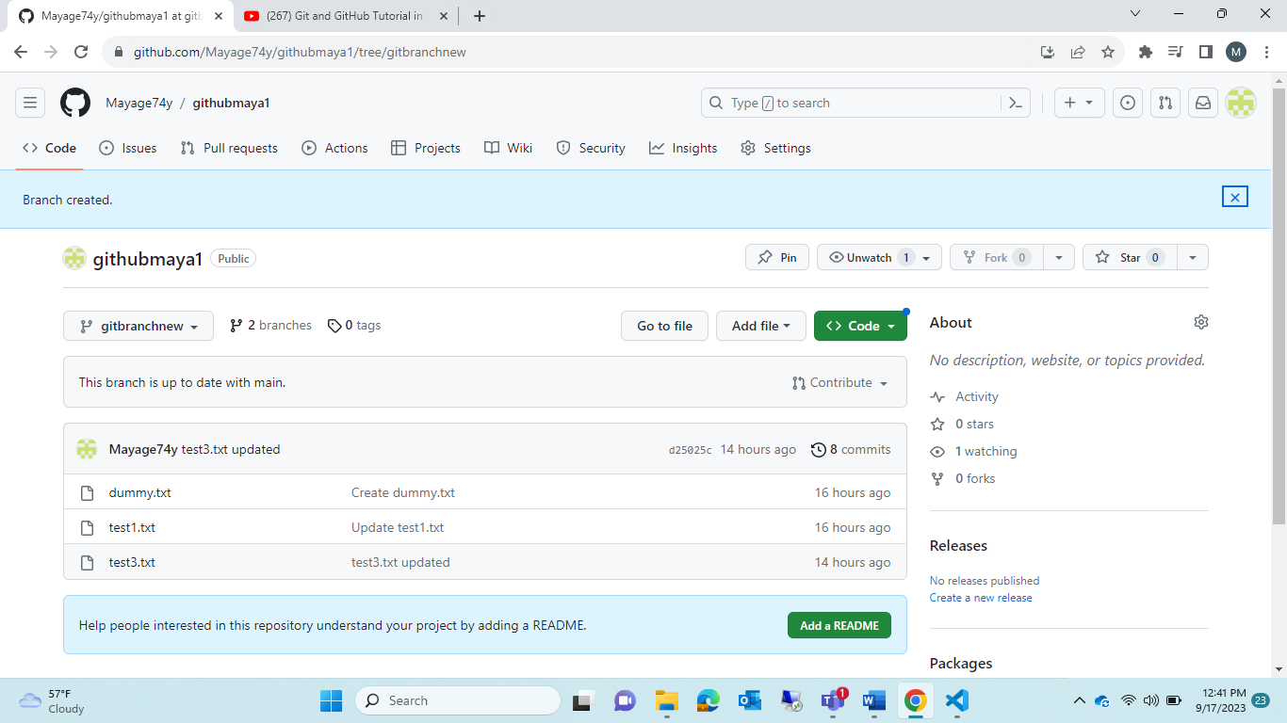

Step3: check in cmd line🡪<git branch -a>🡪it will list down all branches was created

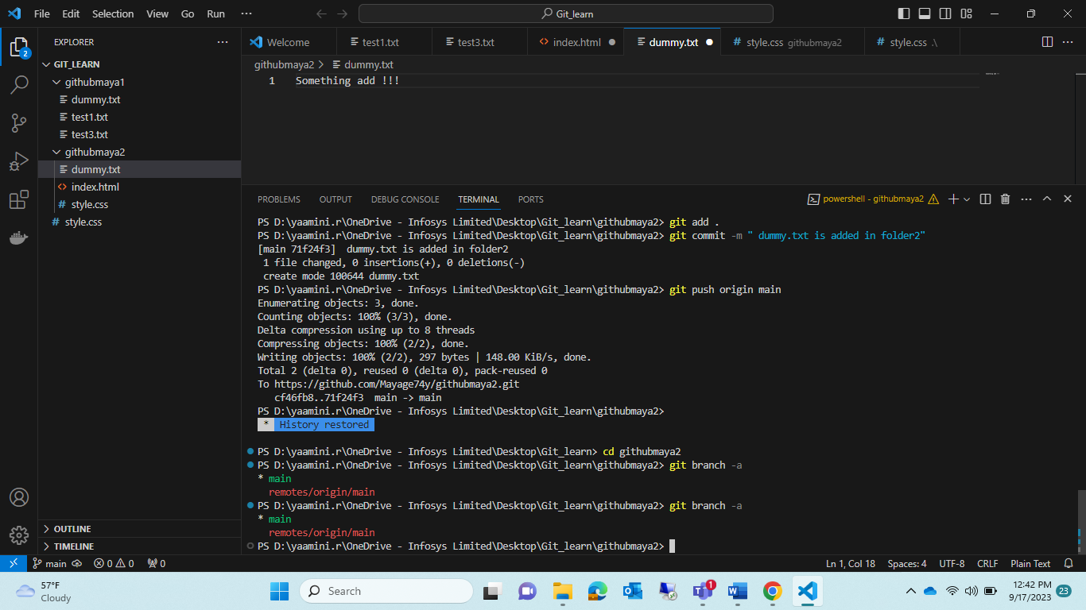

Note : but still we can’t able to see that newbranch created ,only “main “ was there🡪because now we want to use <git pull> cmd it will reflex whethever updated there it will show here

Note : before it tried with wrong path “githubmaya1” in github respostory ,but in vs code I am executing in “githubmaya2”🡪 so it will not work..

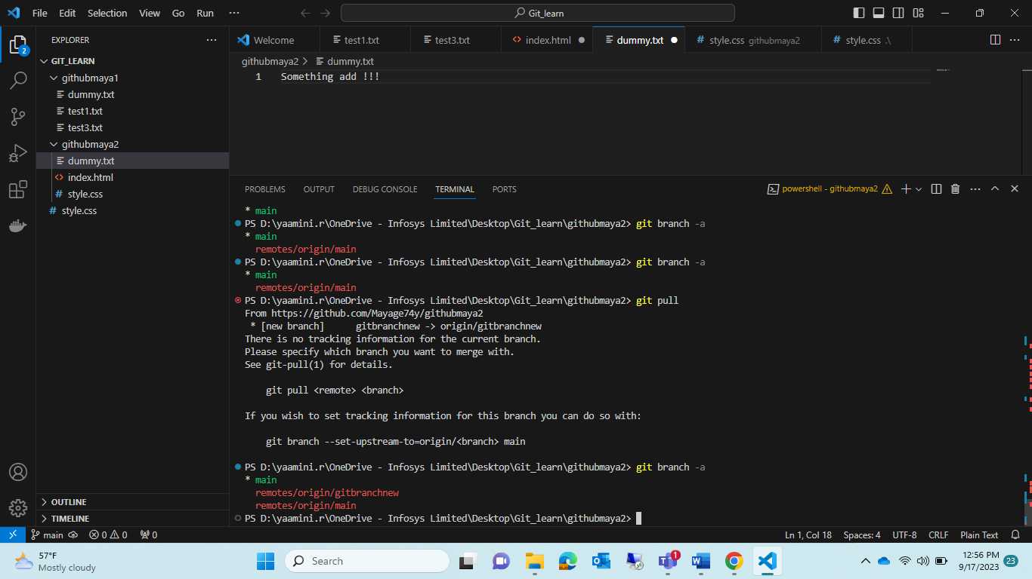

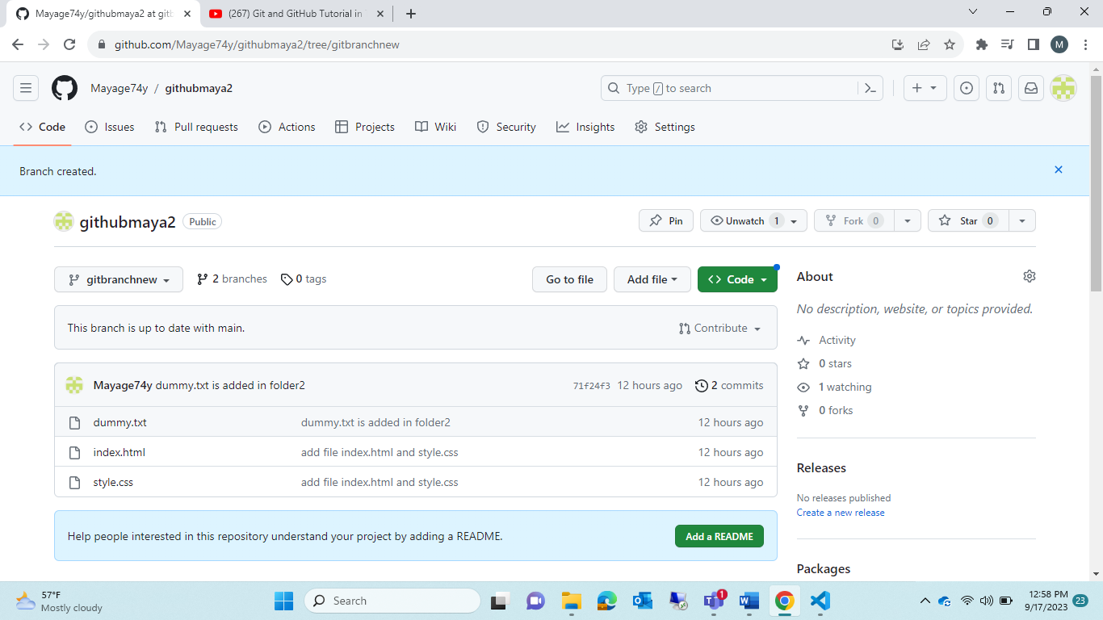

PS D:\yaamini.r\OneDrive - Infosys Limited\Desktop\Git_learn\githubmaya2> git branch -a

* main

remotes/origin/gitbranchnew

remotes/origin/main

note : we are in main-branch (it was our current branch)🡪how to change our current branches ????

<git checkout [branchname]>

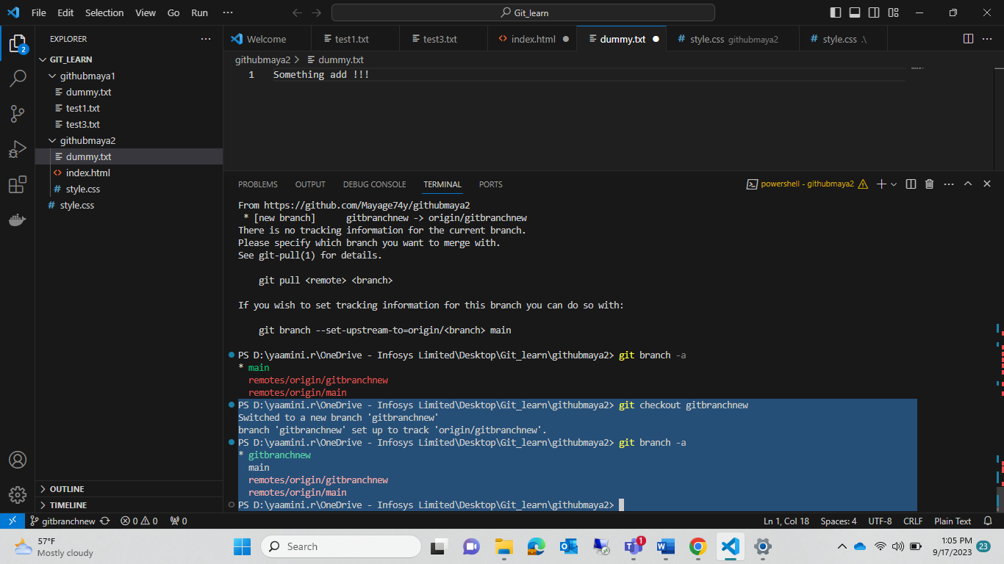

Module 6:

* Now we are inn new branch 🡪”gitbranchnew”🡪we are creating one file in “gitbranchnew”
* And follow all steps like insert🡪Add🡪commit🡪push
* Note : that new file which u created only added to “gitbranchnew” not in “main”
* Why ? this new branch generally created in teams “main “ as all file for creating any new file teams will created someother “newbranch” in that they create code and push to “main” that final stage for stafy propouses.

Step1:

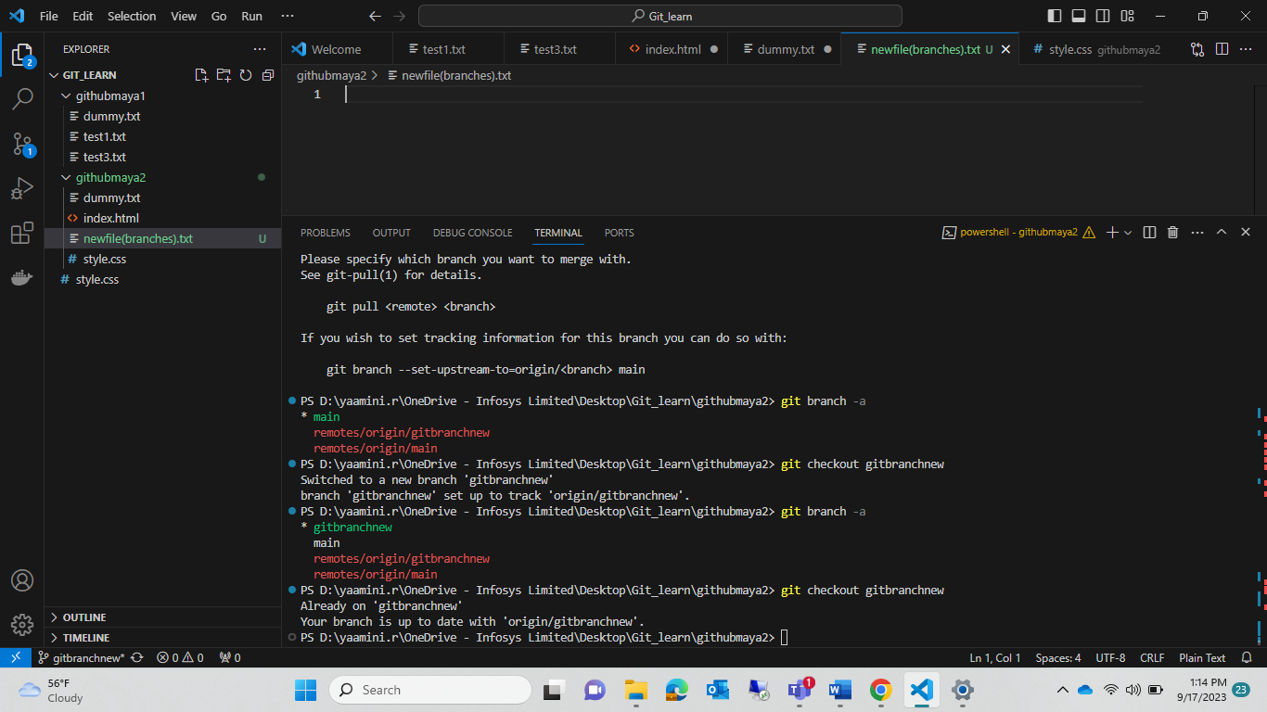

1.git branch -a

* gitbranchnew

main

remotes/origin/gitbranchnew

remotes/origin/main

2. git checkout gitbranchnew

3. git add .

4. git commit -m "Creating new file for new branch"

5. git push origin gitbranchnew

6.now check in github repository.

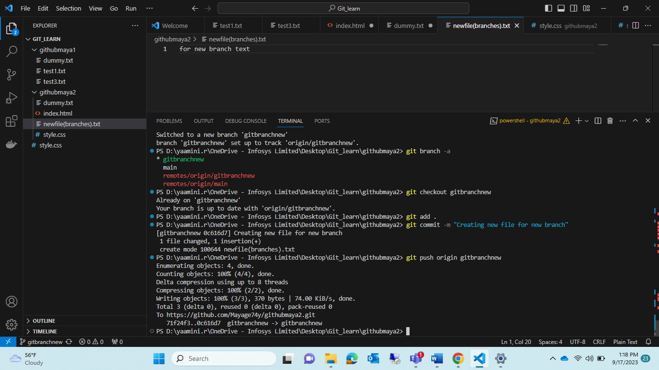

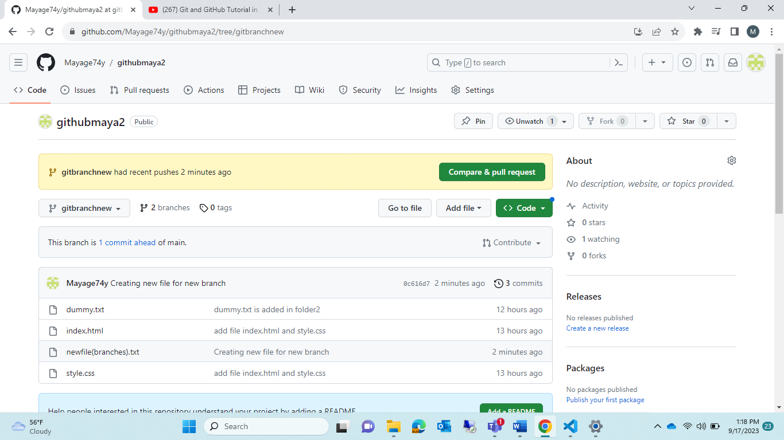

Step2: it u check in “main” in vs code that file will not appear

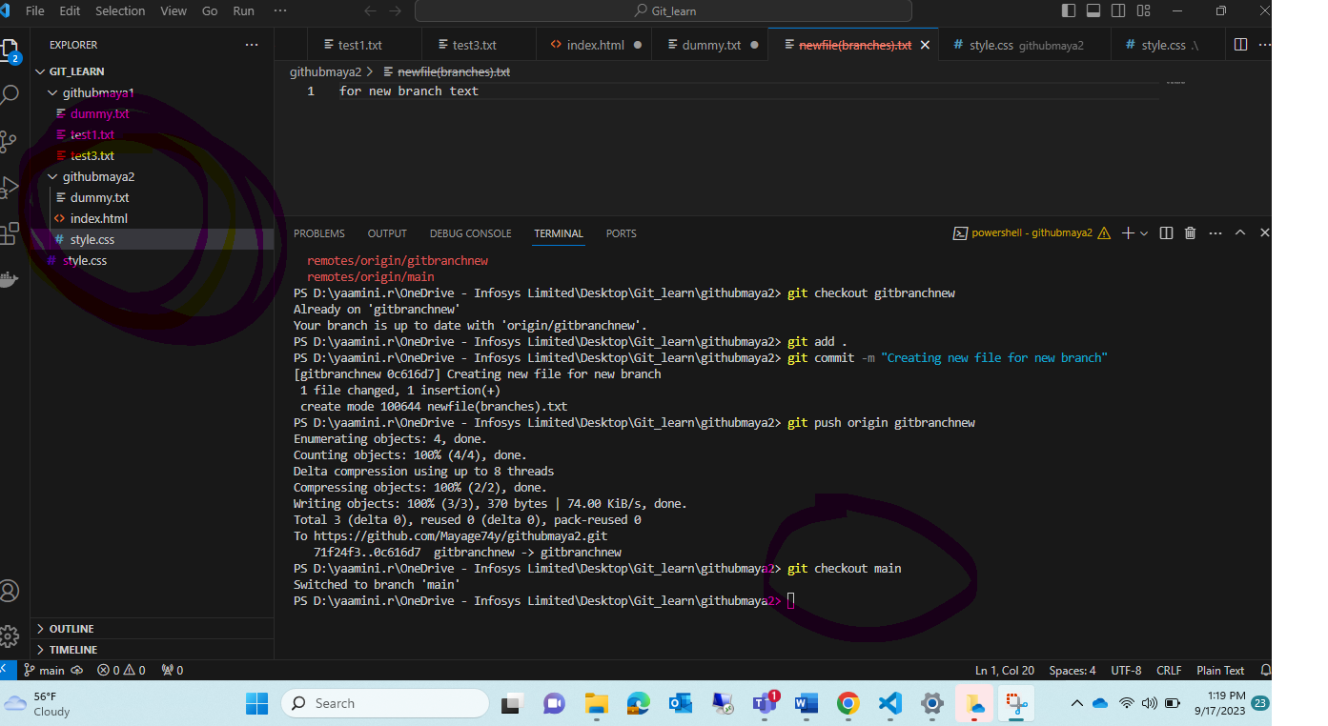

Step3: now check In <git checkout gitbranchnew> that file will appear

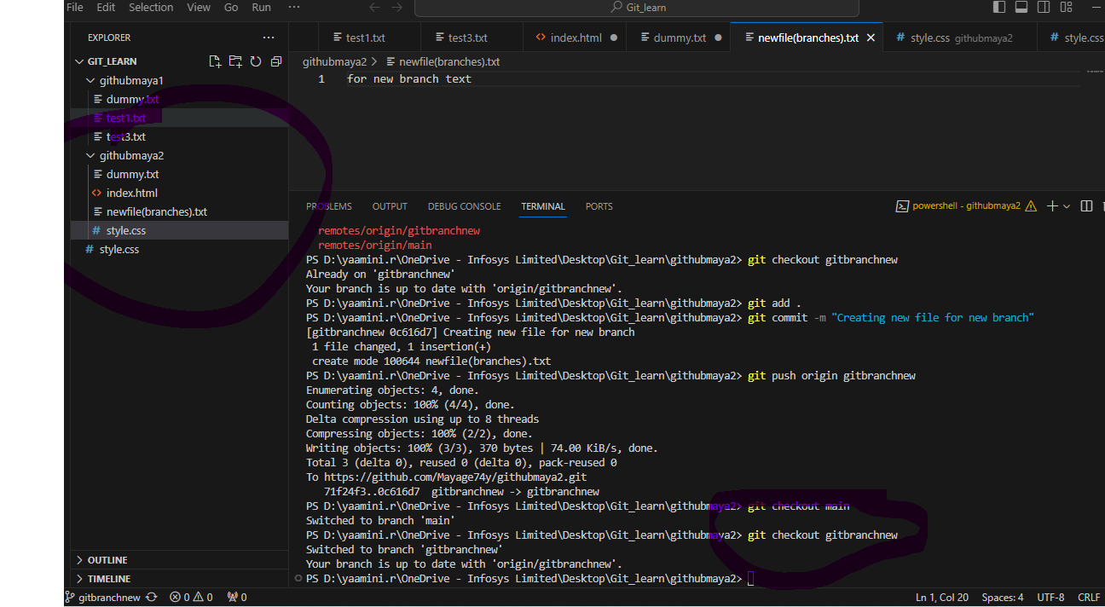

Step4: <git diff gitbranchnew> 🡪it will show different between which file was not there..

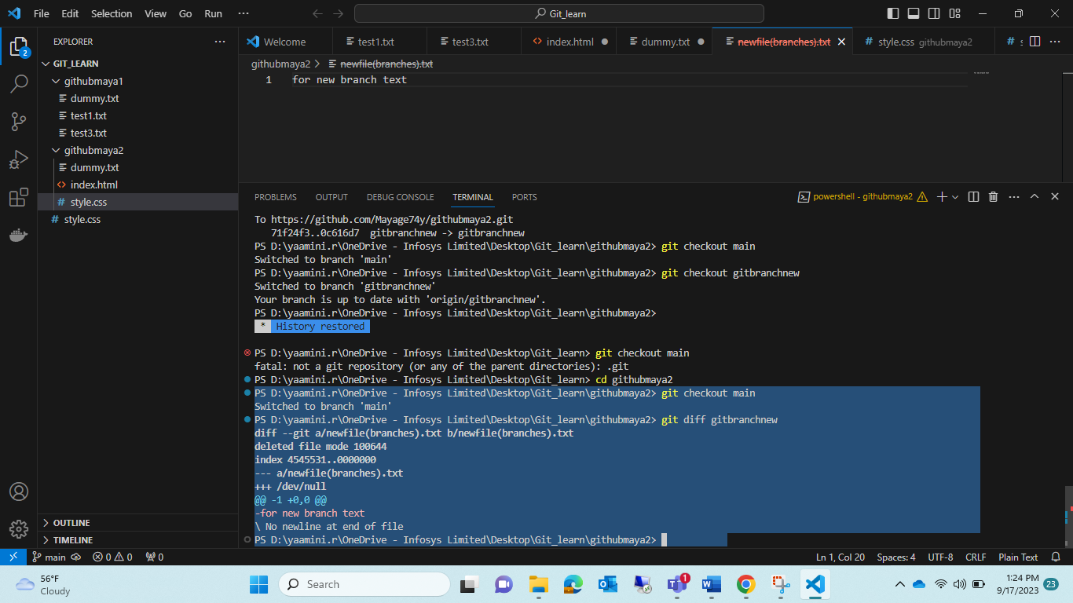

Now in main🡪that newfile.txt not available

Gitbranchnew🡪 that newfile.txt is available 🡺(want to merge in main )so that newfile.txt also available “main”

Cmd:<git merge gitbranchnew>

Step5: make sure ur at which branch (eg: I am at current branch main_

Step6: <git merge gitbranchnew>

Step7:<git push origin main>

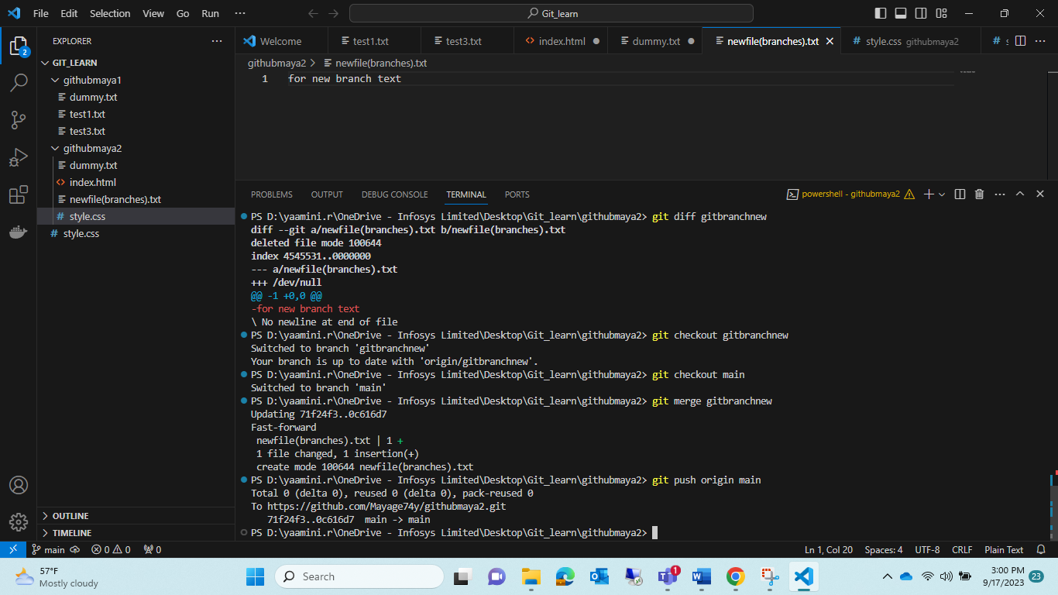

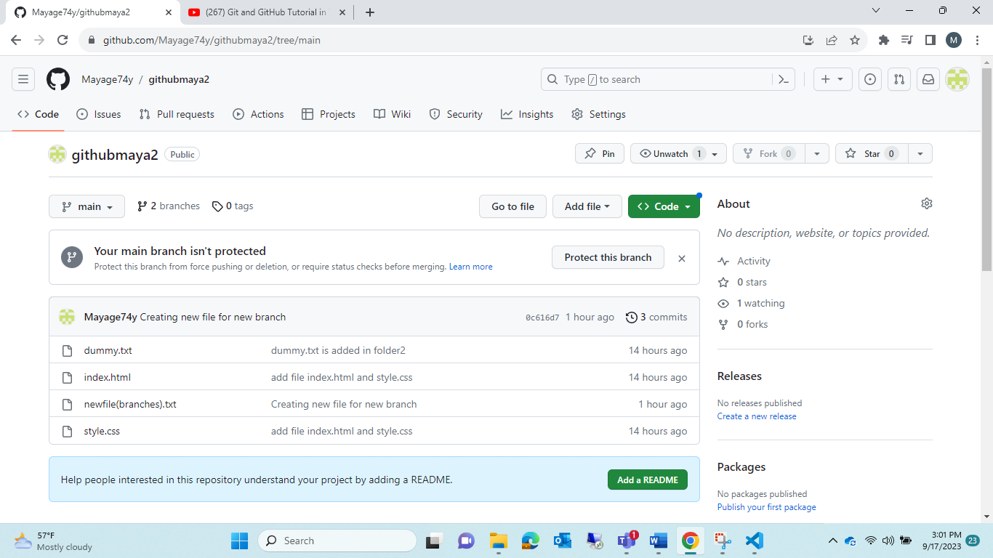

Module6:

Pull Request

1. Create new branch in local respostory🡪<git branch branchnew2>
2. <git branch>🡪 it show ur current branch eg(it was in main)
3. So change the branch 🡪 <git checkout branchnew2>
4. <git branch>🡪 now ur in current branch in eg(branchnew2)
5. Now add one file in “branchnew2”
6. Add🡪commit🡪push

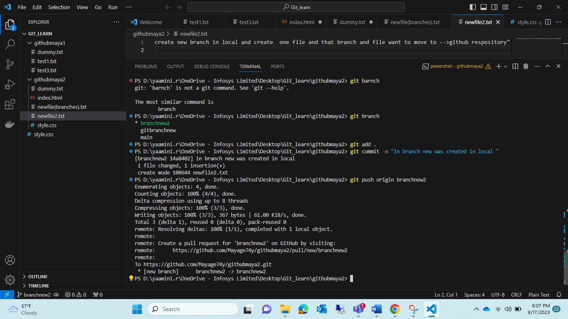

1. Check in github repository🡪 “that file is updated in respostory”

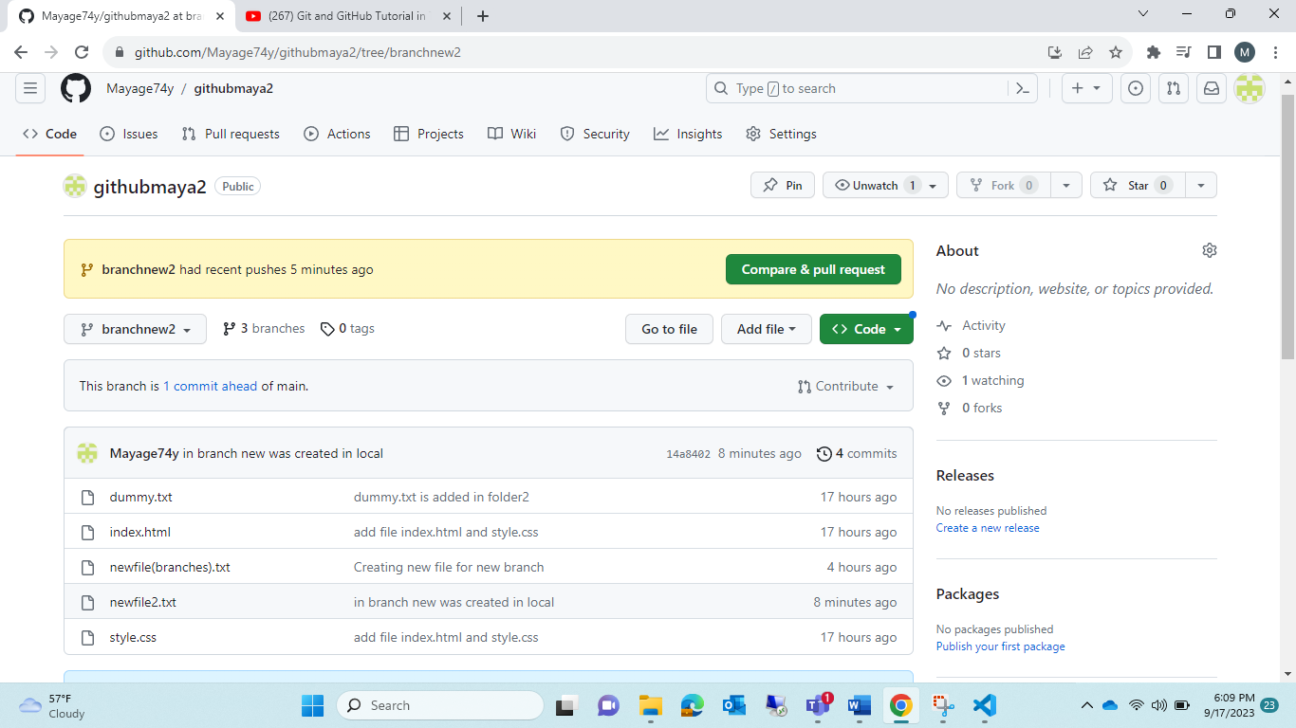

8.”branchnew2” branch 🡪 in that “newfile2.txt” was created by team member

Note:click “Pull request”-🡪or click “compare and pull request”

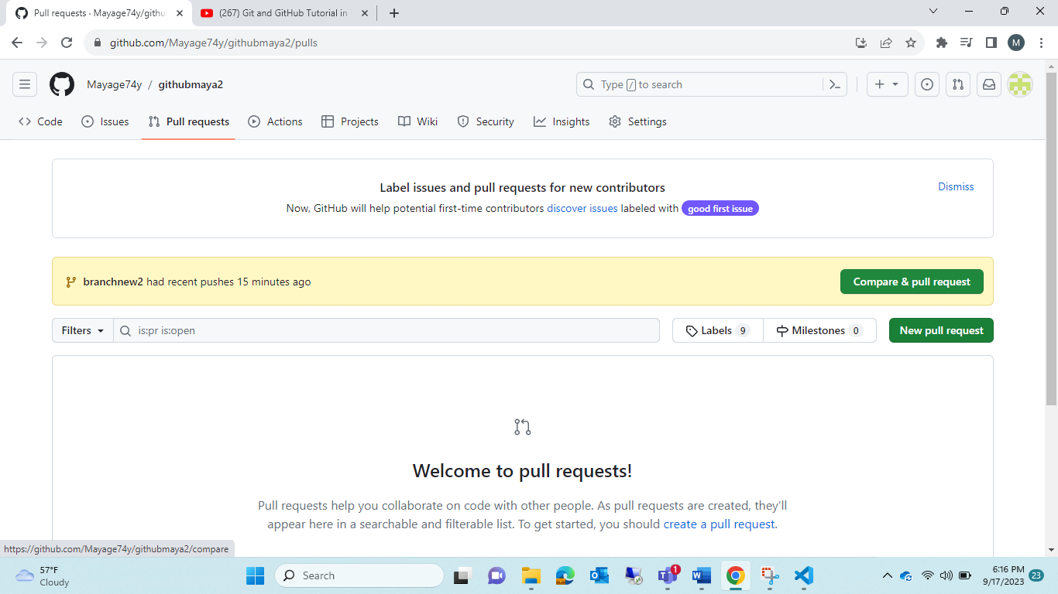

Note: click new pull request🡪

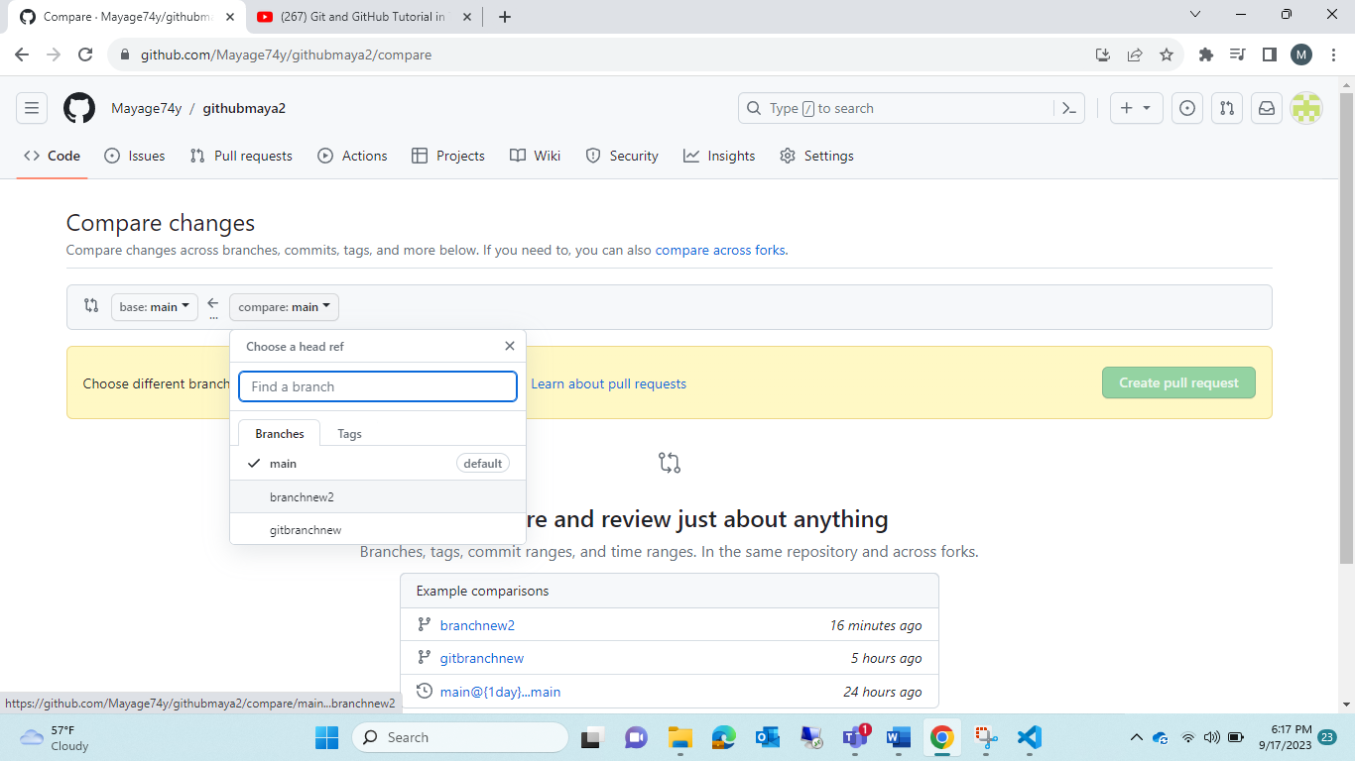

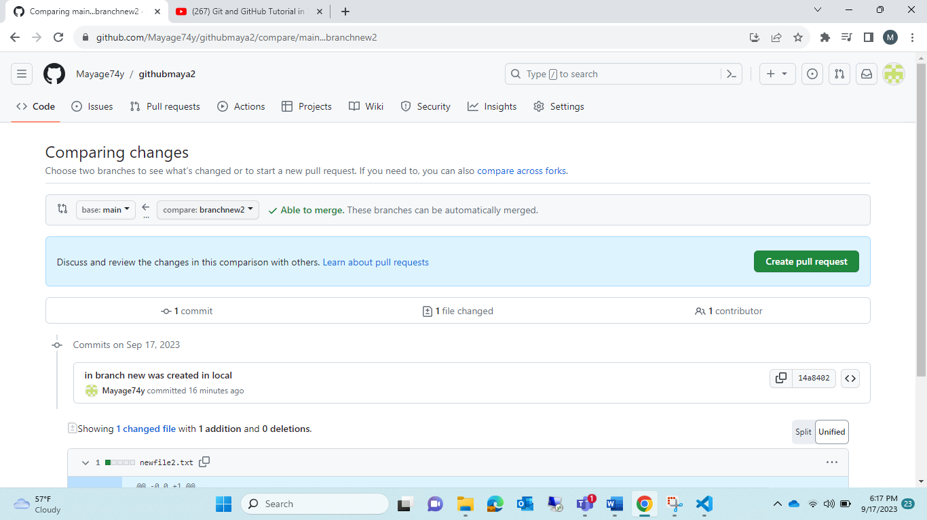

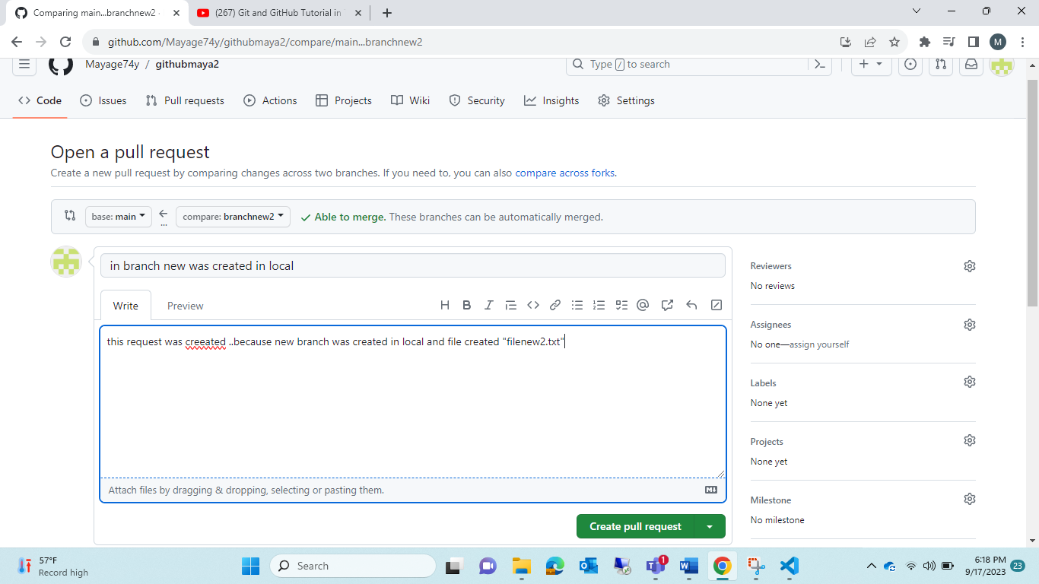

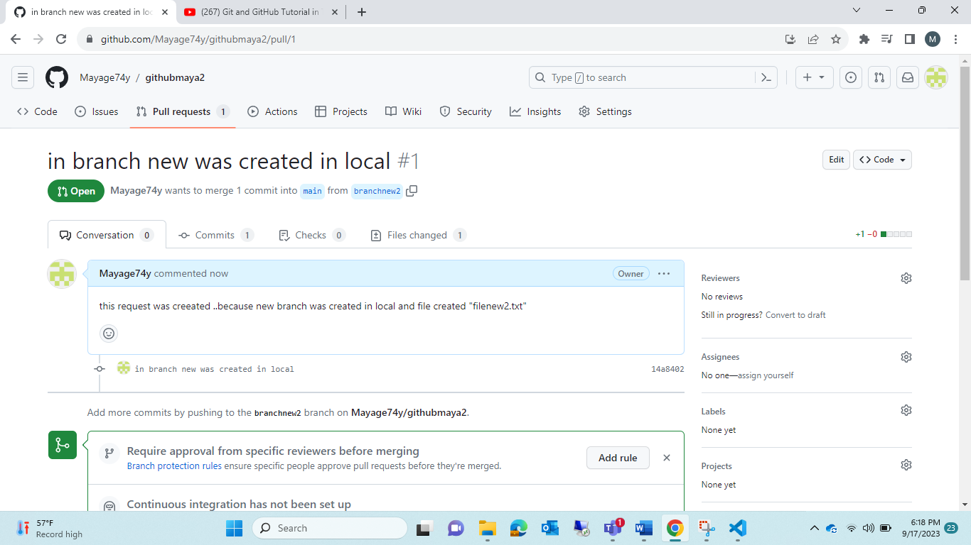

9. in main branch only🡪 if that “manager”🡪accept that pull request which was send by team member if crt 🡪he will approve that request🡪 it will then reflect in “main” branch also..

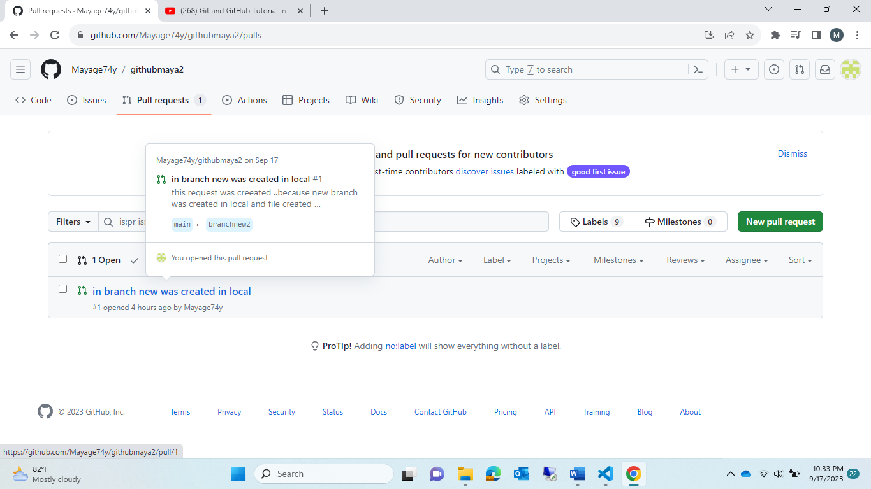

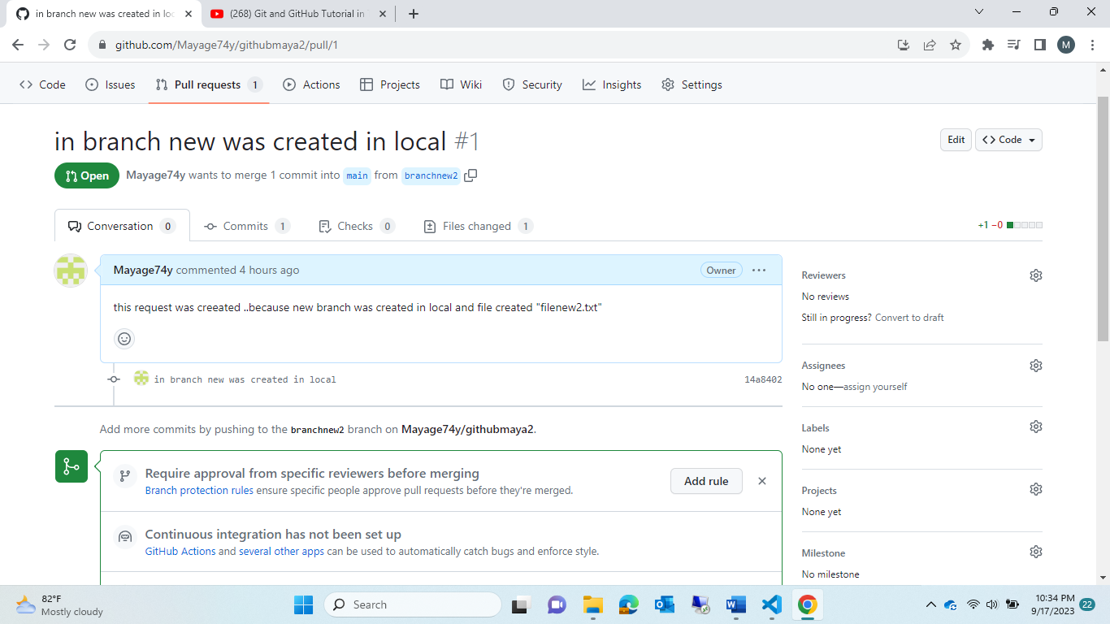

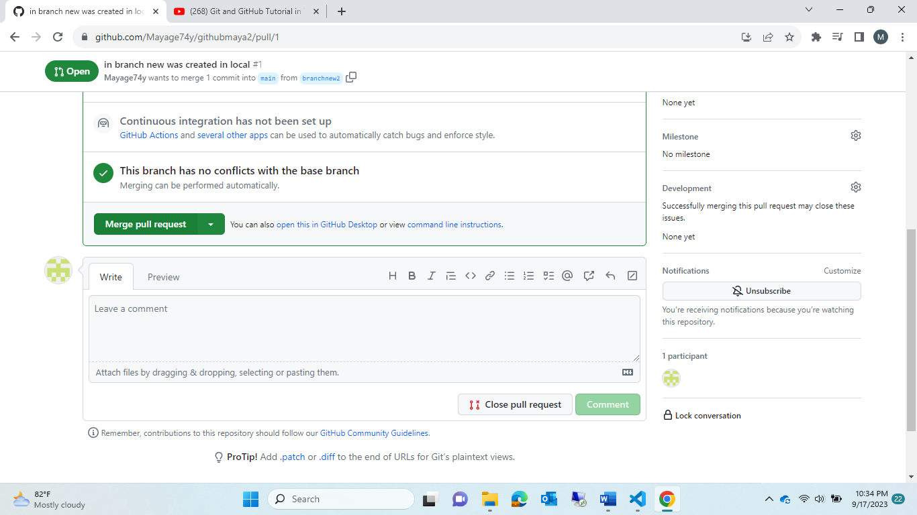lick merge pull reuqeust

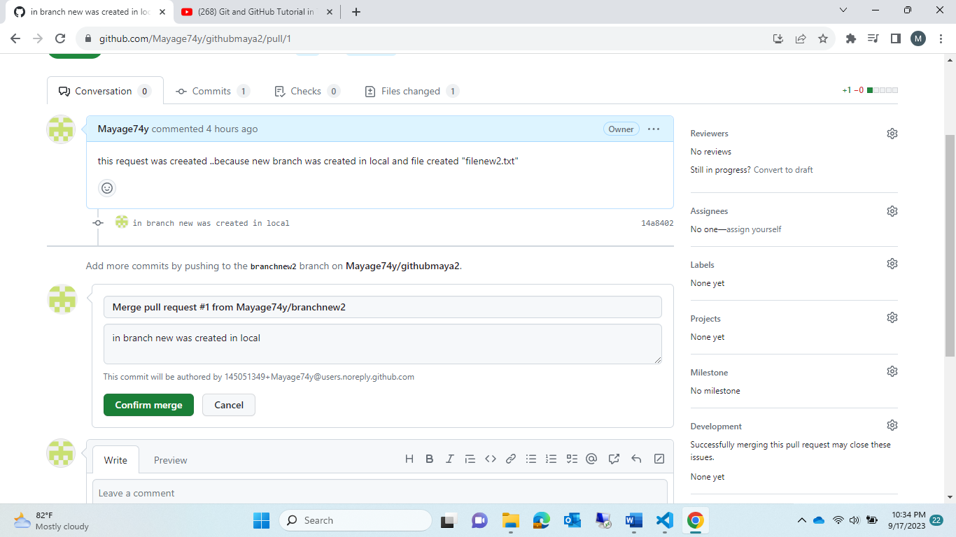click confirm merge.--> so it will merge in “main” branches

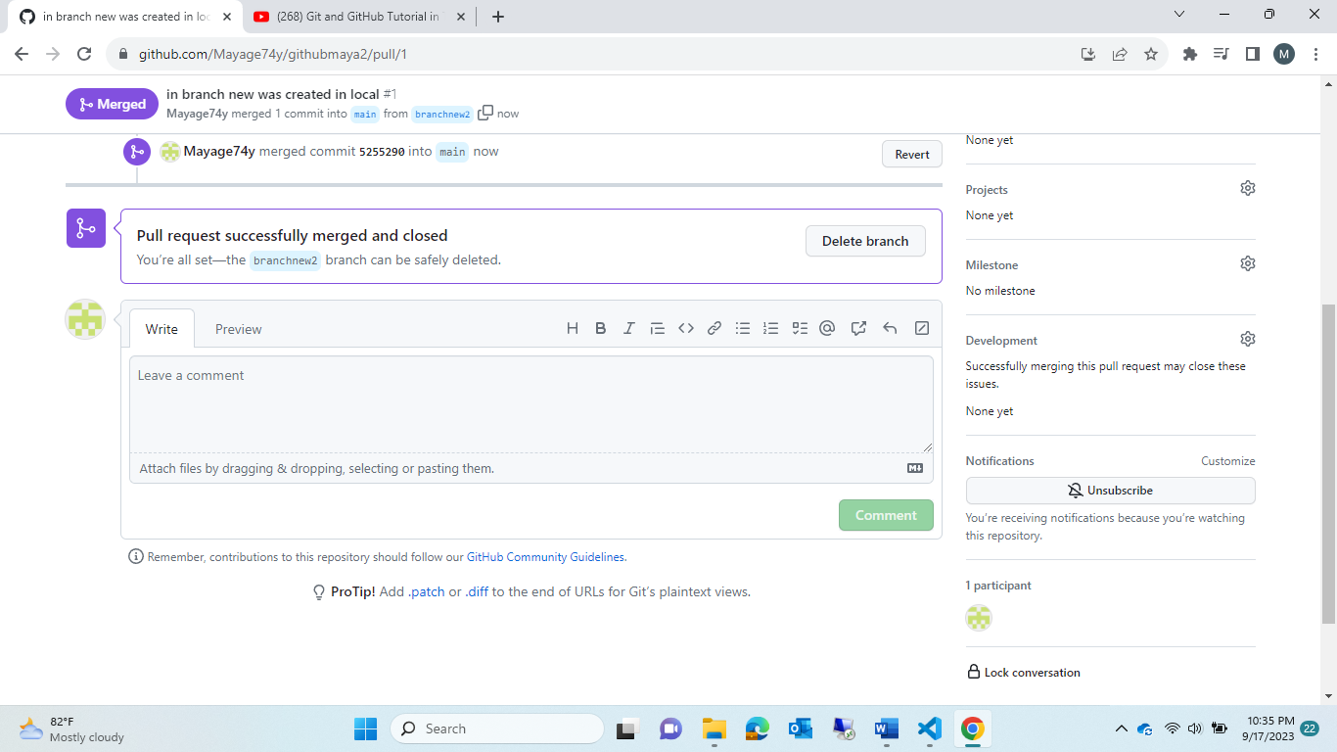

Now check in main that new file is added or not !!

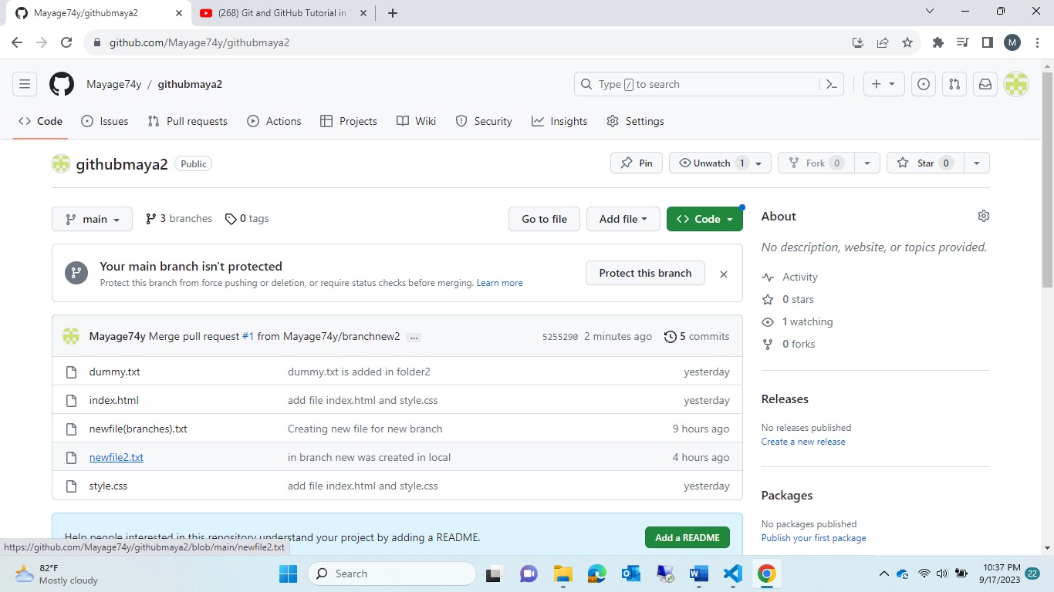

Newfile2.txt was added in “main” branch

Module7:

What is conflict ?

* If two person are trying to do changes in same file 🡪 github got confuse which is crt updated file🡪this can be solve only by manually.

1.create new respostory<mergeconflict>

2.create new file inside that respositiry🡪”textfile.txt”🡪 context of msg was🡪”city:none”🡪commit changes

3.create 2 branch new

*branch1

*branch2 from main

4.in branch1🡪textfile.txt🡪city:banglore

In branch2🡪textfile.txt🡪city:Chennai

1. But in main🡪textfile.txt🡪city:none

Note: branch1 & branch2 file we are trying to send pull request these both

1. So main branch 🡪got confuse which want to take banglore or Chennai ?-->this is called “conflict”
2. * from branch1 send request🡪accepted request by main branch🡪 now updated as city:none🡪 city:bangalore
3. * again from branch2 send request🡪accept request by main branch🡪 but this time the system got confused🡪 to take Chanani or banglore🡪click “resolve conflict” 🡪do manual changes🡪then that error resolve and 🡪finnaly what changes done manual that only reflex there

1.

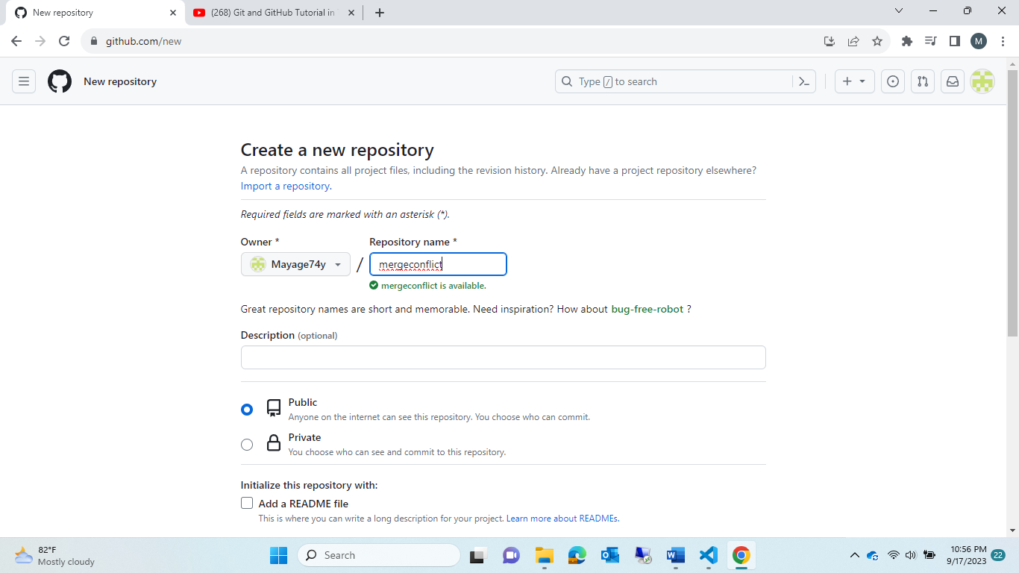

2.create file

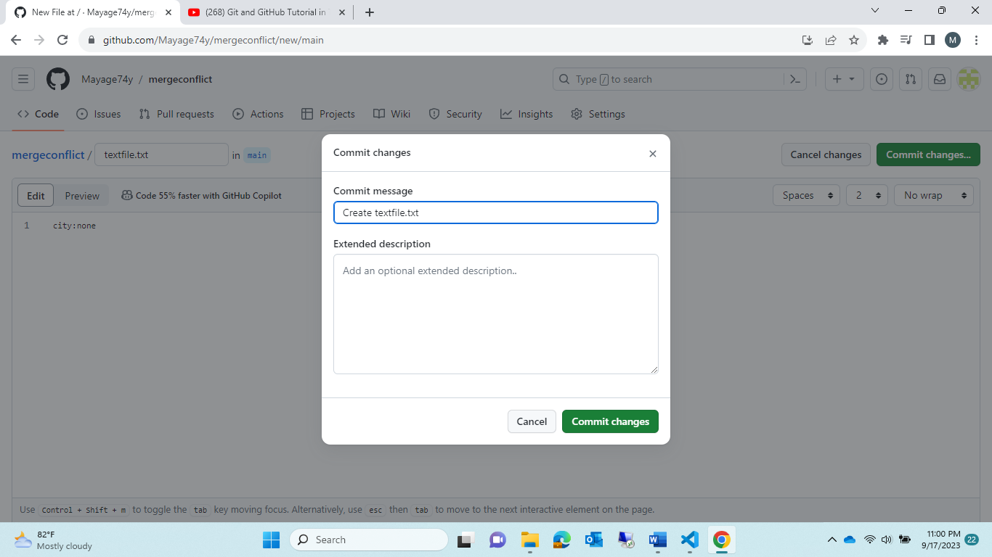

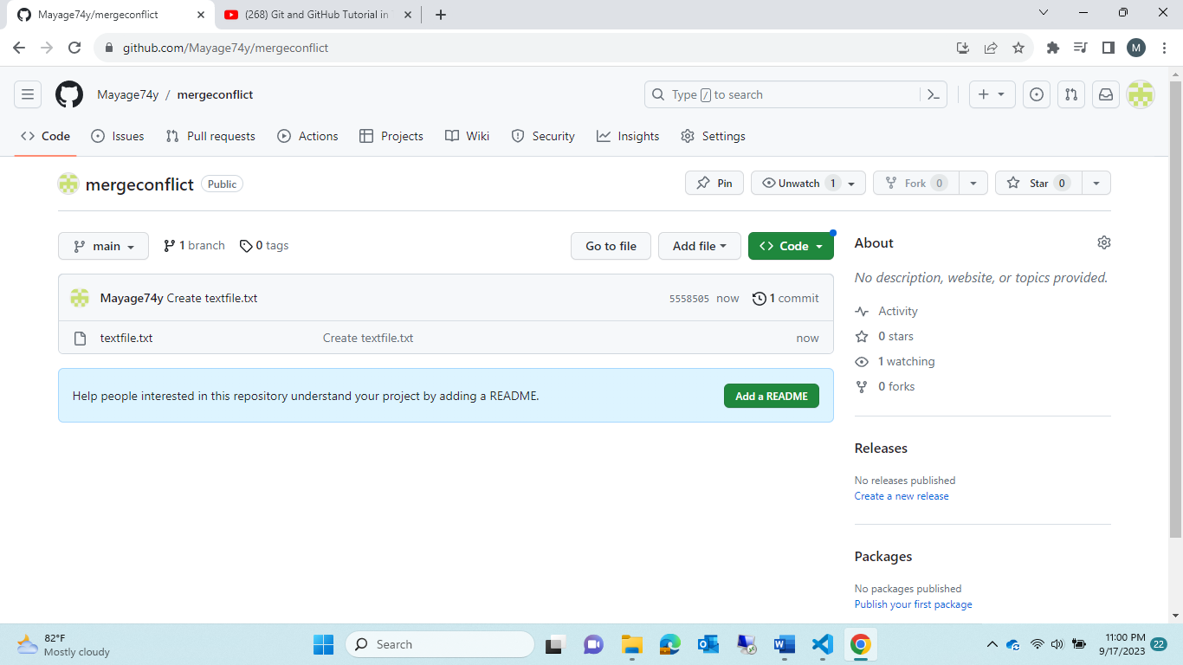

3.create new branch

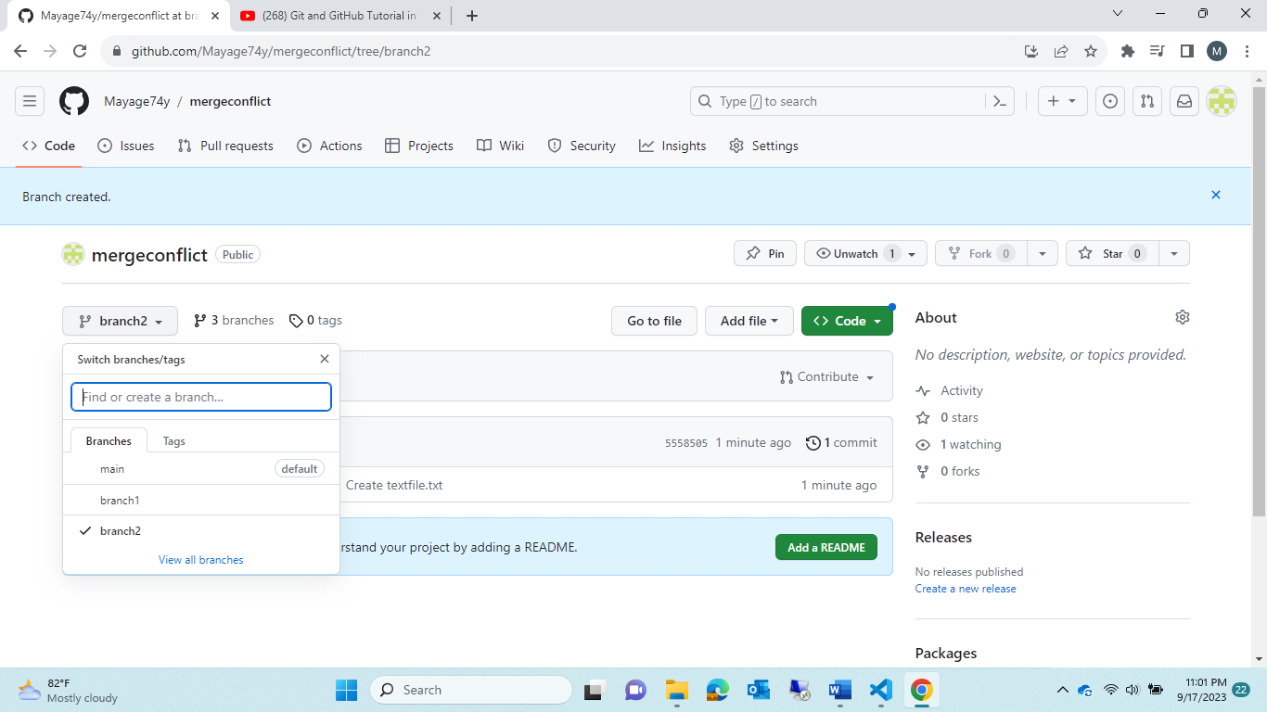

4.update in branch1 file and branch2 file

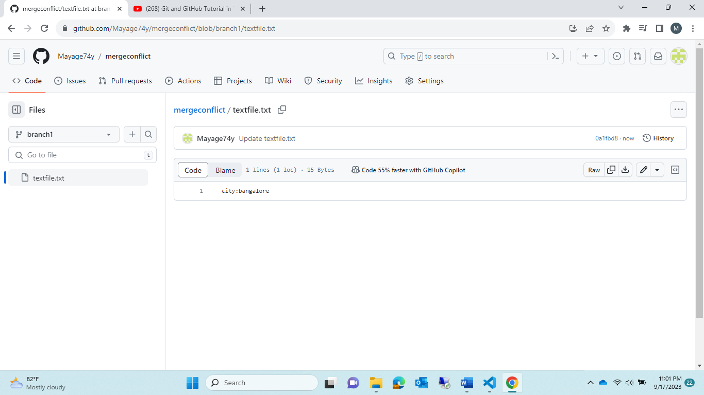

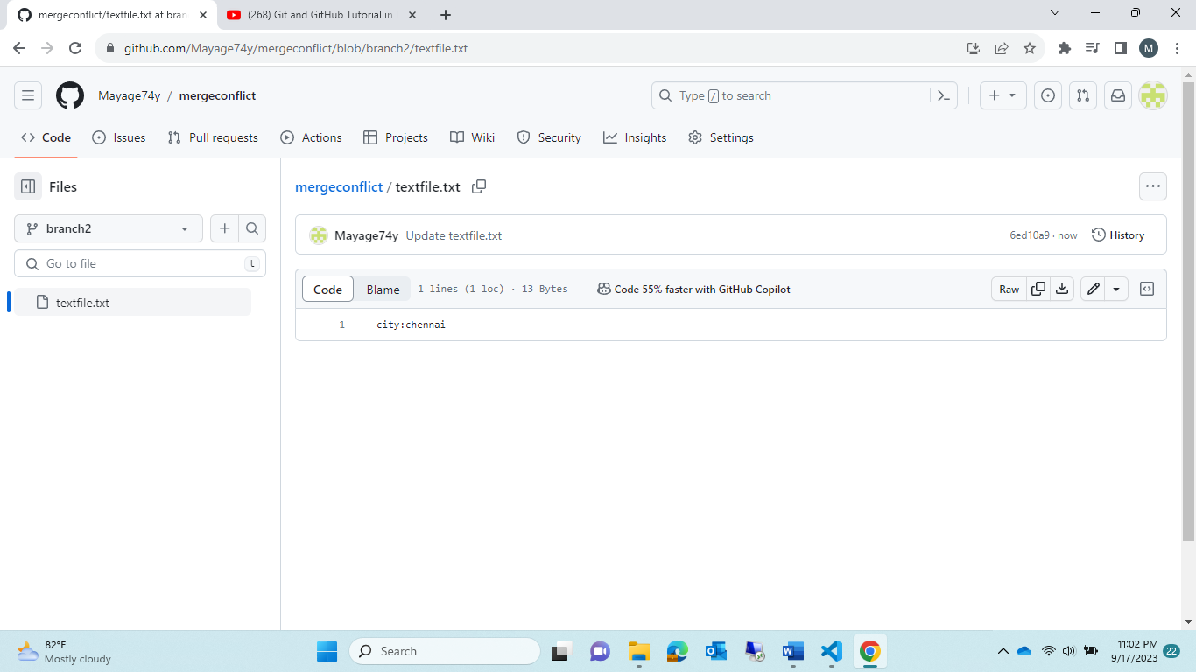

5.

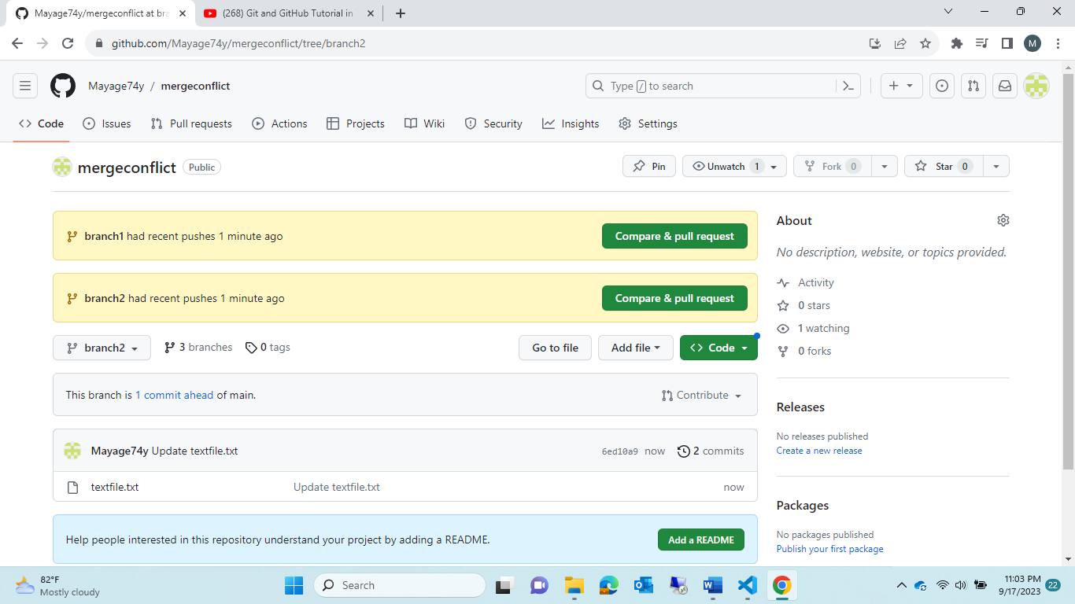

Send request

1.branch1

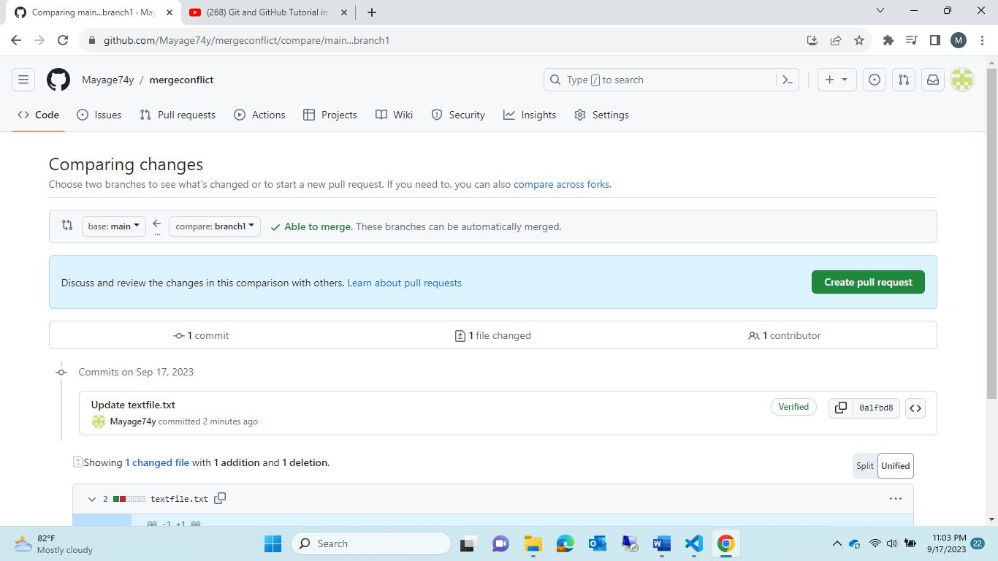

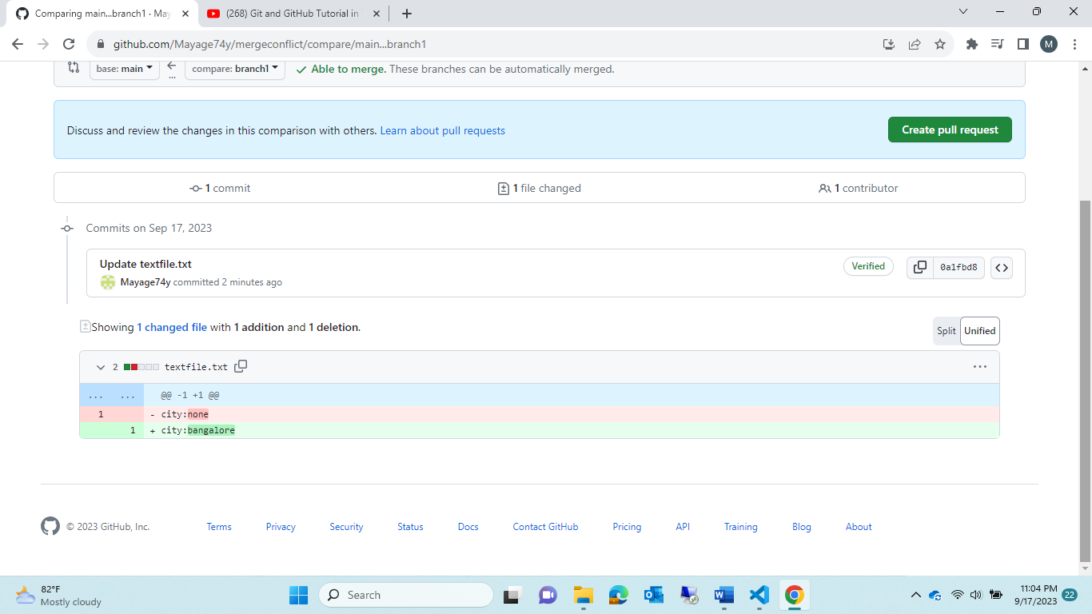

6. check in main🡪 pull request got created 🡪accept that

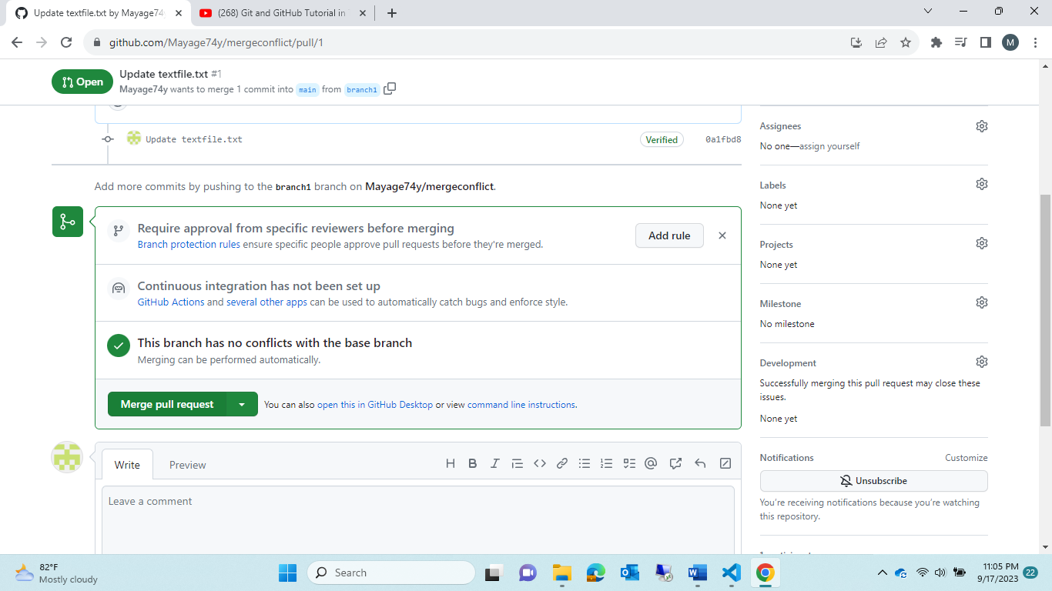

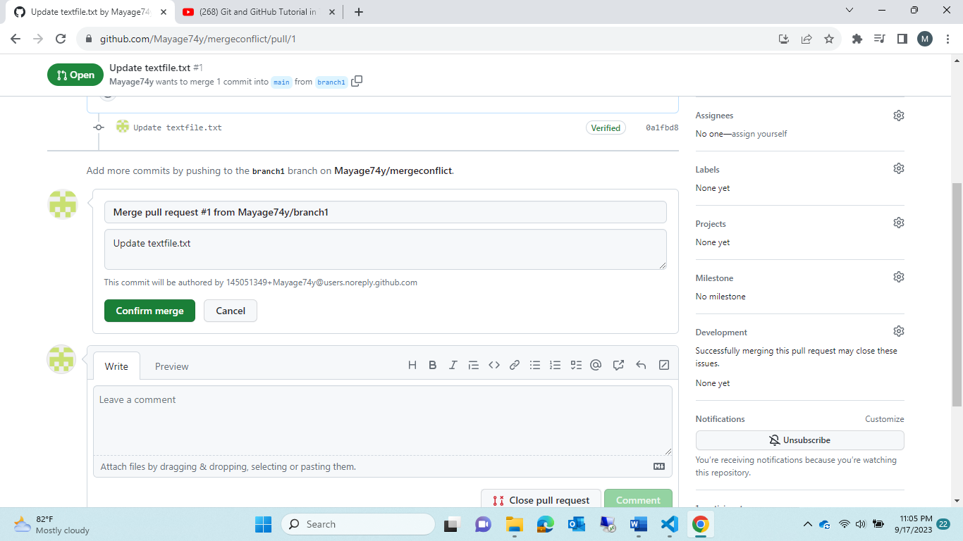

Main got updated

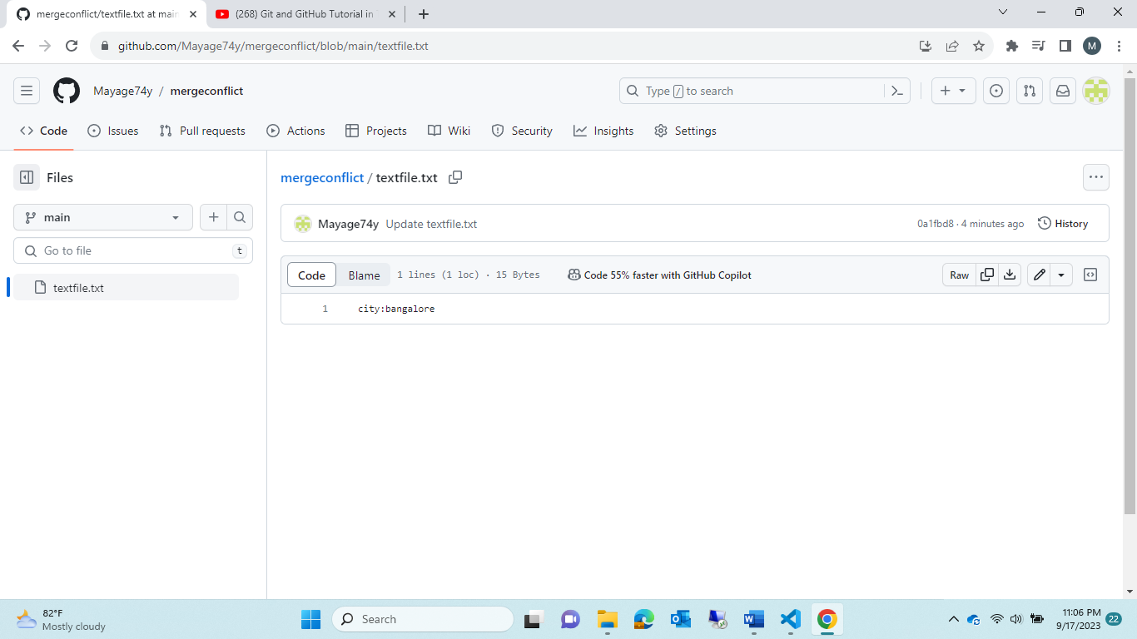

Step8:now send request for branch2

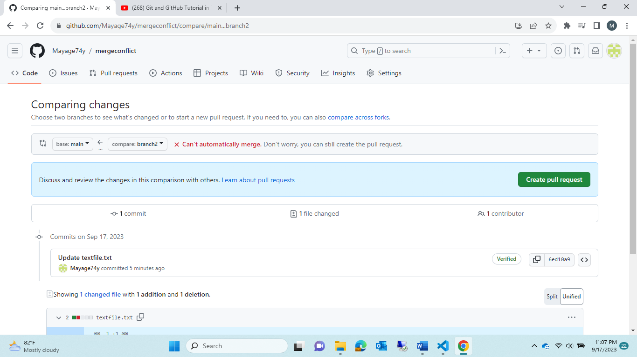

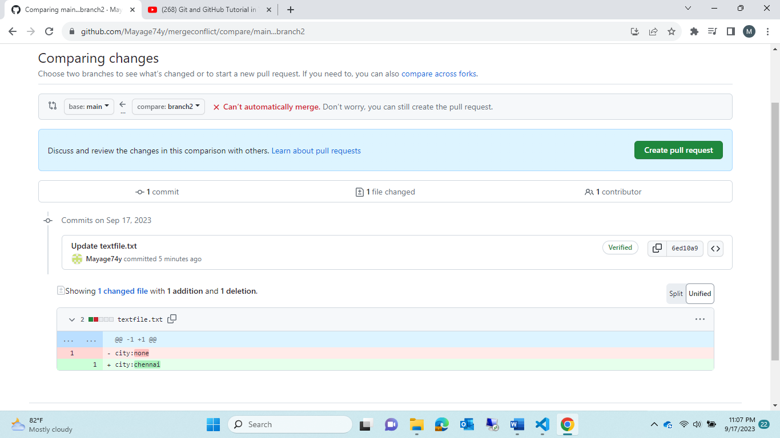

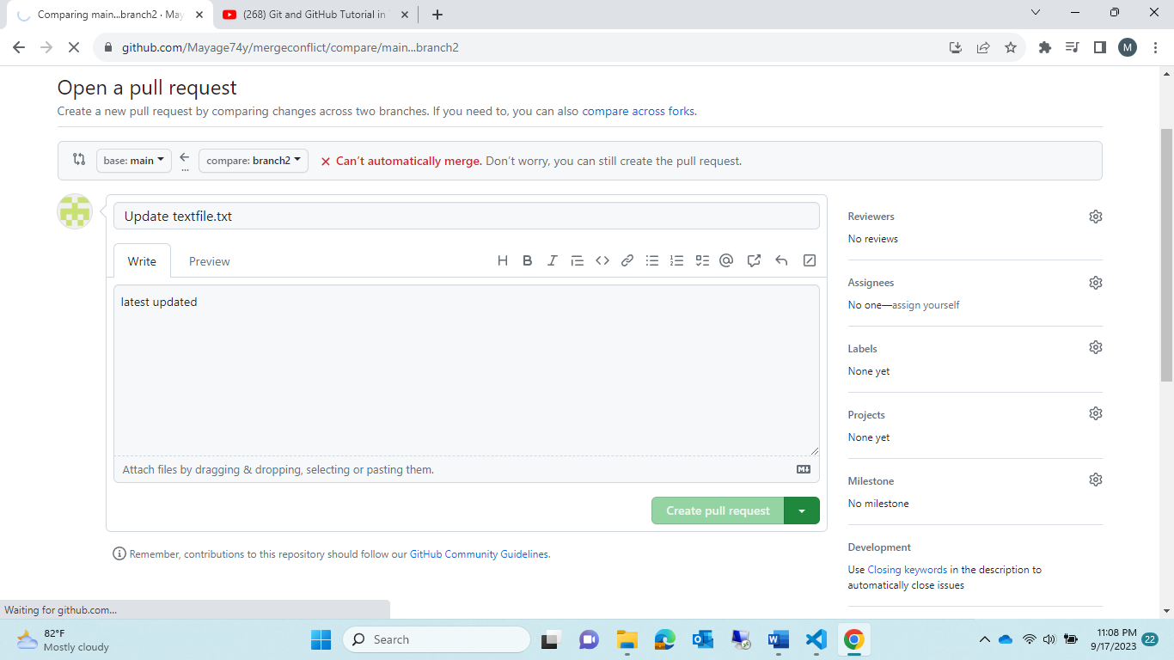

9.want to accept by manager “main”

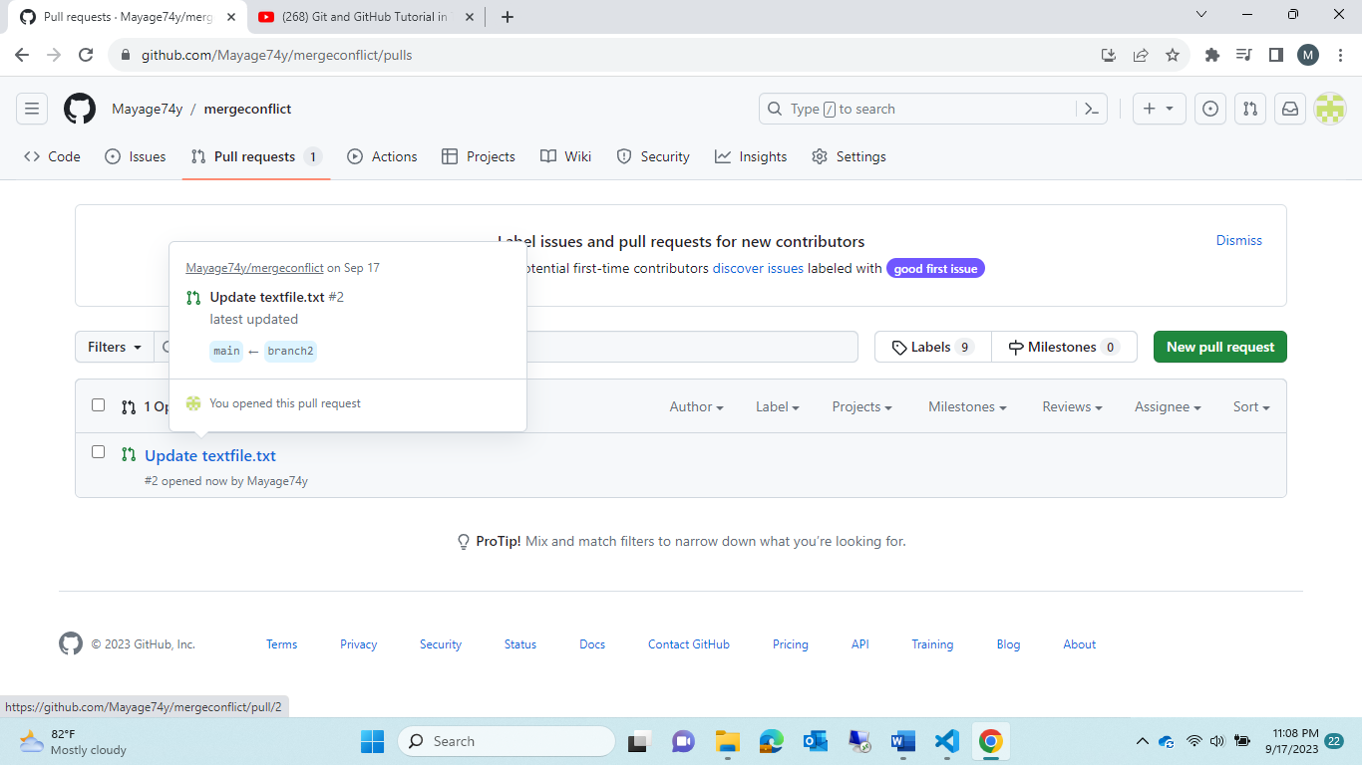

10.warning msg note that “conflict”

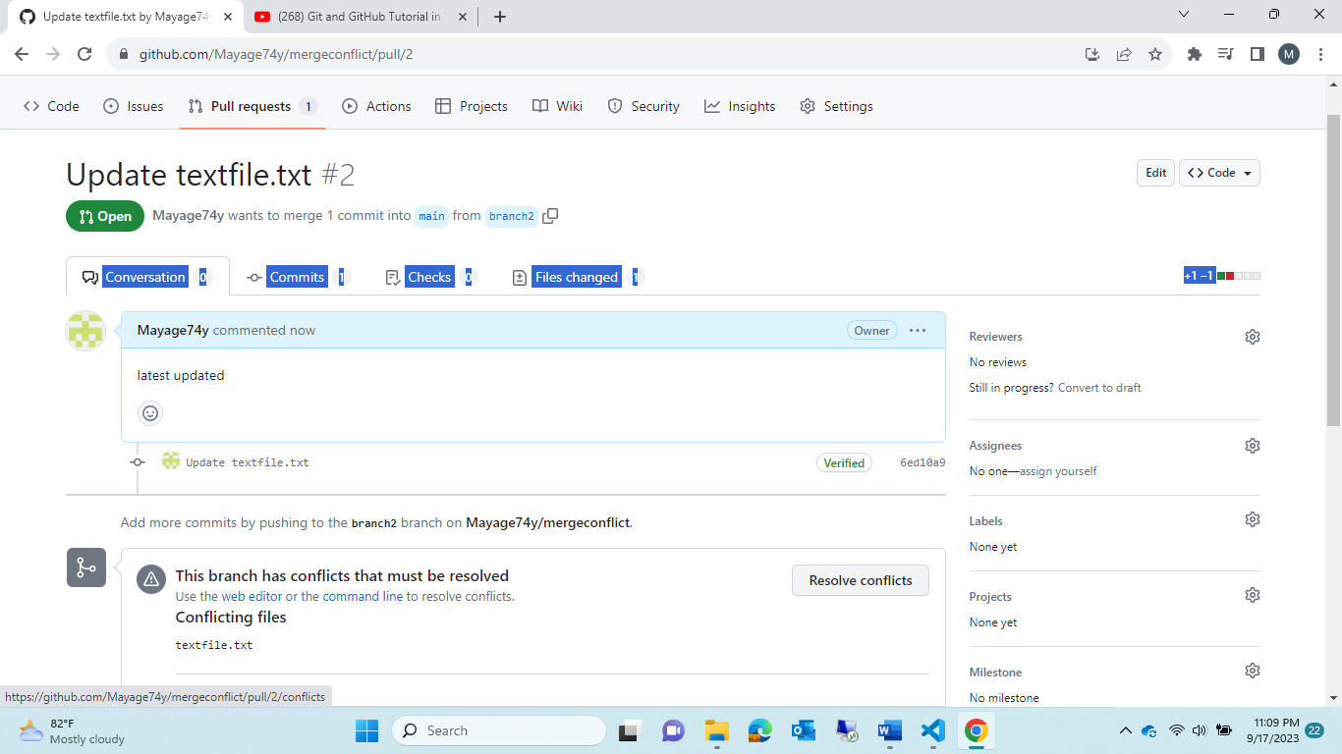

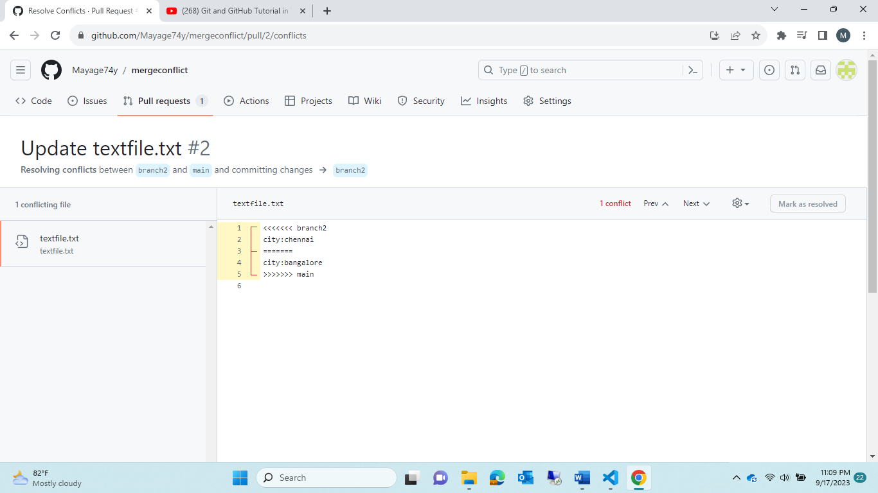

Resolve the conflict manuall;

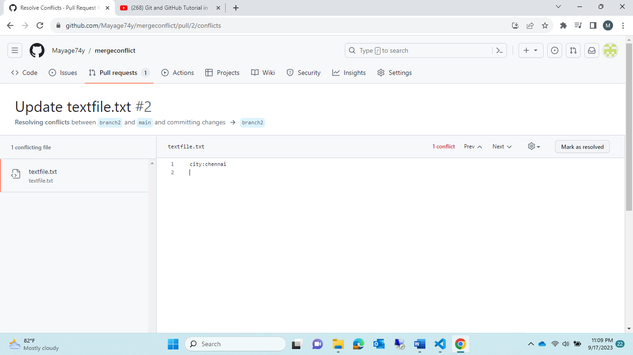

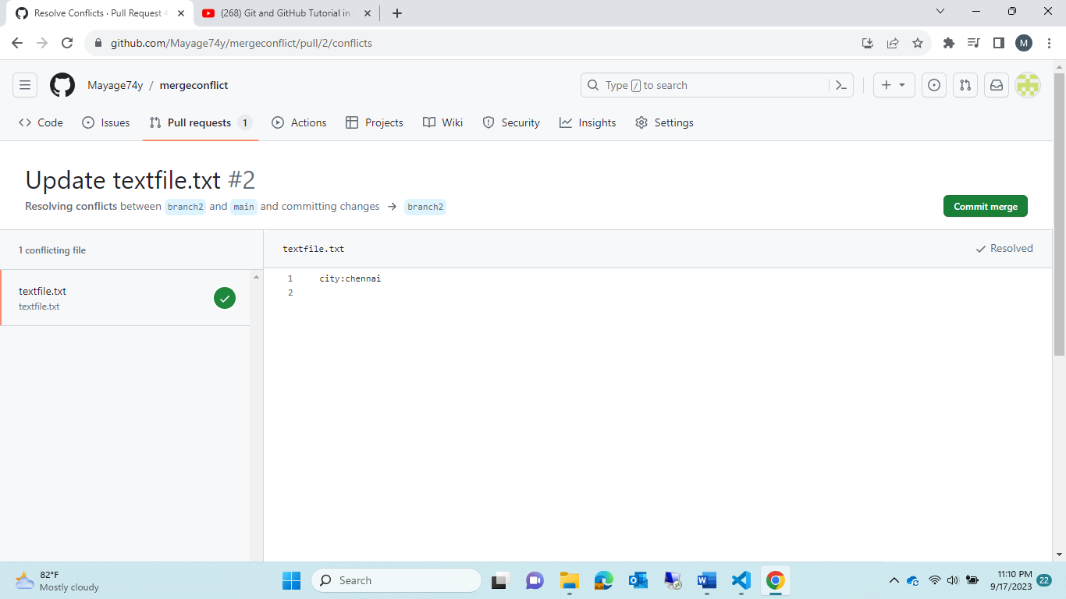

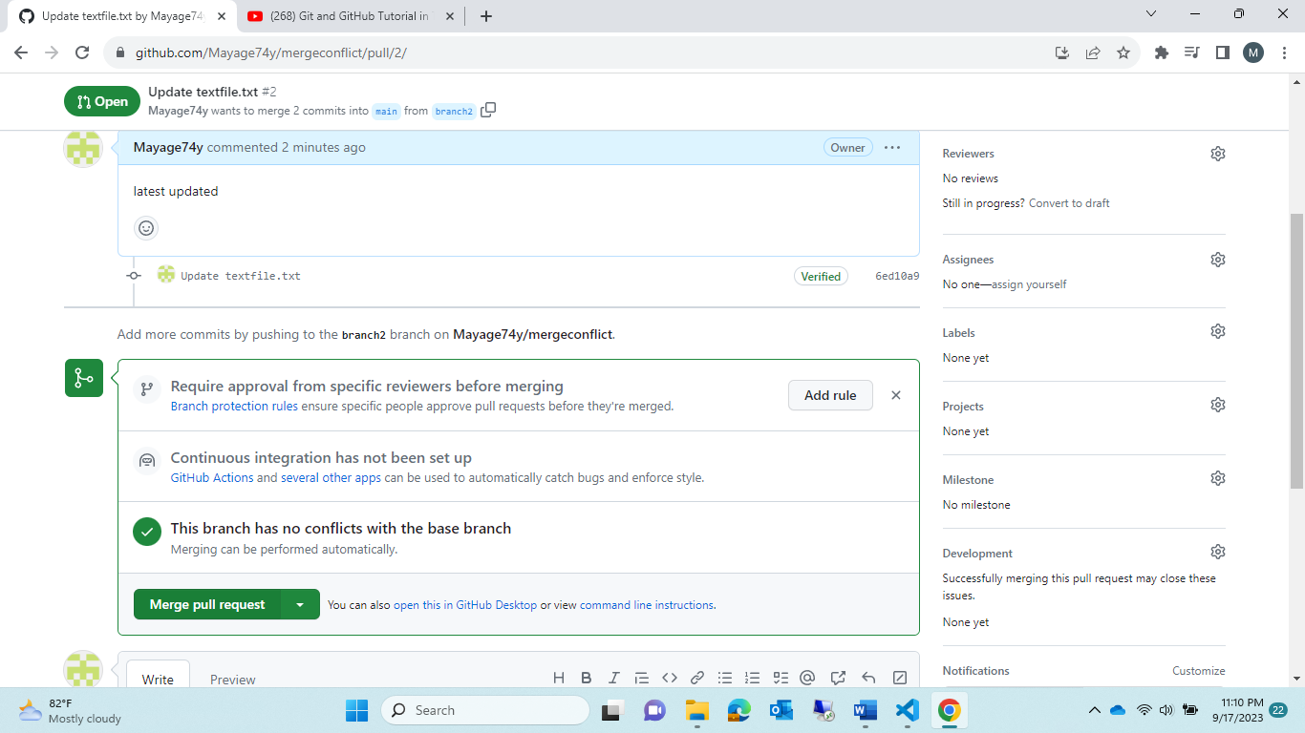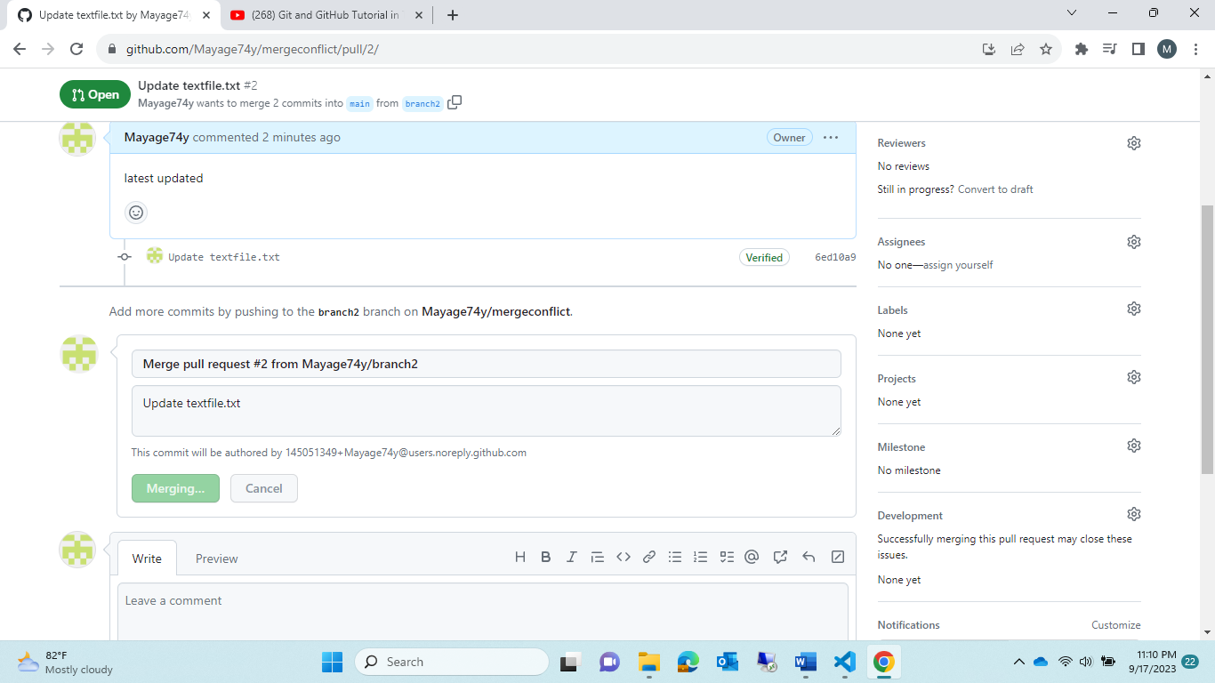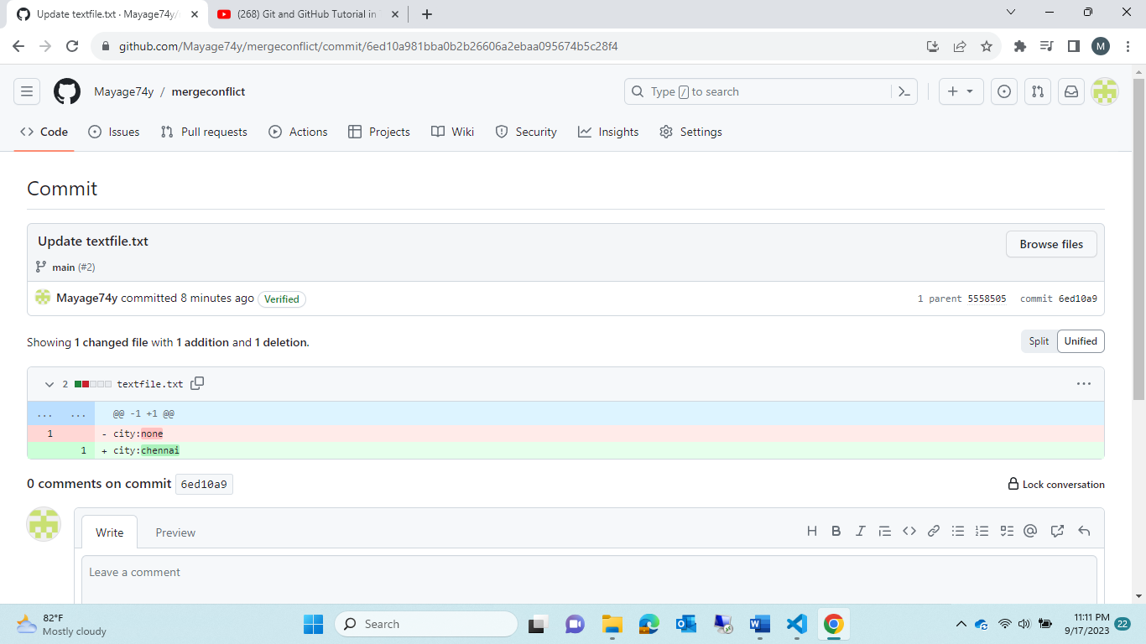

Module9:”

* Trydemo with project

Steps:

1.create repository 🡪HtmlActorPage

2.create a file in “main”🡪vijay.html

<center>

<h1>vijay</h1>

</center>

<hr>

3. create 2 new branches from “main” called as 🡪ramesh,suresh

4. clone the respostory to local 🡪 <git clone [copy that origin path]>

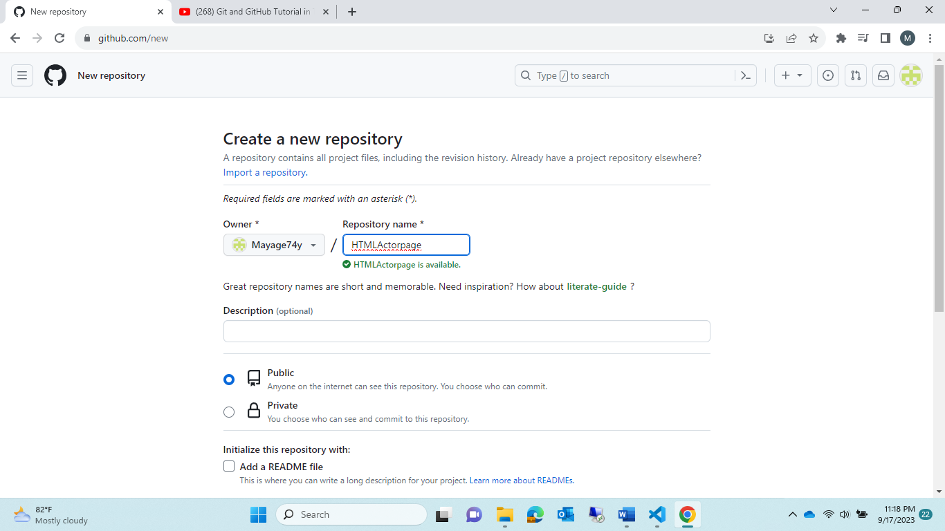

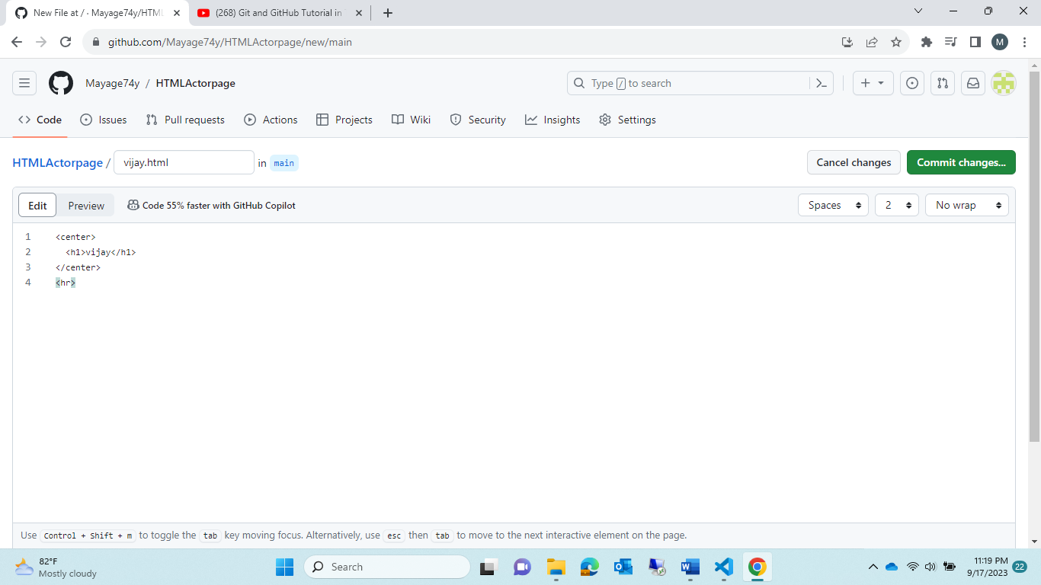

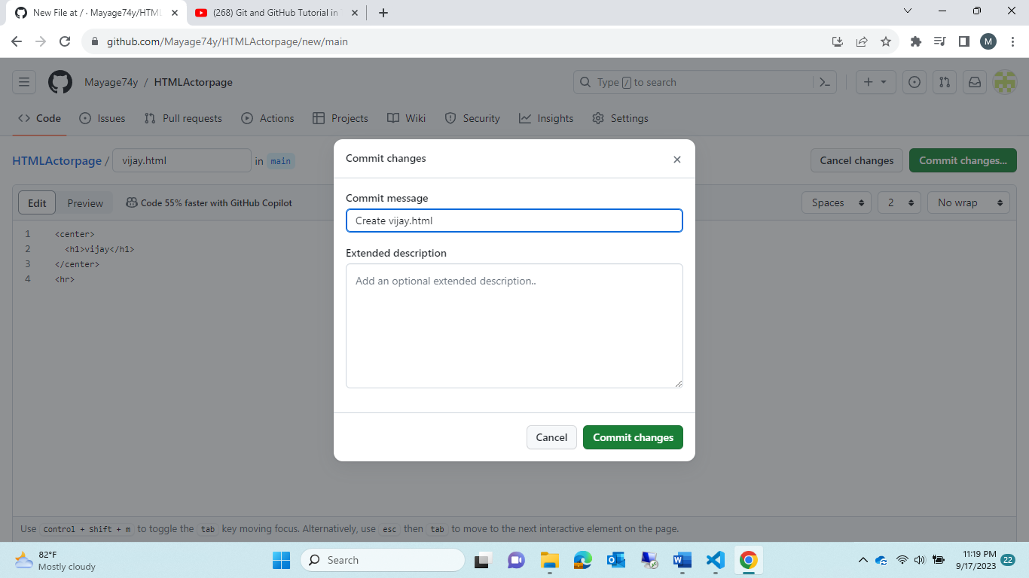

Two branch created

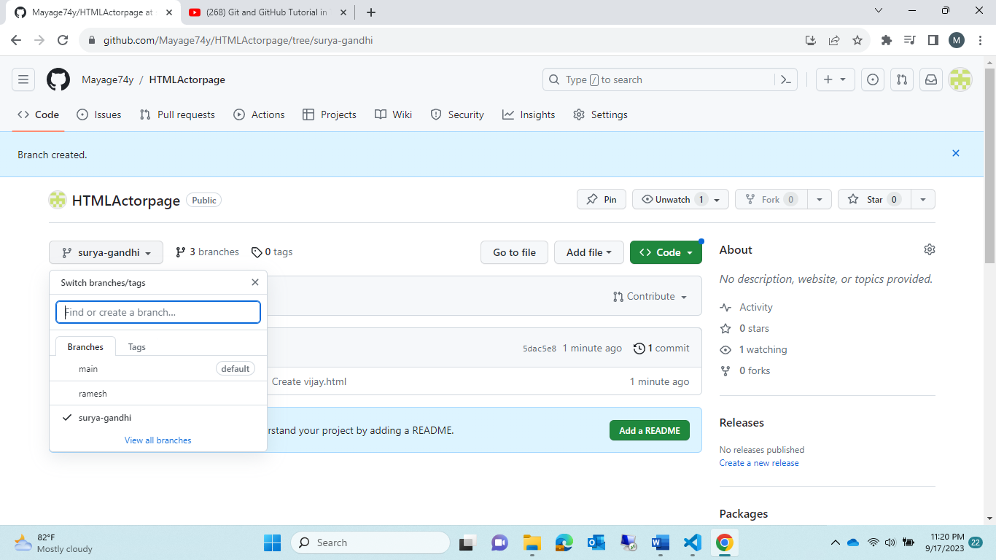

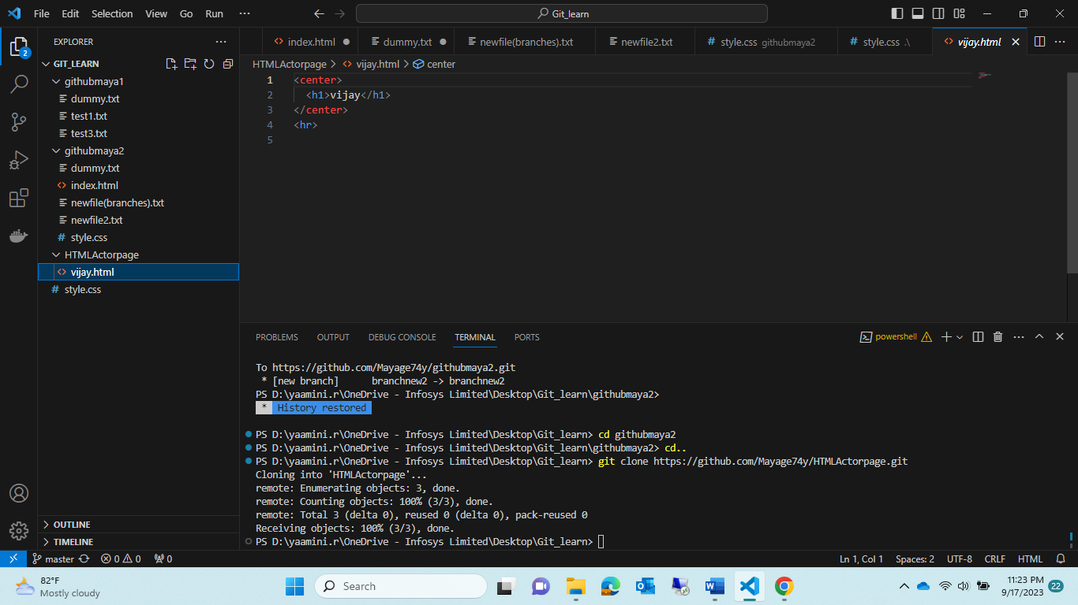

Copy the path 🡪paste in google

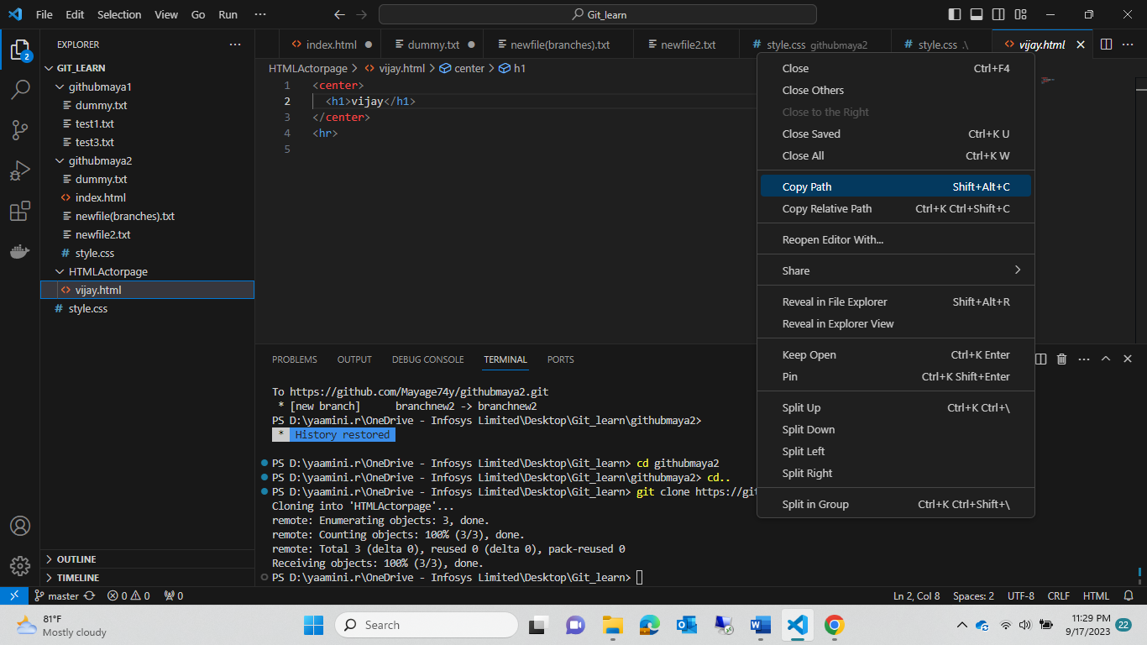

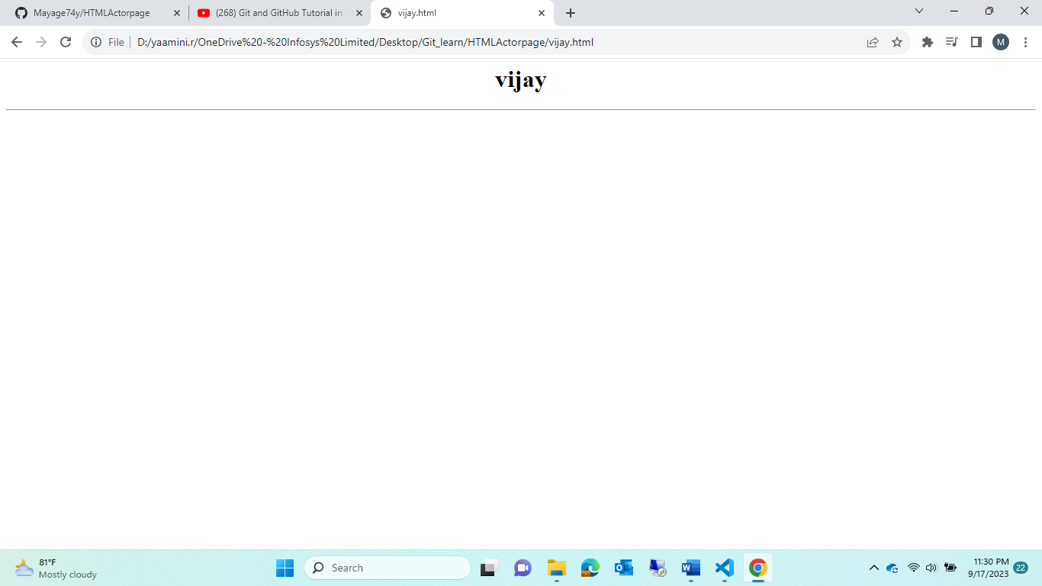

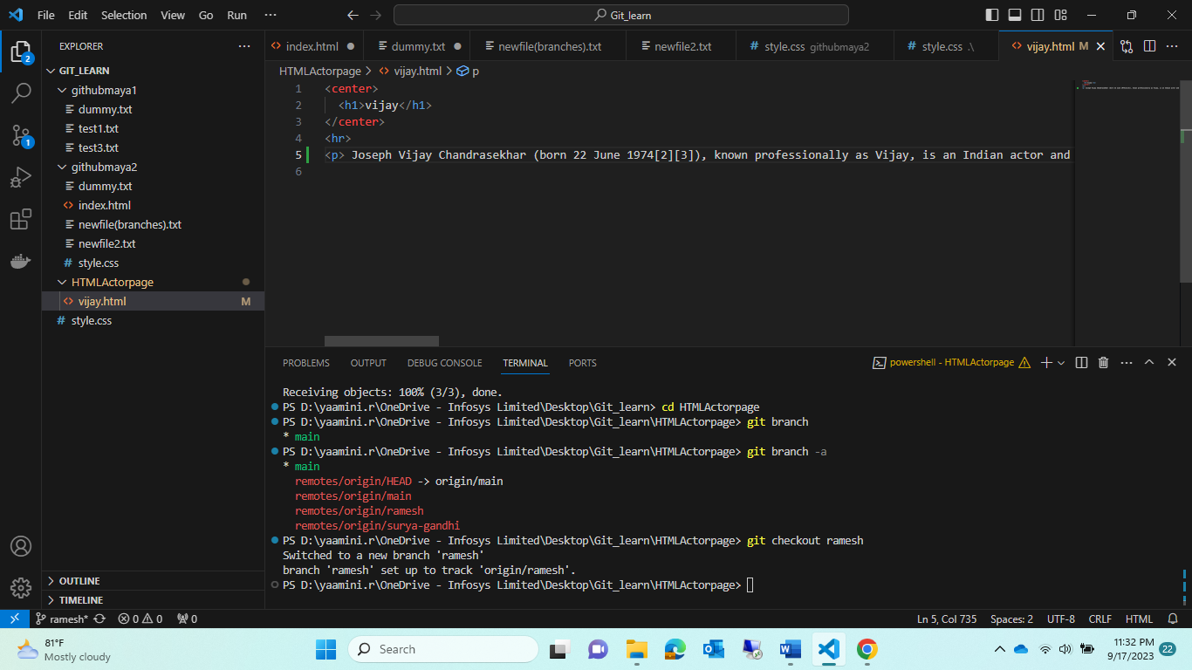

Note :Ramesh was working in vijay.html ,he added one paragraph abt vijay🡪 this changes also want to reflex github follow below img

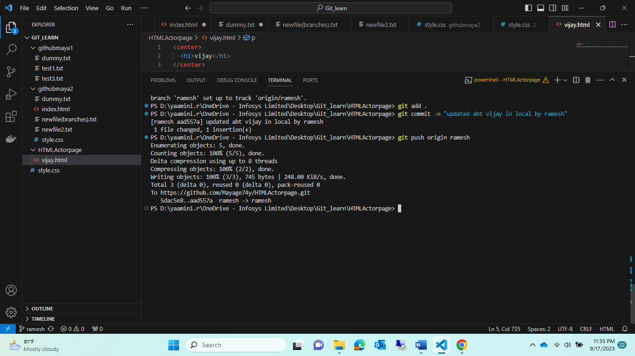

Now check changes was reflex in github

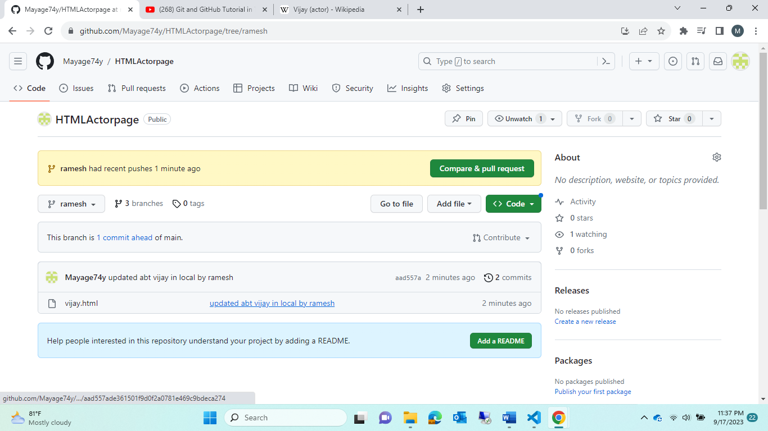

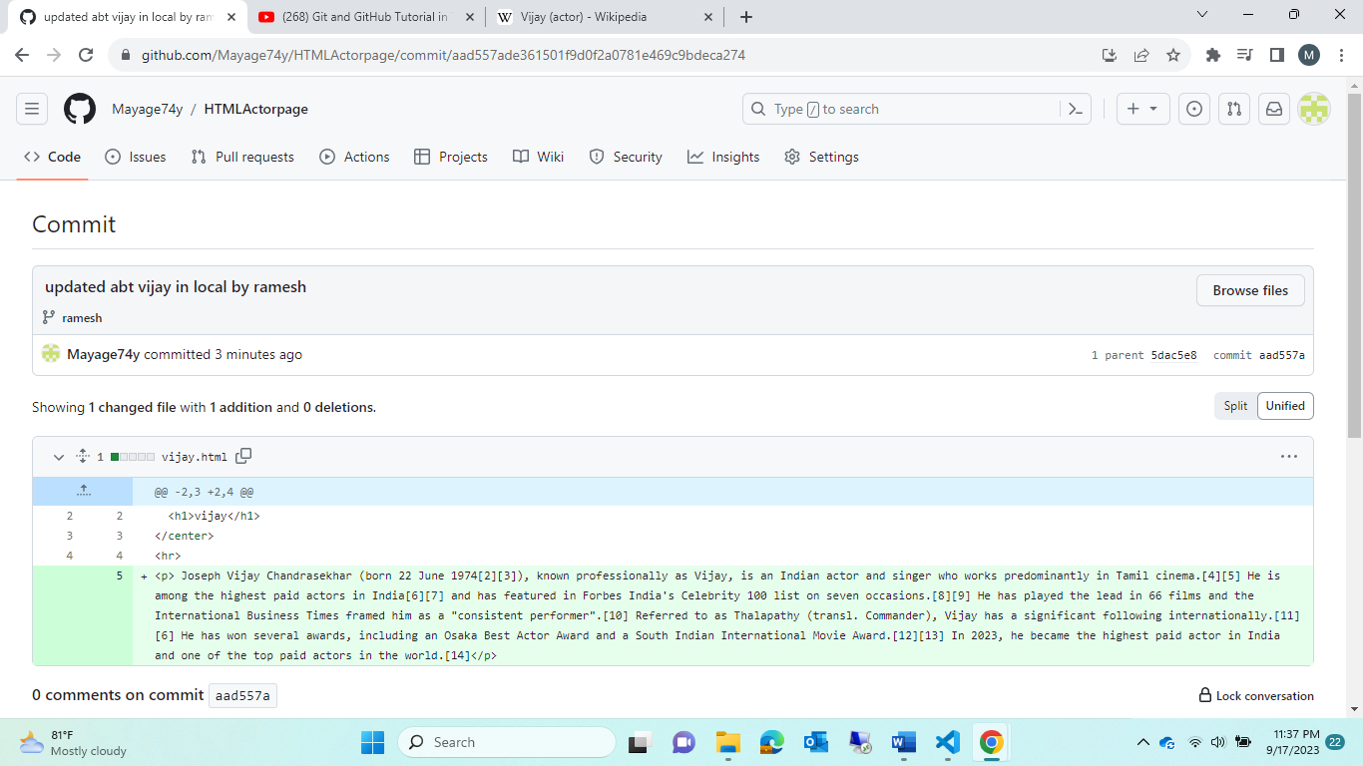

Now whathever changes done in Ramesh branch 🡪 that same should reflex in “main”branches?

Soln 1.git checkout main

2.git merge “Ramesh”

3. git push origin Ramesh

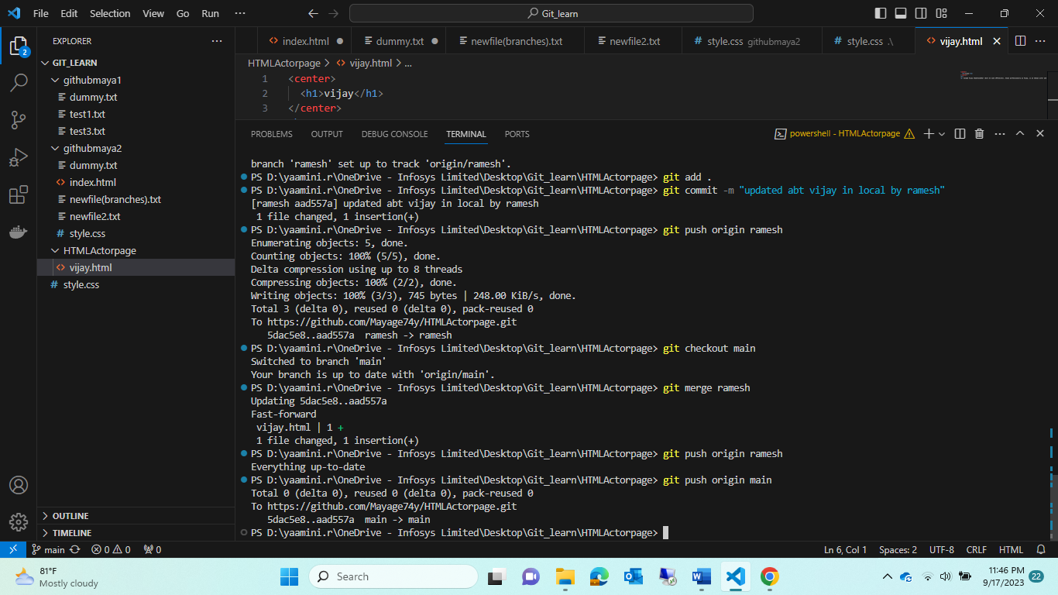

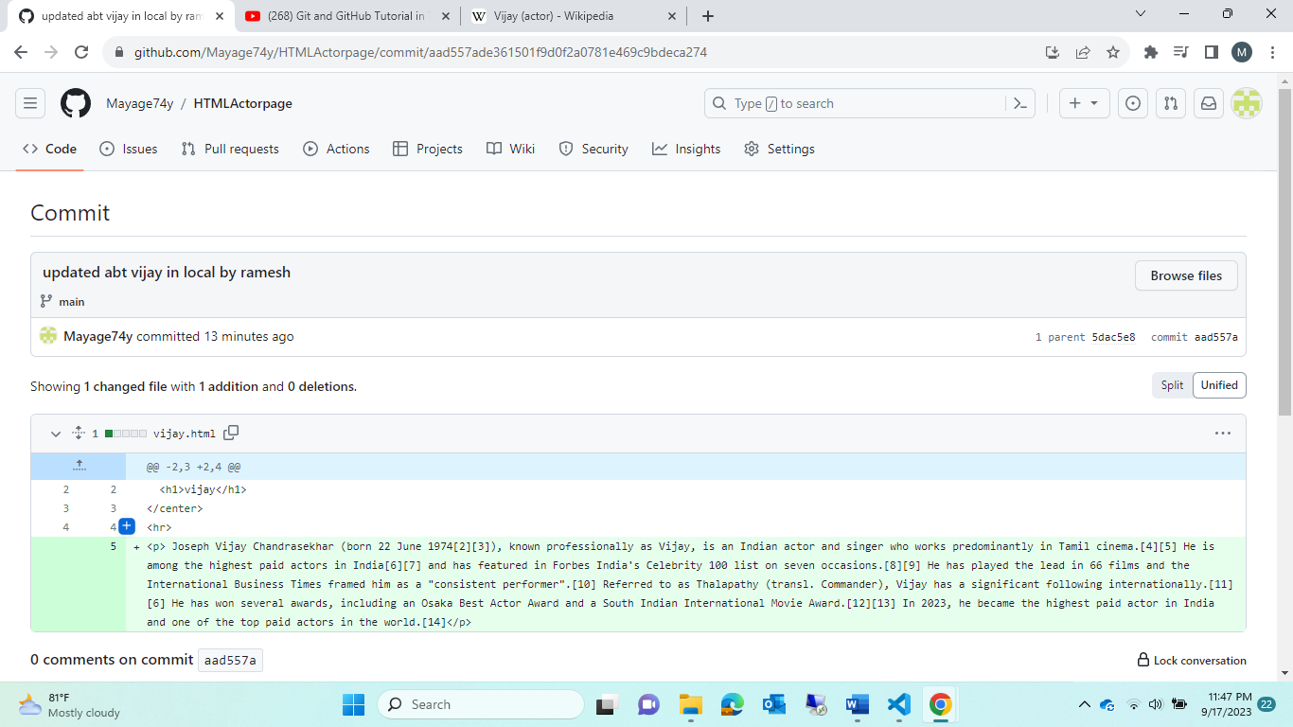

Note :Ramesh complete this work 🡪and moved to main 🡪 now surya-gandhi joined late and start remaining tasks

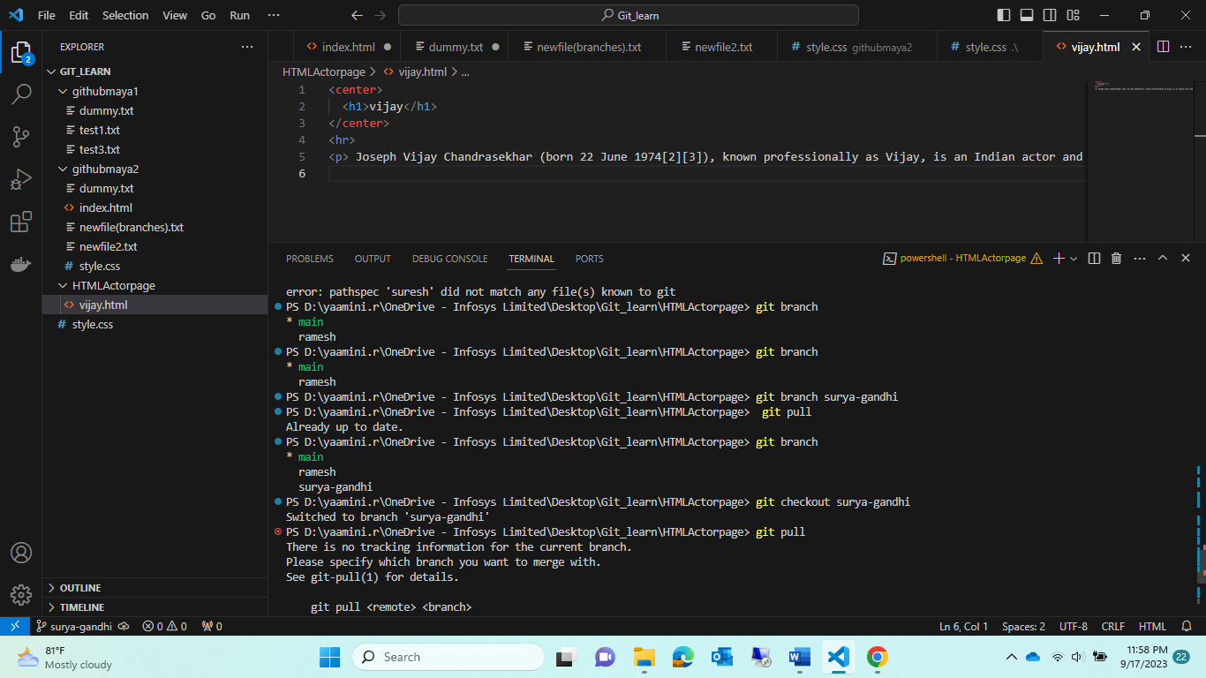

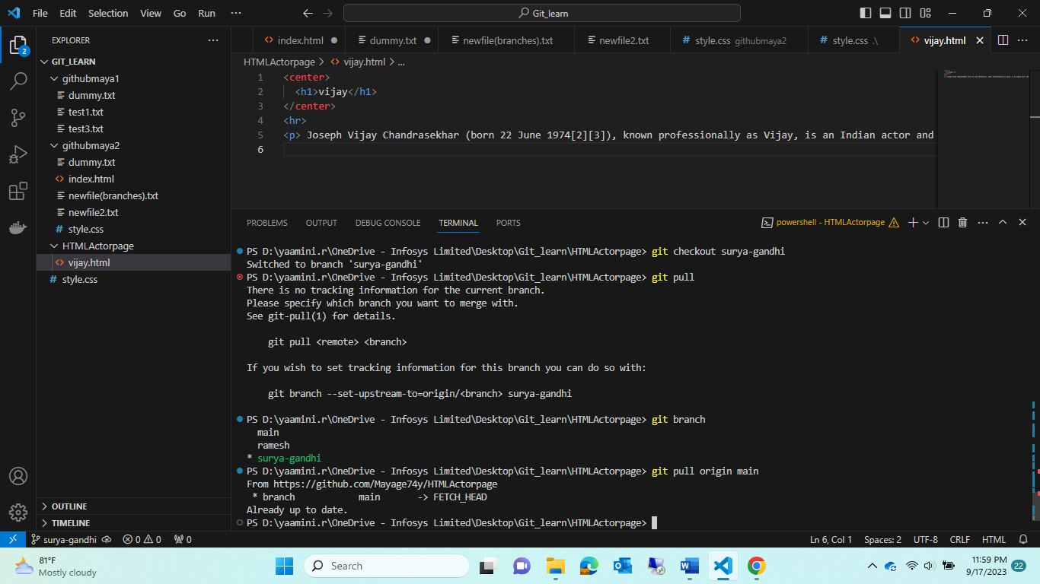

Git pull origin main (it will copy whathever latst updated into this surya-gandi foler branch)

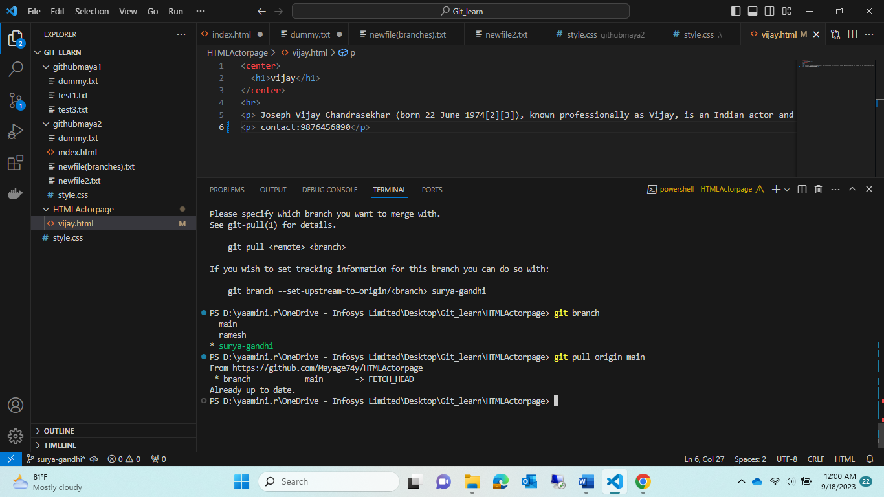

Now surya-gandhi updating contact information 🡪this should reflex in github

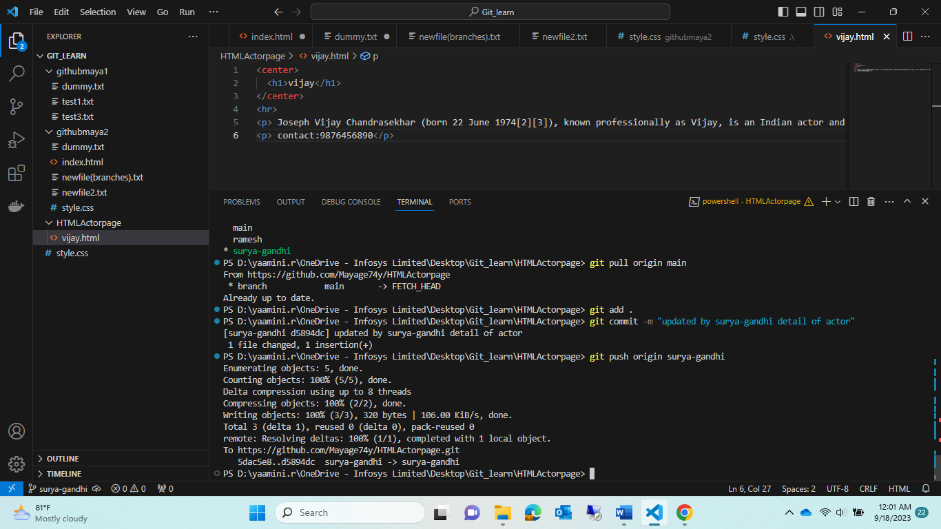

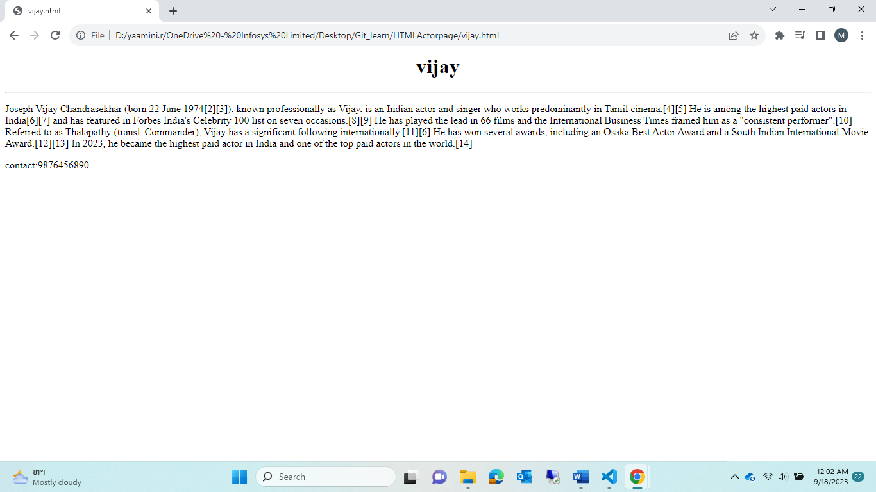\check

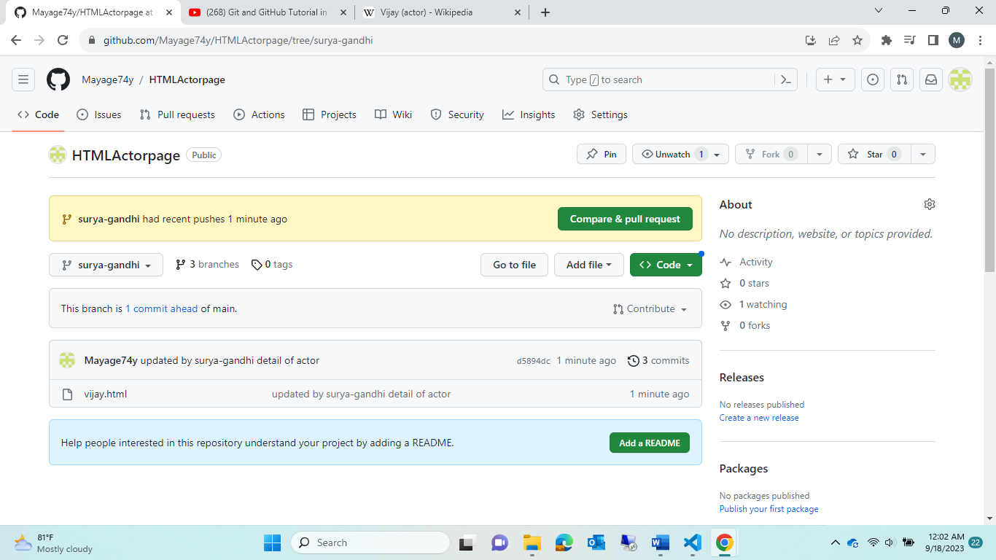

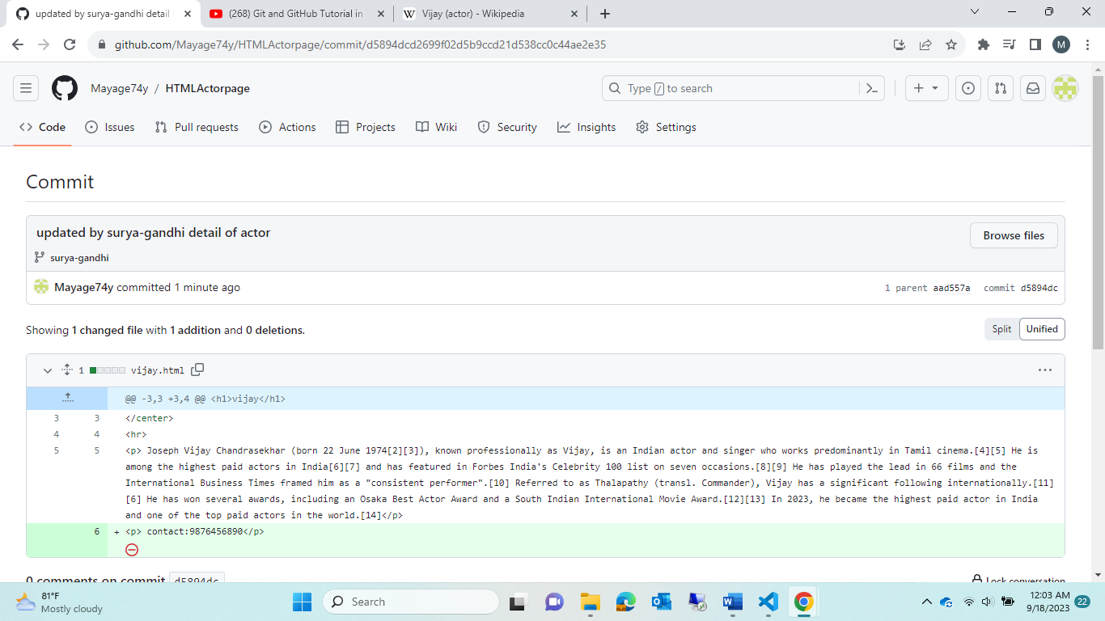

This new changes got reflex in github of surya-gandhi,,,then what abt “main”

Check:

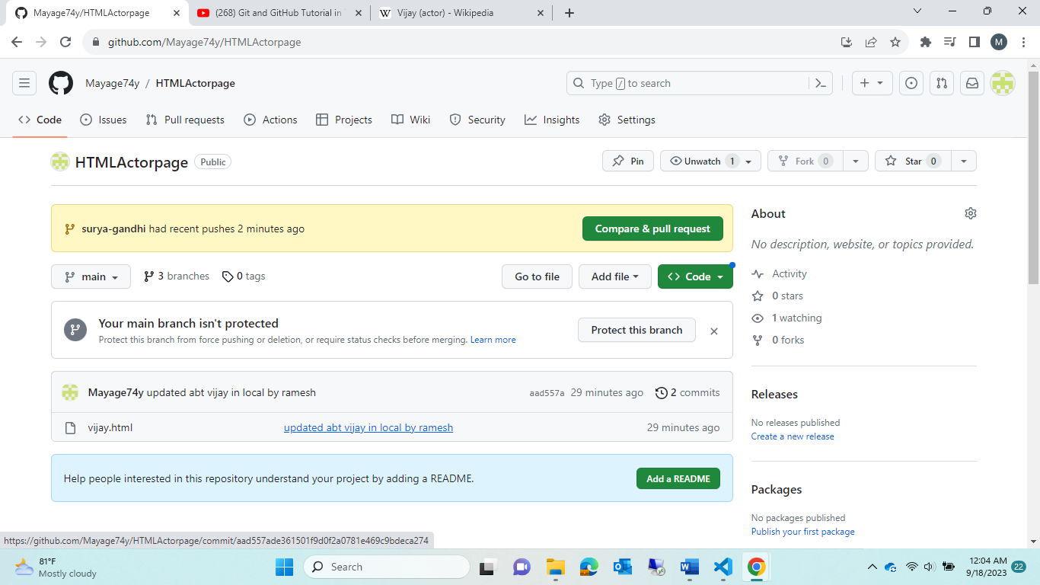

In main still was not changed

For that 🡪 <use merge cmd >

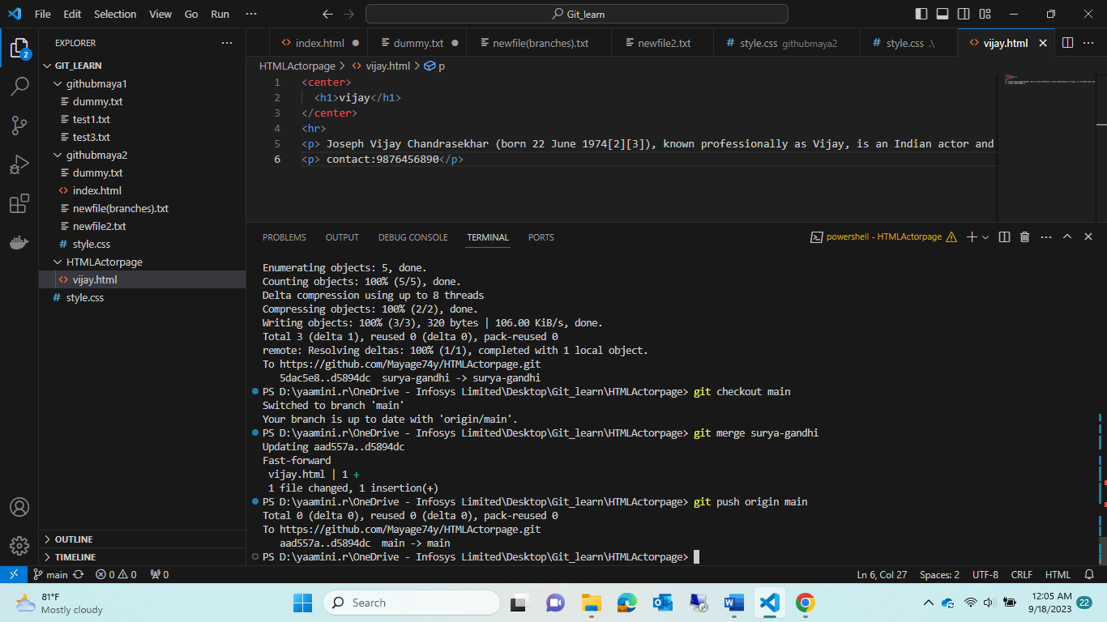

Now updated in main:

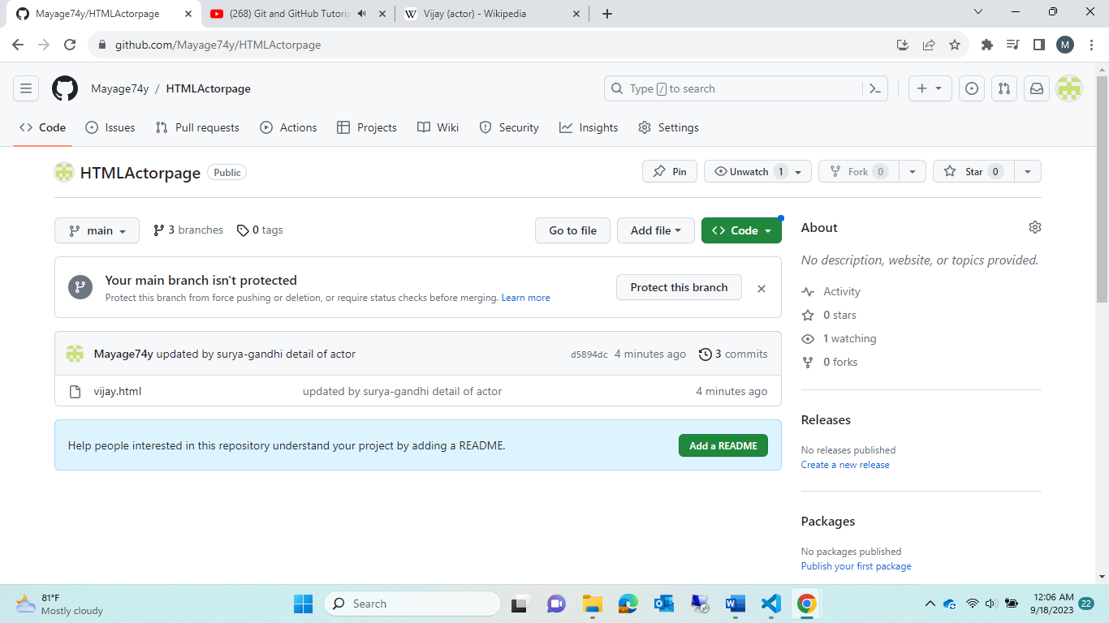

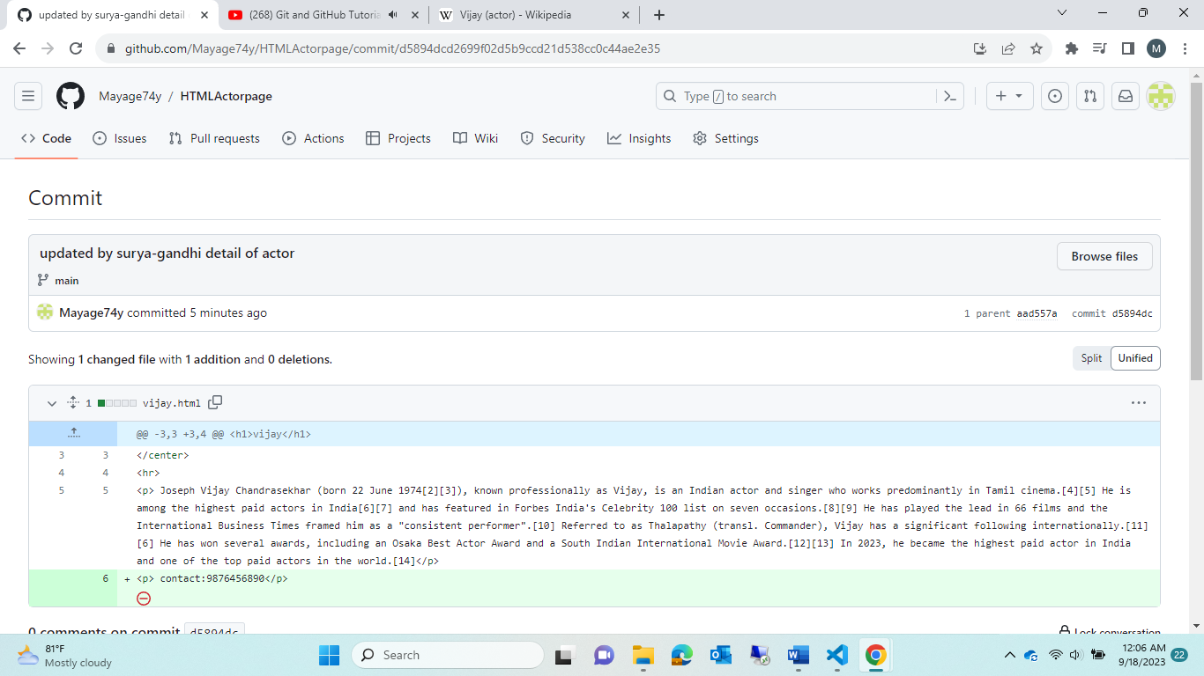

Tryout2:

